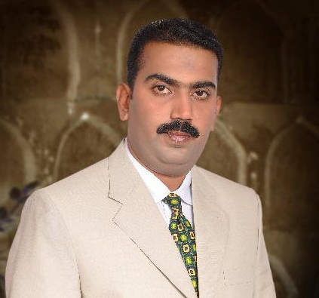
Mubeen Uddin
+92-335-8301020
+92-51-5532698
House # O/153, Street # 13
Kohati Bazar, Muree Road
Rawalpindi, Pakistan.
e-mail: uddin_mubeen@hotmail.com

Career Objective

To be at the post of National Sales Manager till 40 years of my age with a progressively oriented company that utilizes my analytical, interpersonal and communicational skills. And also provide me opportunities for further growth.

Personal Profile

- Father’s Name Moin Uddin (Late)
- Nationality Pakistani
- Date of Birth Feb 03, 1980.
- Marital Status Married.
- Language Skills Fluent in English & Urdu,
Good in Punjabi

.

Summary of Qualifications
.
- Graduation (Pre Medical) from Punjab University in 2001.
- Intermediate (Pre Medical) from Rawalpindi Board in 1999.
- Matriculation (Science) from Rawalpindi Board in 1997.

Professional Experience

- Currently working as Senior Medical Information Manager (Sr. Area Manager) of Rawalpindi Zone & Faisalabad Zone in Reckitt Benckiser Pakistan from Jan 2013 to Date. Worked al Medical Information Manager (Area Manager) of Rawalpindi Zone from Sep 2011 to Dec 2012.

Major Responsibilities included

    - Development & grooming of newly hired sales force.
    - Training of medical knowledge & selling skills at national level.
    - Conduction of product presentations in all major hospitals of major cities of Rwp & Fsd zone by utilizing the KOLs relation.
    - Conduction of training sessions & conferences at national level.
    - Controlling & implementing the professional instructions to field force as & when required by the management.
    - Selection, Development & Coaching a professional sales team (1 Area Managers & 16 Representatives of Rwp & Fsd zone to meet or exceed specific goals for profitable revenue growth.
    - Looking after Disprin, Disprol, Strepsils, Gaviscon and Bonjeela.
    - Development of annual sales plan & implementation from field force.
    - Pursue identified business prospects, participating actively in the planning and sales process for new business opportunities.

- Worked as Area Manager (Rawalpindi & Peshawar) in Barrett Hodgson Pakistan from Nov 2008 to Aug 2011.

Major Responsibilities Included

    - Management of 2 major divisions with 11 representatives.
    - Looking after Cefspan, Losec, Febrol (Gn.Division of Rawalpindi) & Imdur, Plendil, (Cardiovascular Division of Rawalpindi & Peshawar).
    - Arrangement of Symposia & workshops in different institutions of Rawalpindi Zone.
    - Utilizations of KOLs for product presentations & CMs.
    - Development & grooming of newly hired sales force.
- Conductions of medical presentations on different products in different institutions of Rawalpindi Area.
- Hiring, development & grooming of new trainees from appraisal to confirmation.
- Polishing of behaviouristic management of newly hired officers.
- Winners of Gold Medal and Elite Club membership for consecutive three years from 2007 to 2009 in different status.

Worked as Medical Sales Officer in Barrett Hodgson Pakistan from Jan 2004 to Oct 2008,

Worked as Medical Sales Officer in Schwarz group of Cardiology in Atco Laboratories from Aug 2003 to Dec 2003.

Starting of career as Territory Manager in Nabi Qasim Industries from Jan 2003 to Jul 2003.

Professional Skills

- Excellent Communicative & Motivational skills, with strong work ethics.
- Strong belief in Team Work, stream line analytical & presentation skills.
- Massive personal & professional management under pressure to meet objectives by taking strong decisions.
- Very Friendly, Honest & Enthusiastic professional approach.
- Good knowledge of computer in MS Word, Excel, Power Point along with Net surfing.

Professional Training
- Advance Communication Skills.
- Different Behaviors of Leader.
- Customers Attitude and Interaction.
- How to engage the employee.
- Tactical Individual Management.
- Basic Disease and Products Information.
- How to use the customer emotions.
- Effective Leader.
- Selling skills training and presentation at different levels.

References
- Available on request.

