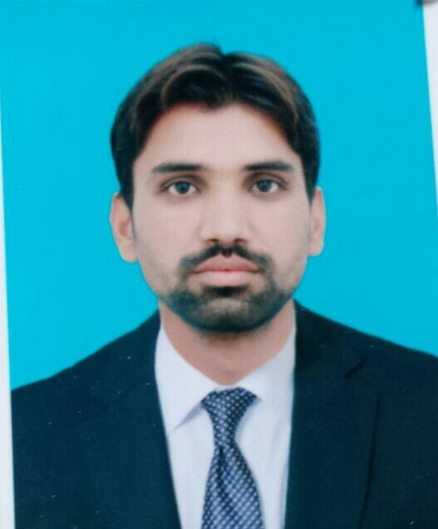
curriculum vitae
Dr. MUHAMMAD AAMIR
PERSONAL DETAILS:  PERSONAL DATA:  Father’s Name :  Sardar Bakhsh  Date of Birth :10-11-1991  NIC # :33402-0339927-7  Gender :MALE  Marital Status :Single  Domicile : (Punjab)  EMAIL:  Dr.aamir159@ gmail.Com  RESIDENCE:  House no 42-13/3 Near Bohar Chowk Mohallah Chanun Pura Sillanwali Tehsil Sillanwali Distt.Sargodha  MOBILE:  0333-7000637  CURRENT ADDRESS:  Muhammad Aamir S/O Sardar Bakhsh House no 42-13/3 Near Bohar Chowk Mohallah Chanun Pura Sillanwali Tehsil Sillanwali Distt.Sargodha  INTERESTS:  - News Paper Reading  - Playing Games  - Listening to the Music  - Watching Cricket etc  LANGUAGES KNOWN:  - English, Urdu  (writing, reading, speaking)  REFERENCE:  Prof. Dr. Sajid Bashir  Prof. Dr. Zubiar Malik  Assistant Prof. Dr. Iftikhar | CAREER OBJECTIVE:  Seeking a career with a future oriented organization, this will provide me the platform for becoming a well-recognized professional and ultimately attaining prestige and pride for the organization and myself  ACADEMICS  - Pharm -D (2010-2015)  UNIVERSITY OF SARGODHA (UOS) SARGODHA.  3.36/4.0 (1st div )  - HSSC (Intermediate in Sciences Pre. Medical) (2007-2009)  PUNJAB GROUP OF COLLEGE SARGODHA,  Board of Intermediate & Secondary Education SARGODHA.  880/1100 (1st div)  - SSC (Sciences) (2005-2007)  GOVERNMENT HIGH SCHOOL # 1 SILLANWALI  Board of Intermediate & Secondary Education SARGODHA  739/850 ( 1st div)  INTERNSHIP  - Worked in DHQ CIVIL HOSPITAL SARGODHA for 40 Days.  - Worked in TRISON LABORATORIES for 40 Days.  PROJECTS:  - formulation and Evaluation of Herbal ointment. (FINAL YEAR)  - Knowledge about tobacco smoking among  pharmacy students in Pakistan: Findings from a pharmacy institute (FINAL YEAR)  ACHIEVEMENT:  - Got best academic performer prize in school.  - Selected as class representative in school and University due to best academic performance.  - Got 3rd Position in SSC Exam at Tehsil Level.  key skills:  - Honest and hard working.  - Enthusiastic and Self Motivated  - Determinant in all situations.  - Good decision making skills.  - Experience of Arranging Seminars  - Good Presentation Skills  - Good Communication Skills  - High Ethical Values & Standards  - Can recognize problems and devise proper implementation plan of action.  Computer Skills:  - MS Office  - Internet Mailing Operation.

