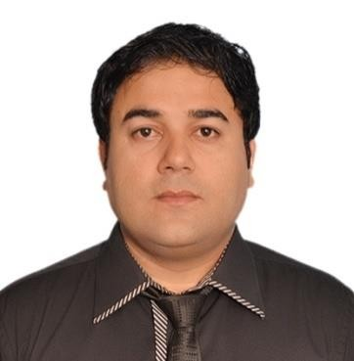
MUHAMMAD DANISH MIRZA
Marketing Professional
(Member of Marketing Association of Pakistan)

Location: Karachi, Pakistan
Mobile: +92 345-6018388
Email: daanishmirzaa@gmail.com Skype ID: Muhammaddanishmirzaa Languages: English, Urdu,

A Marketing Professional (Member Of Marketing Association Of Pakistan) having 8+ years experience and expertise in areas of Marketing, New Business Development, Brand Management, Advertising and Promotion, ATL/BTL Activation, Sales Management, Services Marketing, Demand & Supply Planning, Work Shops Management, International Marketing Strategies, Digital Marketing, A true believer of kaizen philosophy with a solid command over MS Office tools seeking a competitive position to work to add value to the organization.

Key Skills

• Strong Interpersonal Skills | • Market penetration
• New Customer Development | • Outdoor Sales
• Organizational skills | • MS Office
• Sales Management | • Direct Marketing
• Leadership Qualities | • Relationship Marketing

Experience

Marketing and Communication Manager
IQRA University Main Campus (January 2014 – Present)
Job Description:

⇨ Aggressively drive relationship based quality enhancement.
⇨ Build & manage key accounts, corporate, Government etc.
⇨ Respond to the growing number of “warm leads” that come through teams.
⇨ Management and execution of B2B communication.
⇨ Coordinate with internal teams to best address client needs.
⇨ Process requests and orders for large volume deals.
⇨ Work with marketing team to provide marketing support to key clients.
⇨ Determine strategic importance of leads, understanding right product mix to pitch to key accounts.


Brand Manager
STANLEY Pharmaceuticals (September 2012 – October 2013) Job Description:

⇨ Liaising and networking with a range of stakeholders and partner organizations.
⇨ Managing the production of marketing materials, including leaflets, posters, flyers, newsletters.
⇨ Arranging the effective distribution of marketing materials.
⇨ Organizing and attending events such as conferences, seminars, receptions and exhibitions.
⇨ Sourcing and securing marketing plan.
⇨ Conducting market research.
⇨ Developing marketing plans and strategies.
⇨ Sourcing advertising opportunities and evaluating marketing campaigns.
⇨ Monitoring competitor activity.
⇨ Supporting the marketing manager and other colleagues.

Institutional Sales Manager
Tabros Pharmaceuticals (June 2009 – August 2012) Job Description:

⇨ Achieve sales targets.
⇨ Develop territory, market penetration and sales execution strategies to consistently attain and exceed goals.
⇨ Direct sales focus to identify and uncover opportunities.
⇨ Foster an environment of open communication.
⇨ Train, motivate and coach a team of Territory managers.
⇨ Feedback on the performance of Territory managers.

Education:

Bahria University Karachi, Pakistan
Masters of Business Administration (MBA) Marketing -2012
Majors
• Services marketing
• Advertising and promotion
• Brand management
• Marketing Management
• Consumer Behavior
• PR/Event Management

Bachalor of Science (BS) from SU,Pakistan-2008
Majors
• Statistics
• Maths
• Chemistry
Honours / Achievements:

• Appreciation Certificate for conducting a workshop “How to get the best out of people”.
• Certified Marketing Professional.
• DIT(Diploma in information technology from Skill Development council)
• Presentation on “Market penetration strategy”
• Presentation on “Suggestions for the improvement in market development of products”
• Certification “How to improve selling skills”
• "Employee of the month"- TABROS PHARMA
• I was awarded with a "Merit Certificate" for "Academic Excellence" from Bahria
University.
• I was awarded with "Merit Certificate" for Co-coordinating in different activities.

• Arranged a workshop on “How Johnson and Johnson came out of marketing crisis” .

Extracurricular Activities / Hobbies:
• Book reading / Listening Music
• Attending Leadership Conferences

• Following marketing conferences and seminars

• Reading Gary Hamel (What Matters Now)

