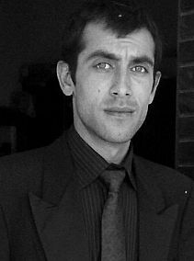
E-mail: m.fawad21@yahoo.com
Mobile: 0333-9444908
0333-9239477
Address: H: 433, ST# 7,sector#k4
Phase 3 Hayatabad Peshawar.

Muhammad Fawad

Educational Background
Area of interest
Work Experience
Command in dispensing

- Spent time in different clinics
With Doctors full command
In health.
- Spent 1 year in Sky Pharmacy
Trainer.
- Well Experience in retail Pharmacy
- 6 Months internship in North West Peshawar hospital.
- Smarks Nutroceutical 1 year experience as a medical representative
- 6 mounths experience in Lotus Pharma as a medical representative
Command on Computer Software:
- Ms. Word
- Ms. Access
- Ms. Front Page
- Ms. Excel
- Ms. PowerPoint
- In page
- Windows XP,7,8

(2013) Sarahad university of Peshawar

Pharm(D) (CGPA 2.5)
(2008) The City College of Arts and sciences Peshawar. Peshawar

HSSC

(2006) Warsak model School and College Peshawar. Peshawar

SSC
Health care/Hospital/ Pharmaceutical Industries marketing site
Hobbies

Playing Badminton,
Reading,
Music
Languages

English, Urdu, Pashto
Refrences

Arbab Afzal
Administrative officer IBMS Agriculture University Peshawar.
Mobile# 03469207206
Daud Jan
FATA Sectrate Population Department Peshawar.
Mobile# 03005666899

