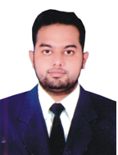

MUHAMMAD Hamza Amin
P-173, Street#4, Mehmoodabad Colony Tariqabad, Faisalabad Punjab Pakistan | 0092-3007588846| muhammadhamzaamin@gmail.com
Objetive
To obtain a responsible, challenging and career growth oriented position in the organization and want to work efficiently by utilizing the potentials of honesty, hard work, dedication and professional skills.
Computer Skills
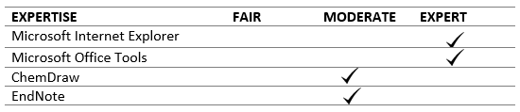
EXPERIENCE
- Working as Medical Service Executive(Derma) in GlaxoSmithKline Pakistan from last 1 years
- Has been worked as a trainee Medical Educator in Eli Lilly & Company, Faisalabad Pakistan
- Two month internship at Faisalabad Institute of Cardiology, Faisalabad Pakistan
- Two month internship at Pioneer Pharmacy , Faisalabad Pakistan

Education
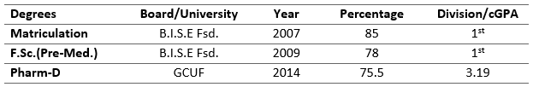

Publications
- Leading cause of addiction among teenagers of Pakistan and the role of security forces regarding their rehabilitation (Journal of Pharmacy and Alternative Medicine www.iiste.org ISSN 2222-5668 (Paper) ISSN 2222-4807 (Online) Vol.3, Nov 3, 2014)
Additional Information
Skilled public speaker and trainer. Presented in seminars and workshops on topics such as:
- DM and HTN (got 2nd position in two day Workshop on scientific Communication held on April 7-8 2014 by ORIC, Government College University Faisalabad)
- Non-Pharmacological Treatment of HTN and DM (got 1st position in poster Competition held at College of Pharmacy, Government College University Faisalabad on December 5, 2012 )
- Research Bibliography ( as a trainer in GCUF Workshop on Research Bibliography- Citation of References on March 12, 2013)
Organized and Participated in many Seminars, Workshops and Symposia on topics such as:
- “1st National Pharmacy Symposium” organized by College of Pharmacy, Government College University Faisalabad on April 21, 2011
- “Pharma Industry Contribution for Diabetes Management and Career Development” organized by College of Pharmacy, Government College University Faisalabad on September 11, 2013
- “Career Counselling” organized by College of Pharmacy, Government College University Faisalabad on June 6, 2013
- “Current Good Manufacturing Practices” organized by College of Pharmacy, Government College University Faisalabad on January 10, 2014
- “Forensic Science: A New Horizon of Pharmacy” organized by College of Pharmacy, Government College University Faisalabad on February 27, 2014
- “Legal Issues: Pharmacy Profession in Saudi Arabia” organized by College of Pharmacy, Government College University Faisalabad on March 19, 2014
- “Two Day Workshop on Scientific Communication” organized by Office of Research, Innovation & Commercialization, Government College University Faisalabad on April 7-8, 2014

PERSONNEL PROFILE
Son of Muhammad Amin
Blood Group B +Ve
ID Card. No 31302-9631608-5
Date of Birth February 16, 1991
Marital Status Single
Languages English & Urdu
Activities Book keeping, watching cricket and documentaries
Area of Interest Communication, manufacturing, innovation & research based approaches
REFERENCES
References will be furnished upon request.

