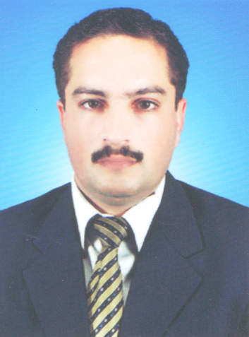
Muhammad Iqbal

C/O AZIZ GENERAL STORE BARKALAY, SAIDU SHARIF, SWAT, K.P.K.

CELL#: 03469403235 E-mail: Iqbal.swati@yahoo.com

Resume

Profile

Dynamic, dedicated and result oriented professional with more than 10 years of expertise in all facets of the Sales and Marketing. Verifiable track record for successfully managing large team with varied area, while meeting rigorous performance standards and demanding schedules. As RFM at Helix, built a structured, nurturing Field environment by utilizing self-made model framework for helping each representative realize their fullest potential. Well versed in career counseling, resolving problems, documentation, maintaining building code regulations of organization, reporting and appraisals.

Areas of Expertise

- Effective Sales Management
- Team Building and Leadership
- Building new concepts & Ideas for better promotion and goals achievement.
- Excellent Communication and Inter-personal skills
- Strong Organizational Abilities
- Highly competitive management skills and knowledge.
- New group/product launching with competitive track record.

Core Competencies

- Having Quality conscious Masters Qualifications in Business Administration from prestigious institute Al-Khair University, AJK
- Over 10 years’ experience in successfully delivering various facets of sales and marketing activities with a special focus on professionalism. Working with multinational organizations with round the clock availability.
- Technologically sound to handle computer involved IT applications.
- Excellent interpersonal relationship and communication skills to interact with all key stake holders effectively.
- A team player with a caring and mentoring attitude towards colleagues, staff and management to develop a healthy and conducive work climate.
- High level of dedication, personal loyalty and professional integrity has always been my hallmark and key to my success.

Academics

F.SC | 1999 | BOARD OF TECHNICAL EDUCATION, PESHAWAR
BA | 2004 | AIOU, ISLAMABAD
MBA | 2012 | AL-KHAIR UNIVERSITY, AJK, ISLAMABAD

Professional Education

- 2014: Diploma in Health Technology KPK Medical Faculty, Peshawar

Summary of Work Experience
BIO LABS, ISLAMABAD | AREA SALES MANAGER | 10/3/2010 TILL TO DATE
HELIX, PHARMA | REGIONAL FIELD MANAGER | 1/04/2008 TO 31/12/2009
HELIX, PHARMA | SENIOR TERRITORY MANAGER | 1/11/2007 TO 30/03/2008
HELIX, PHARMA | TERRITORY MANAGER | 16/02/2004 TO 30/10/2007

Achievements

- 2006: Best performance Award (192% vs Target) Helix Pharma
- 2007: Appreciation Certificate (211% vs Target) Helix Pharma

Training Programs / Seminars

- Dec-2014 Attended One Day Course on “Building Effective Sales Team” Bio-Labs
- Sept-2011` Attended Two Days Conference on Reporting at Rawalpindi HELIX.
- Dec-2010: One week workshop on leadership, staff management and Planning HELIX.
- June-2008 Training for improving managerial skills conducted by Helix Pharma.

Personal Details

Date of birth: 19-04-1978
Domicile: Distt: Swat
Languages known: English, Urdu, Pashto

References
- Mr. AYAZ BAIG, HEAD OF SALES AND MARKETING, BIO LABS, # 03335165236
- Mr. FAISAL NADEEM, EX-BRAND AND PRODUCT MANAGER, BIO LABS, 03219545568
- Dr. Iqbal Hussain, Junior Registrar skin Unit, Central Teaching Hospital, Saidu Sharif, Swat#03339461461
- Dr. Abdullah, (Paed;) Central Teaching Hospital, Saidu Sharif Swat#03349312157

