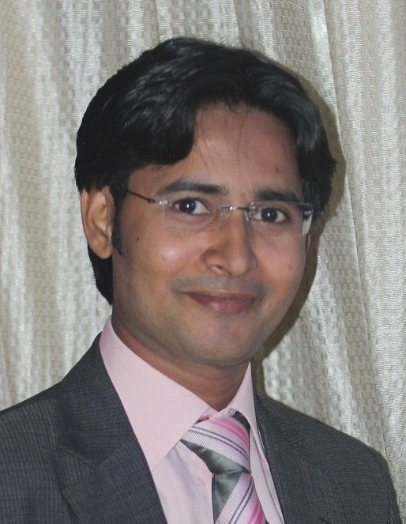

MUHAMMAD JALAL UDDIN
L-141 Sector 4/A Surjani Town, Karachi, Pakistan-75850
Cell #: (0092)0345-2482881
Phone#: (0092) 021-6911161
Email: muhammad.jalal.uddin@hotmail.com

OBJECTIVE:_______________________________

Seeking an organization in need on an aggressive, energetic person to improve performance and get an on original and innovative path to maintain the total concept of personal and professional service.

PERSONAL INFORMATION: _________________________

Father’s Name : Abdul Kareem,
Date of Birth : 07 April 1983,
Gender : Male,
Marital Status : Single,
Nationality : Pakistani,
Religion : Islam,
National N. I. C # : 42101-1678691-5,

QUALIFICATION: ____________________________________
- MBA in HRM from Federal Urdu University, Gulshan-e-Iqbal, Karachi.
- B, Sc (Hons) in Major Botany (Chemistry, Zoology, Botany) From Federal Urdu University, Gulshan-e-Iqbal, Karachi. Pakistan.
- Inter from Govt. Degree College, Shadman Town, Karachi.
- Metric from Public Model Govt. School, North Karachi, Karachi.

EXPERIENCE: _______________________________________
- 9 years work experience in STIEFEL a GSK company in Dermatology, as a Medical Services Executive.

Job Task:

- Plan and manage the entire territory.
- Developed and implemented territory call plan and routing schedule using early view data.
- Ensure the doctors/pharmacy in your territory are called upon at the agreed frequency.
- Maintain current distribution (sales or inventory) of existing products
- Ensure all administration procedures are followed.
- Develop and improve relationship with key accounts (doctors/pharmacies).
- Identify and act on opportunities to wide distribution and supplies through distributors.
- Obtain, update and record knowledge of pharmacies i.e. names, address, key personnel, trading and discount policy etc.
- Obtain Update and record knowledge of doctors i.e. name, addresses, specialty, type of practice and our product prescribed etc.
- Making online Report on daily basis.

COMPETENCIES: _________________________________
- Has competent skill in management, marketing and sales.
- Has an excellent ability in devising strategic management plan in the long run.
- Has excellent problem solving and strategizing skills.
- Skillful in controlling the business based on a strategy being employed.
- Has excellent communication skill both in written and oral.
- Has ability to work with team, and support to team members.
ACHIEVEMENT: _________________________________

- Successfully developed loyal relationship with key targeted Dermatologist, Pediatrician physician, gynecologist, general practitioners as well as CMOs and RMOs.
- Highly regarded for consistently achieving superior sales result through planning and effective implementation.
- I have attended different courses like Therapy work, Peak Performance behavior, Customer Satisfaction.
- Gain two times Regional Star award

ADDITIONAL SKILLS: _________________________________
- I use computer in daily basis and I am proficient in using program such as Microsoft Word/ Excel, E-mail, Internet.
- Interests / Hobbies: listening to music, playing cricket, Reading the informative books, tours, painting also my good hobby.

