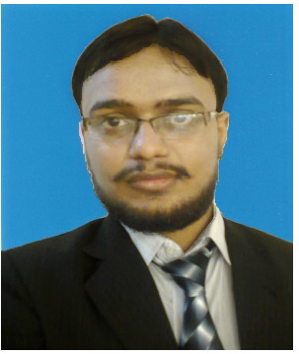
MUHAMMAD JAWAD KHALIL
B.COM (BACHELOR OF COMMERCE)
CAREER OBJECTIVE

To pursue a professional career in an organization that offers highly competitive environment demands excellence in performance and provide opportunities to attune professional growth based on the individual’s merit, performance and capabilities.

PERSONAL PROFILE
Father’s Name: Khalil Ahmad
Date of Birth: 23/10/1988
Contact #: 0313-6366712
E-mail jawadkhalil130@yahoo.com
Domicile: Multan.
Address: House # 536/51A Street # 11 Bukhari Colony Nawan Shaher, Multan.
PROFESSIONAL MARKETING EXPERIENCE:
TO WORK IN GSK PHARMACEUTICAL COMPANY AS A BMD CO-ORDINATOR:
DURTION: CURRENTLY WORKING IN GSK (GLAXO SMITH KLINE).
MY RESPONSIBILITIES:
- TO PLAN AND ORGANIZE THE CAMP IN MULTAN AND OUTSIDE OF THE MULTAN.
- TO OPERATE THE BMD MACHINE.
- TO CONDUCT THE TEST OF THE PATIENT ACCORDING TO THE DOCTOR ADVISE.
- TO GENERATE RESULT AND SUBMITTED TO THE DOCTOR.
- TO MAKING THE REPORT ON DAILY BASIS AND REPORT TO THE RELEVANT AUTHORITY.
- TO PROMOTE THE CAC 1000 PLUS & QALSON – D AND INCREASE THE SALES BY ADOPTING DIFFERENT STRATEGIES.

 | ACADEMIC QUALIFICATION
QUALIFICATION |  | %age/CGPA | YEAR | INSTITUTE
B.COM |  | 63.40% | 2011 | BAHAUDDIN ZAKARIYA UNIVERSITY, MULTAN
F.A |  | 75.90% | 2009 | B.I.S.E MULTAN
MATRIC (SCIENCE) |  | 56.50% | 2004 | FEDERAL BOARD ISLAMABAD
HIFZ-UL-QURAN |  |  | 2008 | MADRASSA ISLAMIYA ARBIYA ANWAR UL ALOOM, MULTAN

 | CAPABILITIES
- Notable written and verbal communication skills.
- Complete control on making use of basic Microsoft office tools.
- Strong communication skill
- Efficiency & dedication to work
- Clientele relationship developing ability
- Highly other technical skills.

ADDITIONAL SKILLS

- Internet Applications
- MS Office (Word, Excel, PowerPoint)
- MS Operating Systems (98,NT,Vista,7 & 8)

LANGUAGE SKILLS

- English, Urdu, Punjabi, Saraiki

INTERESTS & OTHER EXPERIENCES

- Volunteer: Organize & Manage several events (Fund Raising, Dinners, Sports week) during studies & Job
- Sports: Play Cricket & watching Cricket, Football.
- Social: Running strong social groups both Online & Offline

REFERENCES

- Reference will be furnished on demand.

