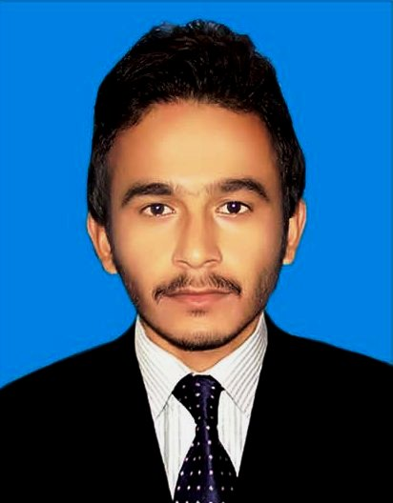

M. Mazharuddin Jokhio

CAREER OBJECTIVES

To work with any competitive organization where I can upgrade my knowledge about Industrial Engineering & Management, acquire competence in applying engineering principles to practical problems.

PERSONAL INFORMATION

Name : Muhammad Mazharuddin Jokhio
Father Name : Sabhago Khan
Date of Birth : 04-Sep-1993
Home Address : House # 265 F, Block VI PECHS Karachi
Cell Number : +92332-7342804
Email : 12in42@student.muet.edu.pk

ACADEMIC & PROFESSIONAL EDUCATION

2016 BE Industrial Engineering & Management
Mehran University of Engineering & Technology Jamshoro

2011 Intermediate (Pre-Engineering)
Board of Intermediate and Secondary Education Hyderabad

2009 Matriculation (Science)
Board of Intermediate and Secondary Education Hyderabad

FINAL YEAR PROJECT

B.Engg: Minimization of Cost and Quality issues at Lucky Knits Pvt Ltd Karachi.
- Worked on Automation
- Methods Improvement
- Scrap Reduction
- Overhead Reduction

TRAININGS

- Total Quality Management (TQM) by Industrial Student Organization (ISO)
- Disaster Preparedness and Management by Strengthening Participatory Org: (SPO)
- Primavera Project Planner (P6) by Industrial Student Organization (ISO)

AS AN INTERNEE

2014 4 weeks Internship Training
Pakistan Steel Mills Corporation (PVT) LTD
(Administration & Personnel (A&P), Industrial Engineering Department (IED), Raw Material Handling Department (RMHD), Iron Making Department (IMD),)

2015 1 week Internship Training
Dawlance Pvt Limited Pakistan
(United Refrigeration Industries Limited)
(Health, Safety & Environment, Supply Chain, Production Planning, Quality Control, Refrigerator Manufacturing, Deep Freezer Manufacturing).

OTHER COURSES

2010 75 Days Executive English Language Course
Sir Wazir’s English Language, ILETS Center Thatta
(OCPS, Personality Development, Job Search & International Relations)

2010 4 Months Web Designing Course
FAST-NU Karachi

SOCIAL ACTIVITIES

- Six months experience of working with Web For Human Development Thatta as a Program Assistant
- Office Documentation
- Event Management
- Project Management

- Experience of working with Chinese medical camp for flood effectives (Two Months)
- (Translator)

- Experience of working with Delegation of students from Berlin University Germany During their visit to Thatta.
- (Translator)

- Worked as an Advisor to Industrial Student Organization (ISO)
Member organizing committees for different social events and trainings
- Groom Yourself (Academic & Motivational event)
- Training on TQM,
- Explore Yourself (Motivational event)

- Member organizing counsel Neron Kot Model United Nations (NKMUN)
- Worked with Team Finance

- Experience of attending several training workshops.

AREAS OF INTREST

- Supply Chain Management
- Maintenance & Safety
- Production Planning & Control
- Human Recourse Management (HRM)
- Sales & Marketing Management
- Cost Reduction
- Total Quality Management
- Research and Development (R&D)
- Decision Making

INTERPERSONEL SKILLS

- Ability to design and conduct experiments, as well as to analyze and interpret data
- Ability to design a system, component, or process to meet desired needs within realistic constraints such as economic, environmental, social, political, ethical, health and safety, manufacturability, and sustainability
- Ability to identify, formulate, and solve engineering problems
- Ability to understand professional and ethical responsibility
- Ability to communicate effectively
- Ability to engage in life-long learning
- Ability to use the techniques, skills, and modern engineering tools necessary for engineering practice

COMPUTER SKILLS

- Usage of Microsoft Word, Excel, PowerPoint
- Hardware Maintenance
- Software Installations

LANGUAGES

- English, Urdu, Sindhi

