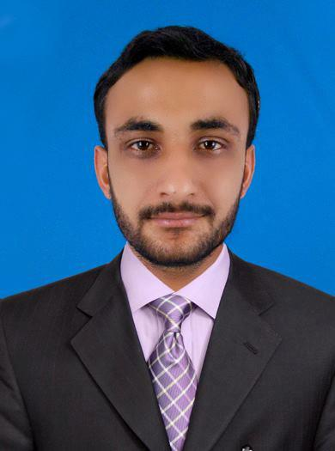
Muhammad Mukarram
BS (Hons) Microbiology
Contact No. 0300-3791828
0332-3791828

Address: House number F/7 street number 2 Al jahmuria
Colony station road gari khata Hyderabad.
E-mail: mukarramughal17@yahoo.com

CAREER Objective:
A self-motivated candidate for the post of Quality Control Microbiologist with a strong academic and practical knowledge. Able to work on own initiative and as part of a team. Proven leadership skills involving managing, developing and motivating teams to achieve their objectives.
ACADEMIC QUALIFICATION:
- BS(Hons)Microbiology ( 4 yrs Degree equivalent to MSc)
Institution: University of sindh Jamshoro, Pakistan.
Session: 2006 – 2009
Division / Grade: Second Division

- HIGHER SECONDARY SCHOOL CERTIFICATE (SCIENCE).
Institution: Board of Intermediate & Secondary Education, Hyderabad Pakistan.
Session: 2003 – 2005
Division / Grade: 1st Division

- SECONDARY SCHOOL CERTIFICATE (SCIENCE).
Institution: Board of Intermediate & Secondary Education, Hyderabad Pakistan.
Session: 2000 – 2002
Division / Grade: 2nd Division

PRACTICAL EXPERIENCE:

- MTI Medical Pvt Ltd Lahore, Pakistan
Designation: Quality control Microbiologist
& Quality Assurance Officer
Duration: January 2014 – To Till Date

- Mac & Rains Pharmaceutical Lahore, Pakistan
Designation: Quality control Microbiologist.
Duration: March 2010 – December 2013

PROFESSIONAL SKILLS:
As the microbiologist of the quality control department I can perform the following duties and responsibilities:
- Preparation of Media
- Sterility Test
- Endotoxin test by gel clot method
- Endotoxin test by chromogenic method
- Area monitoring by settle plate Particle counter and by air sampling
- Swab test
- Figure test
- Water testing
- Raw material testing
- Pyrogen test
- Validation of autoclave

- COMPUTER Skill:
- Software Installation.
- Microsoft Windows.
- Microsoft Office Automation, i.e. MS Words, MS Excel, MS Power-Point.

PERSONAL INFORMATION:
- Father’s Name: Nazir Ahmed
- Nationality: Pakistani
- Date of Birth: April, 01, 1987
- Marital Status: Married
- Nic Number: 41303-8595089-1

LANGUAGES KNOWN:
- Punjabi. (Native Language). Read, Speak
- Urdu. (National Language). Read, Write, Speak
- English. Read, Write, Speak

REFRENCE:
Dr Ghulam Murtaza (Plastic Surgery Specialist)
Al Noor Specialist Hospital, Makkah +966551384548
Mohammad Ahsan (Quality Control Manager)
Searle Pharmaceutical, Lahore Pakistan +92322-4296493
Adnan Tahir (Quality Control Manager)
Mti medical, Lahore Pakistan +92333-4207630

