MUHAMMAD NADEEM SIDDIQUI 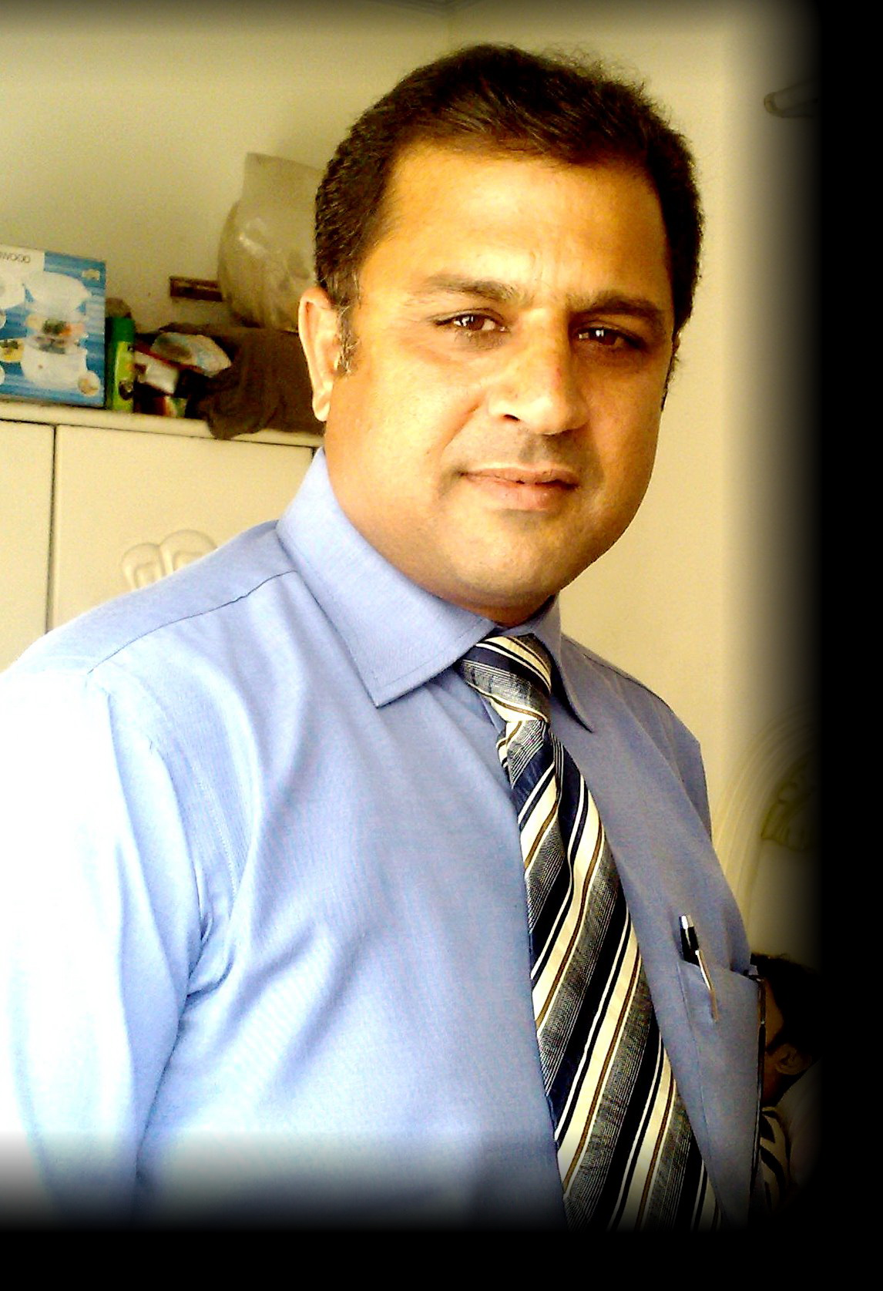

PERSONAL SUMMARY:

Father’s Name Abdul Jabbar Siddiqui
Date of Birth 12-11-1969
NIC No 61101-1906647-1
Phone No. 0307-2223259
Material Status Married
Religion Islam

ACADEMIC QUALIFICATION

- B.Com

ADDRESS

House # 99,
Block—A St # 2 PAK PWD
Islamabad

OBJECTIVE:
Seeking a position with opportunities which allows ample room for career growth in sales and marketing and let me do innovative and challenging tasks.
PROFESSIONAL EXPERIENCE:
Hilton Pharma (Pvt) Ltd. 8-years experience in sales
Sales promotion Officer
Hilton Pharma.
1994-1997.
- Worked as sales promotion officer in Hilton Pharma 3-years
Area Sales Manager
Hilton Pharma
1997-2003
- 3-years experiences as a Area Sales Manager in Rawalpindi.
- 2-years experience as a Area Sales Manger in Lahore.
Sales Manager (Central)
Getz Pharma.
2003 (Feb to Aug. 2004)
- 1 ½ years experience as a Sales Manager Central.
Sales Manger Central
Shaigan Pharma.
2004 (Sep to Dec. 2005)
- 15 months experience as a sales manager central.
Lunch Nexcen Pharma (Pvt) Ltd
Jan 06 to Jun 08
- 2 ½ -years experience as a NSM.

Genix Pharma as SM
- July 2008 -2009
- Ferozosns Labs
- Aug 2009- till to date
Key Achievements (As Area Sales Manager)
- Best area sales manager of Pakistan in 2000 as ASM Rawalpindi.
- Top Seller of Hilton’s biggest product Methycobal in Pakistan as ASM Lahore. Achieved highest growth 24% in Business Unit—Aggressive in 2002.
- Won Eisai Japan’s award of methycobal on highest sales as ASM in Dubai
- Highest productive area in Business Unit – Aggressive in Hilton by achieving a yield of Rs. 5,50,500/- TM
- Managing a team of 10 TM in Lahore.
- Successfully Launched gevolox (Glucosamine) in Lahore as ASM and become second highest seller in Pakistan by achieving 200 Packs/Month
- 5 TMs were developed as a ASM under my leadership as ASM
- Successfully arranged 3 Orthocon of 1997, 2000, 20001.
- I team achieved best SPO Award in 2002 by achieving Rs. 8,00,000/-

Key Achievements (As SM)
- Highest seller of CELBEXX, LEFLOX, in Pakistan Getzs.
- Successfully Launched LEFLOX I.V. in central region and become Second highest seller in Pakistan by achieving 2200 I.V/Months.
- Launch SHAIGAN PHARMA in Lahore.
- Managing team of 60 SPO’s 7 ASM’s 1ZSM.
- Launch Genix Pharma Ortho Group in Central and North Region Successfully
- Successfully managed South Region sales and developed teams in Ferozsons
- Managing 3 groups and team of 50 Hcrs and 8 Asm’s in Ferozsons
- In 2014 Declared Best Zsm in Ferozsons amongst all Zone

Core Responsibilities.
- Handled Distributors of Central, South and North Region as Sales Manger.
- Managed a large field force of TM’s ASM’s
- Monitored every Area Manager through brick analysis.
- Monitored and managed the Sales of Central ,South and North Region.
- Monitored the stocks inventories and in time deliveries and supplies at distributor’s level.
- Coaching and developing Territory Manager and Area Mangers.
- Practicing, productivity through Motivation and accountability.
Area Knowledge
Central Region. Managed the major portion of central region i.e.
Lahore, Faisalabad, Multan.
North Region Effectively managed the Rawalpindi and Peshawar region.
South Region Managed the major portion of south region i,e Khi-Hyd-Suk-Lark-
Skills & Strengths
- Extensive Traveling
- Accept Challenges
- Team Leadership
- Solution oriented Approach
- Good PR with key customers
- Human Resource development
- Conduct activities i.e. Melas, RTDs, Symposia,
- Ward presentation.
Customer Knowledge / Relationship
Orthopedics -Excellent Relation in Orthopedices i.e.
-Prof Kazi Saeed, Dr. Sohail Iqbal Sh. Dr. Zubair Javed
-Prof Irfan Mehboob. Dr. Prof. Naseer
Physicians -Dr. Fazal Rehman, Dr. Hashim Uddin, Dr. Najam-un-Nasir,
Gynecologist -Good relations with Dr Shamsa Tariq, Fehmida Shaheen
-Nabila Shami, Razia Ashraf. Dr Rizwana ch, Fareesa Waqar
Ghazala Mehmood
Cardiologist Dr Asad Raiz, Dr Naeem Malik, Dr Nasir Moin, Dr Adnan Gul
Dr Amber Ashraf , Dr Hafeez Ullah, Dr Mushtaq
Training Courses
-Communication Skills Course by Mr. Farooq Sheikh
-SSC Course by AR Puri.
-Basic in Field Management by C.B.S by AR Puri.

