Muhammad Naseer 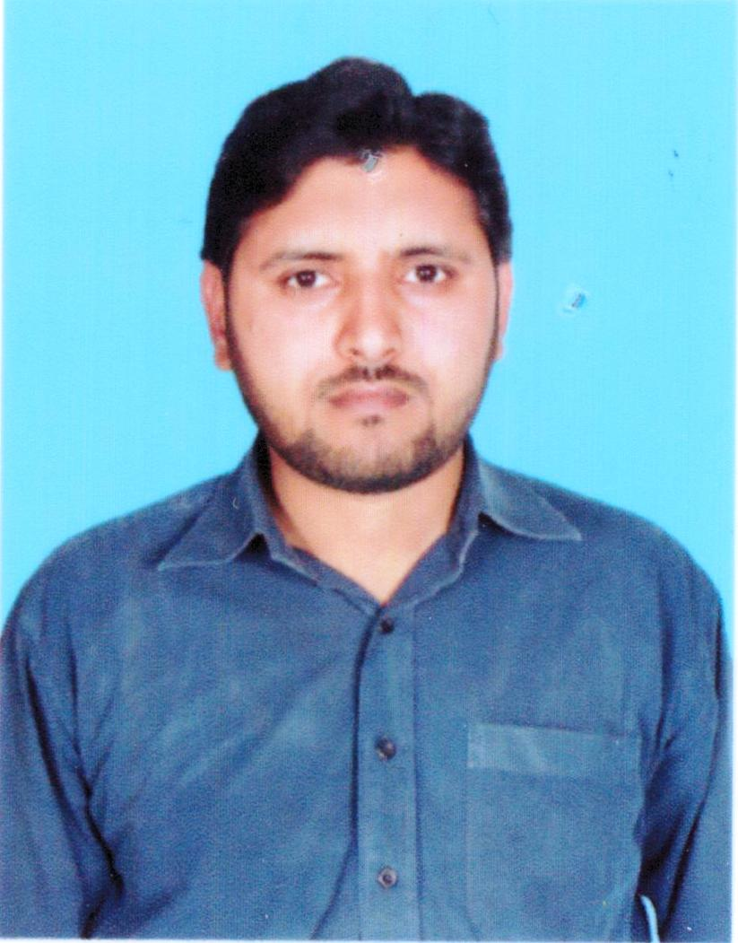
Cell No: +92-3215009471 +92-3035585896 E. mail: janjua009@hotmail.com

Summary
I am a highly productive professional with Project Management skills and good communication skills. I can work under pressure and have ability to meet deadlines. I have strong ability to understand and adopt organization’s culture. I have equal ability to work in groups as well as individually
Education
MS(mgt) 2015 Iqra University, Islamabad Campus
MBA-HRM 2011 Virtual University, Rawalpindi Campus
B.A 2003 Allama Iqbal Open University
F.A 2001 B.I.S.E. Rwp
SSC 1997 B.I.S.E. Rwp
Work Experience
- Hospital Services (2014 to date)
Designation Regional Sales Manager (Institutions)

Responsibilities:
- Supply of Medicines & Surgical Products to Military Hospitals (Nationwide)
- Purchase of quality products from well reputed pharmaceuticals
- Contract with leading hospitals for maximum sales generation
- Strategy Formulation
- Planning , Training & Development of Sales Team

- Bosch Pharmaceuticals (Pvt) Ltd. (2007-2014)
Designation: Area Sales Manager

Responsibilities:
- Setting targets for individual Reps and teams as a whole
- Training and Development
- Establishing, maintaining, and expanding customer base
- Developing sales strategies and setting targets
- Keeping up-to-date with products and competitors
- Acting as a liaison between sub-ordinates and senior management etc

- Glitz Pharmaceuticals (Pvt) Ltd. (Jan2012-March 2012)
Designation: Area Sales Manager

- Neomedix Pharmaceuticals (Pvt) Ltd. (Jan 2007-June 2007)
Designation: SPO

- LCPW (Howards) Pharmaceuticals (Pvt) Ltd. (Sep 2006- Dec 2006)
Designation: SPO

- Pakistan Army, Pakistan (1998-2006)
Designation: Medical Technician

Responsibilities:
- Medical & Surgical Emergencies
- Procurement
- Community Medicine
- Public Health
- Hygiene & Sanitation

Internship/Training
- PASDEC Islamabad, Pakistan
Designation: Internee (HR Assistant)

Research/Projects
- MS-Thesis (Mgmt Sciences)
  - Title: “What Pharmaceutical Employees Think about Themselves?”
Papers Published in International Journals
Naseer, M. (2014), “What Pharmaceutical Employees think about themselves?” Paper Accepted for Publication in European Journal of Social Sciences, 2014.
Computer Skills
- MS Office (Word, Excel and Power Point)
- SPSS, AMOS,
- Internet Surfing
Management Skills
- Efficient spoken and written English skills
- Leadership skills
- Compliance with Ethics Standards
- Interpersonal skills
- Informational and Decision-making skill
- Training & Development (Sales Team)
- Training & Development (Public Health/Community Medicines)

Personal Information
Father’s Name : Muhammad Wazir
Date of Birth : 20-07-1979
NIC # : 37302-1140712-9
Marital Status : Married
Nationality : Pakistani
Domicile : Jhelum (Punjab)

