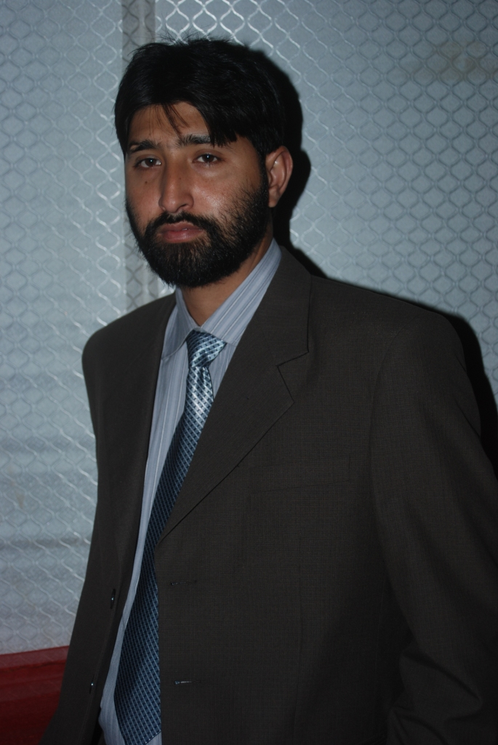
Muhammad Naveed Shahzad

House # 351-D Punjab co-operative housing society
Defense road Lahore Cantt
cell# 0342-4087152;
e-mail : Naveedshahzadfarma@Gmail.com

Career Objective
Seeking a career with a progressive organization where I can utilize my skills,
Knowledge in marketing with the challenging role that allows for advancement
and growth

Education

2011 Virtual University Lahore

MBA (marketing)

2007 Islamia University Bahawalpur Bahawalpur
B. pharmacy

2002 Lahore board Lahore
F.S.c (premedical)

2000 Lahore board Lahore
Matriculation

Experience

may 2007 High Noon Laboratories Ltd. Lahore
Sales and marketing (Sales Executive)
- Aggressively working in the musculoskeletal and ENT division as Sales Executive
Sep 2011 Schazoo SPL. Lahore
Sales and marketing (Product Manager)
- Responsible for providing the sales team with the necessary technical expertise to enable them to sell the product, by involves printed and electronic promotional material, product training, and relevant clinical papers.
- Responsible for reviewing product data to ensure that the field force is kept up to date on new developments regarding the companies or competitor’s products.
- Act as point of first reference for all product related enquiries and work collaboratively with colleagues in Clinical Research.
- Close liaison with the field force to assess the response to and suitability of current promotional material and to ensure that the printed promotional material is being used optimally.
- Design market research projects to assess customer attitudes to the current product range and new product introductions.
- The development of the annual marketing plan and for controlling advertising, promotion and sales aids in accordance with the annual marketing plan.
- Responsible for preparing product forecasts, and constantly monitoring inventory levels held at central finished goods store and distributors including liaison with production to ensure supply timelines.
- Liaise with the advertising agency regarding the product campaign including journal advertising, direct mail and conferences.
- Implementation of field force operation management system

March 2013 High Noon Laboratories Ltd. Lahore
(Product Manager)
- Looking after musculoskeletal, allergy & cardiovascular portfolio
- Responsible for the life cycle of main products ( kestine, Hiloric, (currently)
- Going to launch Fenaso ( Solifenacin Succinate) in Urology segment

Achievements
- Kestine become 2nd leading brand from 7th position within two years on MAT basis
- Within 6 month promoted as Product Manager
- Win best Marketing plan 2016
- Win best campaign award in 2014 & 2016
- Win creativity award in 2015

Projects
- First time in Pakistan launch Mascot Puppet Show
- First Time in Pakistan launch Broad coverage android game campaign
- Post Marketing Surveillance on Hiloric
- Model Development for Cidine
- Best campaigns are…
  - Ebass Man Development contest
  - Phool tu achay hotay hain
  - Ebass Man Parents greeting cards development contest
  - The Power of K
  - Offload the Extra Burden
.
Symposia and seminars
- Always actively participated in conducting and arranging
- Working with Prof Amir Aziz on The Clinical Trial Of Airtal
- Conduct the temporal bone work shop with Prof MUJEEB in services twice in a year
- Conduct a symposium on Head & Neck Cancer Surgery and Mastoid Surgery for Chronic Discharging Ears
- A health program on FM103 on Allergic Rhinitis
- PSORL monthly meetings
- Patient awareness programs
- Scientific product presentations
- Local speaker programs
- Foreign speaker programs
- Launches Post Marketing Surveillance
Personal skills
- Strong interpersonal and communication skills in English both verbally and written
- High level of enthusiasm
- Ability to work independently and as part of team even under stress
- Ample knowledge of IMS
- Ability to initiate solving the problems

Distinctions
- National level debater
- Member of chess sport society

Reference
- Will be provided on demand

