Professional Objectives:

TO work with esteemed organization where I can combine my skills and talent in a better way and get a challenging career in return.

Curriculum Vitae
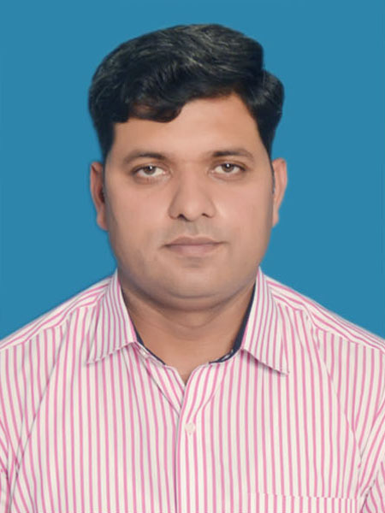

Personals:

- Name : Muhammad Nawaz
- Gender : Male
- Date of Birth : 14-08-1979
- Marital Status : Married
- Address : H.No: 372 B/8 Shaheen Road,sahiwal
- N.I.C # : 36502-1367478-3
- Phone No. : 0321-6913115
- E-mail : nawazswl@hotmail.com

Qualification:

- Matric : With science subjects from Govt Urban Area
High School, Sahiwal in 1995.

- D.Com. : From Punjab Board of Technical
Education,Lahore in 1997.

- B.Com : From Punjab University, Lahore
In 2000.

- Computer Course : M.S. Office 2000

: Computer Graphics

Experience:

- 10 Years and 2 Months Work in Saffron Pharmaceutical Company (pvt) ltd as a Territory Manager, Assistant Field Manager and Field Manager.
- From 01-01-2003 T0 31-02-2013.

- 3 Years and 2 Months Work in Bioceutics Pharmaceutical as a Regional Sales Manager from 01-03-2013 to 08-05-2016.
- Join Shaigan Pharmaceutical Company (pvt) Ltd on 14-05-2016 as a Area Sales Manager till continue.
Achievements.

SAFFRON PHARMACEUTICALS.

- In 2003 Top Achiever T.M in pioneer group and in all groups national wise.
- In 2003 win the car from company as a first T.M of Saffron.
- In 2004 again Top Achiever Territory Manager National wise, best T.M Of the Saffron and declared the HERO of saffron.
- In 2005 Top Achiever in all groups National wise.
- In 2006 Top Achiever in Saffron Pharma in all groups as a stm.
- In 2007 again Top Achiever in Pioneer group and in all group national wise, and declared the best working AFM of saffron national level.
- In 2008 top achiever in pioneer group and second position on national level in all groups.
- In 2009 company promoted me as a FIELD MANAGER in general group in okara and sahiwal.
- In 2009 declared the best FM.
- In 2010 company give me the new area Toba Tek Singh and Jhang as a challenging area Al Hamd u Lillah we make these are best sales area of saffron.
- In 2011 receive the best FM award.
- In 2012 company give the disturbed group (creative) as a challenge, AL HAMD U LLILAH set the group in my area sahiwal, okara, burewala and vehari as a best sales group of saffron.

BIOCEUTICS PHARMACUTICALS

- In 2013 join and launched Bioceutics Pharmaceutical company as a Regional Sales Manager, established and produce the best sales in SAHIWAL, OKARA, VEHARI AND BUREWALA.
- In 2014 produced highest annual sales best per person productivity and declared the best RSM of Bioceutics .
AL HAMD U LILLAH I achive the above mentioned success with team work and very low team turn over.

Practical work:
.
I arranged different seminars in many different areas of Sahiwal, Okara, Vehari, Burewala, Jhang, and Toba Tek Singh.

Skills:

Computer skills:

Excellent computer skills.

Quick in learning new programmes and soft wares.

Having good command on Micro Soft office.

Communication skills

Good written and oral communication in Urdu, English, Punjabi.

Other Skills:

Good in team management and Group work.
Having great command of taking case histories.
Good in community development programmes.
Very professional in collect data’s.
Command on stress management, good decision making, having leaderships qualities.

INTERESTS:
Listening music
Current Affairs
Public relations
Communications

