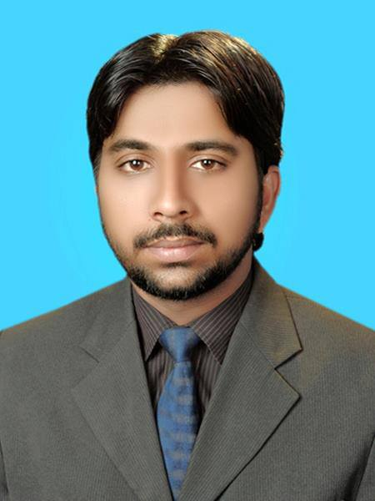

OBJECTIVE

Seeking a challenging career with a dynamic organization that would help me to cultivate and nurture my skills to the fullest with an opportunity to display my talent and become an asset to the organization.

QUALIFICATION

- Pharm-D (Doctor of Pharmacy) Hamdard University (2005 – 2010)

- Intermediate (Pre-Medical) Govt. S.E College ,Bahawalpur(2004)

- Matriculation (Science) BISE MULTAN(2002)

PROFESSIONAL EXPERIENCE

- Fresenius Medical Care Pakistan (Pvt) Ltd as (Assistant Manager) 05-10-2015 to Present

- CCL Pharmaceuticals (Pvt) Ltd as (Sr.Regulatory Affairs Officer) 21-05-2014 to30-09-2015

- Muller & Phipps Pakistan (Pvt) Ltd (Regulatory Affairs Officer) 23-11-2011 to 20-05-2014

- Multinational Business Link (Regulatory Affairs Officer) 01-06-2011 to 17-09-2011

PROFESSIONAL STRENGTH

- Proficient to prepare and submit domestic/export dossiers of selected international markets handle queries and follow up till registration with DRAP.
- Proficient to prepare and submit dossiers for Alternative Medicines and Health products according to Alternative Medicines and Health Products (Enlistment) Rules, 2014 in DRAP.
- Proficient to prepare and submit dossiers for Food supplements registration according to guidelines of Cambodia, Kazakhstan, Kyrgyzstan & Uzbekistan.
- Proficient to prepare and submit Medical Devices Dossiers.
- Proficient to prepare regulatory documents for DRAP and Provincial health department.
- Proficient in conducting training of staff.
- Proficient in conducting internal audit.
- Well accustomed to The Drugs Act 1976, DRAP Act 2012, Punjab Drug Rules 2007, Alternative medicines and Health Product Enlistment Rules 2014 and regulatory requirements.

SEMINAR ATTENDED

- 14th International Pharmacist Conference & Exhibition (IPCE – 2007)

- 2nd National Pharmacy Conference & Exhibition (NPCE-2013)

- Training Course on Common Technical Document (CTD) (2015)

ACKNOWLEDGMENTS & CERTIFICATES

- Letter of Appreciation 11th Convocation 2007 at Hamdard University

- Letter of Appreciation FOP - Annual Dinner 2008 at Hamdard University

- Letter of Appreciation 12th Convocation 2008 at Hamdard University

- Letter of Appreciation 13th Convocation 2009 at Hamdard University

- Acknowledgement Letter 2nd October 2014 at CCL Pharmaceuticals

- Corporate Values Training Certificate 2014 at CCL Pharmaceuticals

- Certificate of Code of Ethics 18th December 2015 at Fresenius Medical Care

PROJECT
Final Year Pharm-D (Clinical Project)
Project Title:
“INCIDENCE OF DERMATOLOGICAL DISEASES AND COMPARATIVE STUDY OF PRESCRIBED DRUG WITH THE RECOMMENDED DRUG GUIDELINES AT JPMC” (2009). At Jinnah Post-Graduate Medical Centre (JPMC), Karachi

INTERNSHIP ____________

- Clinical Attachment at Jinnah Postgraduate Medical Centre Karachi (2007)
- Clinical Pharmacy Training Course for One Year at Jinnah Post Graduate Medical Center Karachi.
SKILLS ____________
- Analytical & Critical Thinking
- Project Management Skills
- Communication Skills
- Regulatory Intelligence
- MS Office
- Net Surfing

LANGUAGE PROFICIENCY
- English - Good in Reading, Writing and Fair in Speaking.
- Urdu - Excellent in Reading, Writing and in Speaking.

PERSONAL INFORMATION
Father Name Muhammad Munshi Khan
Citizenship No 36203-0941868-7
Registration No 6263-A/10
Date of Birth 10th Sept 1986
Marital Status Married
Nationality Pakistan
Mailing Address Muhammad Sohail House No.112 Block: E Street No.03 Makah Colony Gulberg III Lahore Punjab Pakistan.
Email Address hamdard_pharmacist@yahoo.com
Contact # (Mob) 0321-2996004, (Mob) 0322-3595696

