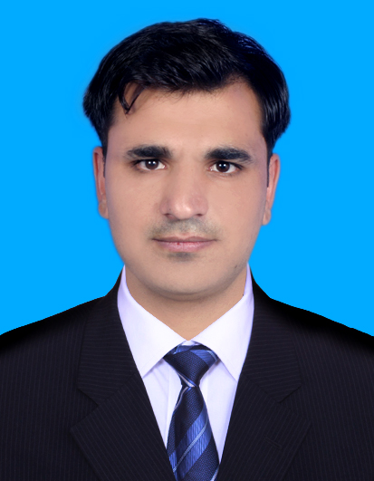
Title
Mr. Muhammad Tahir
Postal Address | Department of Pharmacy, University of Peshawar, Peshawar, Pakistan.
Cell | +92-346-0061421
DoB | 30-04-1995
Nationality | Pakistani
CNIC | 22501-9271608-9
Domicile | FR Peshawar (FATA)
E-mail | tahirafridi863@gmail.com

PERSONAL INFORMATION

EDUCATIONAL PROFILE

S.NO | Certificate/Degree | University | Year | Marks Obtained |  | Div
1. | Pharm-D (1st Proff.) | University of Peshawar | 2013 | 637/950 |  | 1st
2. | Pharm-D (2nd Proff.) | University of Peshawar | 2014 | 666/900 |  | 1st
3. | Pharm-D (3rd Proff.) | University of Peshawar | 2015 | 602/900 |  | 1st
4. | Pharm-D (4th Proff.) | University of Peshawar | 2016 | 636/900 |  | 1st
5. | Pharm-D (5th Proff.) | University of Peshawar | 2017 | 665/900 |  | 1st

6. HSSC | BISE Peshawar | 2011 | 845/1100 | 1st
7. Matric | BISE Peshawar | 2009 | 844/1050 | 1st

Pharm-D THESIS
Anemia Disease
Total 20 cases of anemia were collected. The following data were collected: patient’s demographic information, complete disease and medication history, labs data, therapy provided at the hospital, and monitoring notes. Important parameters of data were analyzed such as medication history, indications and dosage of treatment provided in the hospital, adverse drug reactions, drug-interactions and treatment outcomes.

WORK EXPERIENCE
- Novo Diabetes Educator
- Currently working as Diabetes Educator with Novo Nordisk under Novocare Project.
- Participation in ward rounds and covering OPDs in public sector hospital in Peshawar.
- Management and follow up of diabetes patient admitted in hospital.
- Working as educator in clinic with Endocrinologist.
- Patient counselling.
- Motivating and guiding diabetes patients for self-monitoring blood glucose levels and their management.
- Two Months Internship at Northwest General hospital and Research Centre Peshawar
- Forty Five Days industrial Internship at Stanley pharmaceuticals Peshawar
- Greenstar National TB control program
• Field force pharmacist for collecting data from TB suspected patients and following them till recovery.
• Training and motivating pharmacy owners to refer TB suspected patients
- Worked as a trainee Pharmacist in “Rehman Medical Institute (RMI)” for Two months.
Responsibilities:
  - Inpatient Pharmacy Services
  - Outpatient Pharmacy Services
  - Compounding Services
  - OT Pharmacy Services
  - Drug and Poison Information
  - Wards
- Internship at Lady Reading Hospital (LRH) Peshawar for Two Months
• Participation in rounds
• Collection of case histories, their documentation and analysis
- Organizer for Welcome and Farewell Party 2016 at Department of Pharmacy, UOP
- Organizer for Sports week 2017 at Department of Pharmacy, UOP
- Awareness Panel Organizer for an Event Jehaad For Zero Thalassemia (JZT) 2016 at Islamia College University, Peshawar
- Participation in ‘Seminar on Career Cuonselling’ 2017 at Department of Pharmacy, UOP
- Participation in ‘Diabetes Education Programme’ 2017 at Department of pharmacy, UOP
- Participation in ‘Navigating the Future of Community Pharmacy in Pakistan’ 2015 at UOP

DETAILS OF STUDIED COURSES IN Pharm.D
Pharmaceutics, organic Chemistry, Biochemistry, Physiology, Anatomy, Maths and Statistics, Pharmacology, Pharmacognosy, Microbiology, Instrumentation, Dispensing and Community Pharmacy, Pathology, Biopharmaceutics, Industrial Pharmacy, Hospital Pharmacy, Clinical Pharmacy, Quality Control, Medicinal Chemistry, Forensic Pharmacy, Pharmaceutical Technology, pharmaceutical Management and Marketing, Computer and its Applications in Pharmacy
COMPUTER SKILLS
- MS Word
- Excel
- PowerPoint
- Endnote
- HTML (Basic)

REFERENCES

Dr. Syed Muhammad Ashhad Halimi  Assistant Professor  Department of Pharmacy,  University of Peshawar.  E mail: ashhadhalimi@uop.edu.pk  Cell: +92-333-9120750  Office: +92-091-9216750 | Dr. Muhammad Ismail Tajik  Associate Professor  Department of Pharmacy,  University of Peshawar.  E mail: ismailrph@uop.edu.pk  Cell: +92-333-9258518  Office: +92-091-9216750

