 | MR. MUHAMMAD TAUSEEF SIDDIQUI
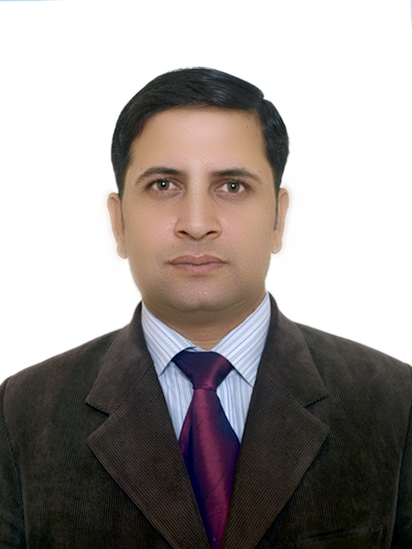 | Permanent Address: Mohallah Akhuun-din-baba , Akroa Khattak, District Nowshera (KPK), Pakistan  Current Address:  House # ZB 668 A (Ist floor) , street #1, Awan colony , Pir wadhai, Rawalpindi.  Mobile #: 0321-9816996  Email Address: tauseefstarplus@yahoo.com

OBJECTIVE

To work in highly motivated environment where one can enhance one’s skills.

PERSONAL DETAILS

Father’s Name: Muhammad Saleem Siddiqui

Date of Birth: 07-04-1980
Nationality: Pakistani
N.I.C: 17201-2081871-7

Marital Status: Married
Religion: Islam

EDUCATION

1999-B. Sc (Premedical) 1st Division- University of Peshawar.

1997-HSSC (Pre-Medical)- 2nd Division- FBISE, Islamabad.

1995-SSC (Science) 1st Division- BISE, Peshawar.

PROFESSIONAL EXPERIENCE

Oct 8th 2013 Till now – Remington Pharmaceuticals ( Pakistan )
ZONAL SALES MANAGER
Current Rawalpindi zone , Ex Peshawar , Mardan, Faisalabad

Feb 2011-Till 8th Oct 2013 – REMINGTON Pharmaceuticals (Pakistan).
DISTRICT MANAGER
Region: Rawalpindi region( Rawalpindi, Islamabad, Hazara Region, Kashmir Region, Jhelum Region, Attock Region, Chakwal Region, Gilgit skardu Region.

January 2010-Till 28^{th Feb 2011} - HEPATOLOGY COORDINATOR- CCL Pharmaceuticals (Pakistan).

Regions:
Rawalpindi city , Abbottabad, Chakwal , Gujar khan, Fateh jang , Kahuta , Talagang, Haripur , Mansehra

April 2008-Till Dec ²⁰⁰⁹ –GULF Pharmaceuticals JULPHAR (UAE).
Regions:
Rawalpindi cantt , Abbottabad, Chakwal , Gujar khan, Fateh jang , Kahuta , Talagang, Haripur , Mansehra

8 March.2004- Ist April 2008- SENIOR BUSINESS DEVELOPMENT OFFICER Servier Research & Pharmaceuticals, Pakistan
Regions: Rawalpindi city, Islamabad, Hazara, Muzaffarabad, FatehJhang,
Chakwal, Kahuta

PRODUCTS PROMOTED

- Antidiabetic (Diamicron MR) (Training achieved at Servier Pakistan)
- Antihypertensives (Coversyl) (Training achieved at Servier Pakistan)
- Proton pump inhibitors (Training achieved at JULPHAR UAE/CCL Pakistan)
- Erythropoetin (Training achieved at julphar UAE)
- INSULIN
- (Training achieved at Julphar UAE)
- Antiasthenic (Training achieved at Servier Pakistan)
Cyclosporin (Training achieved at JULPHAR UAE)
- INTERFERON. (Training achieved at CCL Pakistan)
- ENTECAVIR (Training achieved at CCL Pakistan)
- Ebastine
- URSODEOXYCHOLIC ACID (Only training achieved at CCL PAKISTANS)
- Thiazide type Diuretics
(Trainig achieved at Servier Pakistan)
Ear Drops and Nasal spray.( Remington )
Moxifloxacin. (Remington )
Meloxicam ( julphar)
Leflunomide (julphar)
Betahistine ( Remington Pakistan ) Levofloxacin and
Ciprofloxacin ( Remington pharma)
TEAM RESPONSIBILITIES

Total Team 19 People
Three Regions :
Rawalpindi, Peshawar , Mardan, Faisalabad
3 MANAGERs
16 Territory Managers

TRAINING

. INTEGRATED SALES MANAGEMENT
Selection and Retention of Field Force ( Remington)
Essential trait and skills, Leadership mistakes.(Remington)
- Management of Field Force( Training achieved CCL Pakistan)
(Recruitment and Selection, Traing to FF, Leadership and Supervision, Motivation, Evaluation and Control , Ethics in sales and sales management)
- Objection Handling.
- PDP (Prescription development process).
- FAB (Features Advantages Benefits).
- Pre-post Call Planning (Targeting specific doctors).
- Customer classification at Julphar UAE.

DISTINCTIONS

Assisted Training Department for Afghan Team Training.
Best Zonal Sales Manager 2014- 15.
Best Zonal Sales Manager 2013-14 F1 Remington.
Best District Manager Award with growth of 38% 2013 vs 2012
And 55% growth in 2012 vs 2011.
Highest ever sales for Remington pharma at Rawalpindi Region.
Best Hepatology team award of CCL Pakistan.
- Promoted as Senior Business Development Officer after 2 year and ten months service.
- Best performance award for year 2007 by 107% with GOL 21%.Acheieved 2004by 102%, 2005 by 101%, 2006 by 96%.
- Top Quiz Competition at Annual sales conferences from 2004 to 2007 at Servier got more than 92% marks.
- Best Sales Performance for the product Arcalion in 2004 in Servier.
DEPARTMENTS COVERED

- Medical Department,
- Gastroenterology Department
- Cardiology Department
- Nephrology Department , Neurology Department,
- Urology
- Dermatology
- Rheumatology
- Eye and ENT Department , Gyane Department, Paedes.
- Surgical Department.
- Orthopedic.
- GPs

PERSONAL DISTINCTIONS

. Achieved Presidential Gold medal (Pride of Performance)for the Best Boy scout of Pakistan and represented Pakistan in world level jamboree at Holland and Belgium.
. Achieved Life skills training under UNO for youth .

LAUNCHES

Coversyl 8mg ( Perindopril ) Servier Research and Pharmaceuticals
Triptor ( Ursodeoxycholic acid) CCL Pakistan
Epotin (Erythropoeitin) Julphar UAE
Lignocip Ear drops Remington Pakistan
Tobec – D Ear drops Remington Pakistan
Ocumox Remington Pakistan
Flutex Nasal spray Remington Pakista

