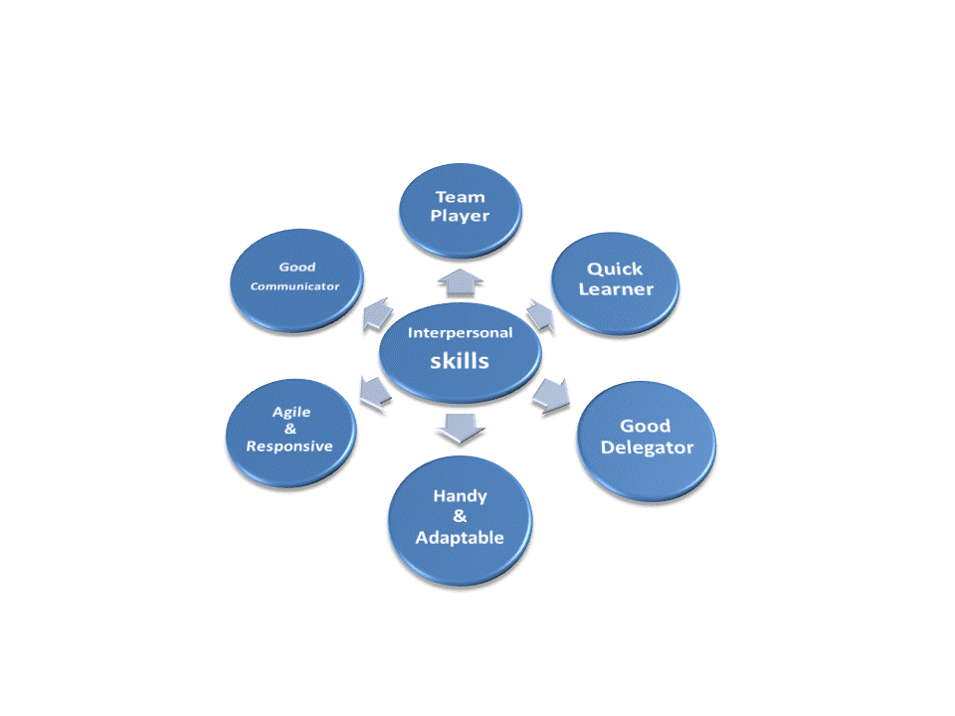


Email: aslam.nom@hotmail.com
Ph.: 0346-2814392 / 02136972581
Address: Flat # A-9, Nazish Apartments, Sector 7D/4, North Karachi

Professional Summary
- An intellectual (M.Sc.) Professional with a deep knowledge of Quality Management System, Quality assurance process, Production Operations and procedures, Good Manufacturing practices and Quality improvement tools.

- Holding a sensational track record of 3+ years, having a solid theoretical and practical background of Quality knowledge with working experience of Production Operations.

- A Certified Quality Professional from PIQC in collaboration with NED University and Six-Sigma certified; Composed a number of projects in cost saving, human error reduction, cut overhead cost , improve work place safety in term of 5S and lean production processes.

- Voracious problem-solver, confident, articulate and goal-driven to succeed in a fast paced environment with keen ability to rapidly assess diverse situation challenges. Equipped with the dexterity of time management, able to handle tricky situations and managing/prioritizing things on timely basis.

- Resourceful and proactive professional looking for solutions to technical challenges and troubleshooting, has practical responses that are readily applicable to produce the desired results and enhance quality.

- A talent full of abilities and determination to serve with enthusiasm and dedication who will be utilizing every possible channel towards the development and betterment of company.

Areas Of Expertise
- Quality Management System.
- Production and Planning/Prioritizing.
- Problem Solving.
- Six Sigma and its tools.
- KAIZEN and 5S.
- ISO 9001.
- Quality Assessment.
- Quality Control.
- Error Reducing Approach.
- Training and Development.
- Presenting ability.
- Soft skills/ Computer Literate.
- Excellent Communication skills in English/ Urdu.

Professional Experience:
- Pfizer Pakistan Limited
  - As a Production Officer (May 2012 till date).
Responsibilities
- Responsible to handle the section through direct supervision and to carry out the job in the light of PQS & Guidelines.
- Plan and carryout production activities in correspondence with the material management department.
- Production Scheduling.
- Maintaining relative and applicable inventories.
- Daily production reporting / documents reconciliation.
- DLH and Productive hours report/DLH variance reporting.
- Record keeping (cleaning, sanitization, and housekeeping, maintenance and training records).
- Document release with M.A.P.S system.
- Complaint handling/investigation procedures.
- Raising appropriate corrective and preventive actions in response to complaints.
- Managing and updating applicable SOP’s.

- Air monitoring/general housekeeping monitoring.
- Preventive maintenance of machines.
- Training of staff and machine operators on job specific SOP’s.
- Training of staff on MSDS.
- Ensure timely delivery of bulk. Finished products according to the Production schedule.
Achievements:
- Reduced daily Documentation. Enhanced tracking and visibility.
- Reduced chances of Human Error in documentation by eliminating repetition.
- Provided a Lean in documentation and eliminated Omission Error.
- For EHS (safety) and HYGIENE awareness of the shop-floor staff, prepared visual guidelines for safe and smooth operations.
- Prepared visual job aids and guidelines for operators and shop floor workers for better understanding of procedure and minimizing defects and lead time.
- Reduced cost and saved DLH by working on the Liquid transfer line. Provided a permanent and safe procedure of syrup transfer to the packaging lines.
- Maintained a safer and cleaner workplace by implementing 5S in the material storage area.

Professional Certifications:
- Certified Quality Professional.
(NED University of Engineering and Technology)
Major Topics Covered:
- Quality Management Tools.
- Management Elements and Methods.
- Leadership.
- Training and Development.
- Supply Chain Management.
- Special Topics (Six Sigma, Total Productivity Maintenance, Communication/Presentation Skills).
- Six Sigma Certification:
- Strategic Time Management.

Trainings:
- Six Sigma Yellow Belt.
- Strategic Time Management.
- Fire Fighting Training.
- GMP Training (Pfizer Pakistan ltd).
- EHS Training (Pfizer Pakistan ltd).
- Process Capability Training (Pfizer Pakistan ltd).
- PHP (Pfizer Human Performance) Training from Pfizer Pakistan Ltd.

Academics:
MBA
M.Sc. Chemistry
University Of Karachi
B.Sc. Chemistry
University Of Karachi

Intermediate
GOVT.DEHLI COLLEGE Karachi
Matriculation
LITTLE FOLK’S SCHOOL Karachi

