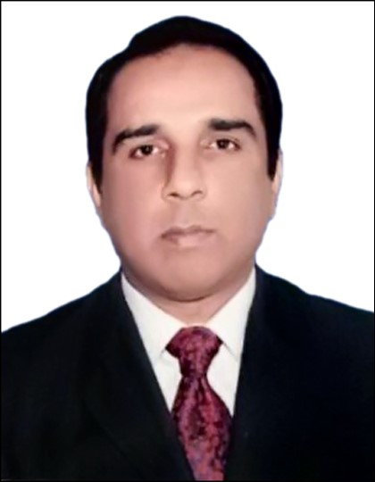
Muhammad Umair Mughal
A-364, Sector 11A,
North Karachi,
Karachi.
Cell +923320340646
mumairmughal@yahoo.com

CAREER OBJECTIVE
A vital position in a reputed and result oriented organization where acquired skills and education will be utilized towards continuous growth and advancement.

EXPERIENCE
Sales Manager. From April 2014 to till date
HealWell Pharmaceutical, UAE.

Job Responsibilities.
- Responsible for obtaining profitable results through the sales team by developing the team through motivation, counselling, skills development and product knowledge development.
- Responsible for managing the sales team, developing a business plan covering sales, revenue, and expense controls, meeting agreed targets, and promoting the organization’s presence throughout United Arab Emirates.
- Assist in the development of the annual marketing plan, specifically advising on: realistic forecasts for each product and territory (based on historical data, market trends, competitive activity, promotional strategy and sales effort), realistic costs of operating the sales force; and sales promotion plans.
- Responsible for monitoring the performance of the sales team by establishing a system of reports and communications involving sales reports, sales meetings.
- Plan and implement a specific appraisal system that describes the responsibilities and performance standards for each member of the sales team, set individual territory sales and commission targets and administer the commission plan.
- Provide high standards of ongoing training for the medical representatives so that they possess sufficient medical and technical knowledge to present information on the company’s products in an accurate and balanced manner.
- Report directly to National Sales Manager.

Zonal Sales Manager. From Jan 2008 to March 2014
South Zone (Khi/Hybd etc)
Biocare Pharmaceutica.

Job Responsibilities.
- Leading teams to achieve Pre Determined Sales objectives through proper Planning, Direction and Motivation.
- Enhancing market share of assign products, lead the sales Teams, training, Planning, organizing & preparing sales targets.
- Identifying sales Targets, Developing sales promotional strategies, Analyzing the Market trends, customer profile, Product positioning as per customer need etc.
- Maintain computerized database of customers profile, call tracking, sales trends & etc.
- Report directly to National Sales Manager.

Field Officer: From Jan2003 to dec 2007

(Consumer Health Division)

Job Responsibilities.
- Aggressively target new customers and create awareness of consumer health group portfolio (Lamisil,Voltral Emulgel,Calcium supplements,Triminic Paeds etc).
- Strongly monitoring the competitors marketing activities in qualitative and quantitative terms.
- Reporting to Sales Manager South. Responsible for Institutions, Hospitals & tender business including government & private sector.
- This was a twin-hat job profile. It involves 2 responsibilities: A) Developing KOls,HODs & formulary committee members to get the products approvals from respective specialties end users. Assisting Zonal Sales Managers in achieving targets from leading hospitals and medical institutions.
- B) Managing all tender business and supervise a team of distributor representatives, supply chain /accounts staff etc. to ensure smooth functioning of the company's business.


Territory Sales Officer. From Nov 1999 to Dec 2002.

- Worked as a territory sales officer in specialty team of Anti Tuberculosis.

EDUCATION
2010 MBA (Marketing) from Preston University.
1996 Bachelor of Commerce from university of Karachi.
1993 Intermediate (Pre Medical) from D.J. Science College.
1991 Matriculation from Azeem Children Paradise School.

SKILLS & COURSES

- Short Course in MS Office Suite & Advance Excel.
- Selling Skills Courses NCE conducted by Novartis Pharma, Consumer Health.
- Workshop on “Skills in Supervision”, to enhance the abilities of leadership, conducted by Novartis Consumer Health.
- REP1 & REP 2 Pharmaceutical selling skills courses conducted by Wyeth-Lederle.

PERSONAL
Date of birth: June 07, 1975.
Marital status: Married.
Nationality: Pakistani

REFERRENCE

Will be furnished if required.

