MUHAMMAD Umar
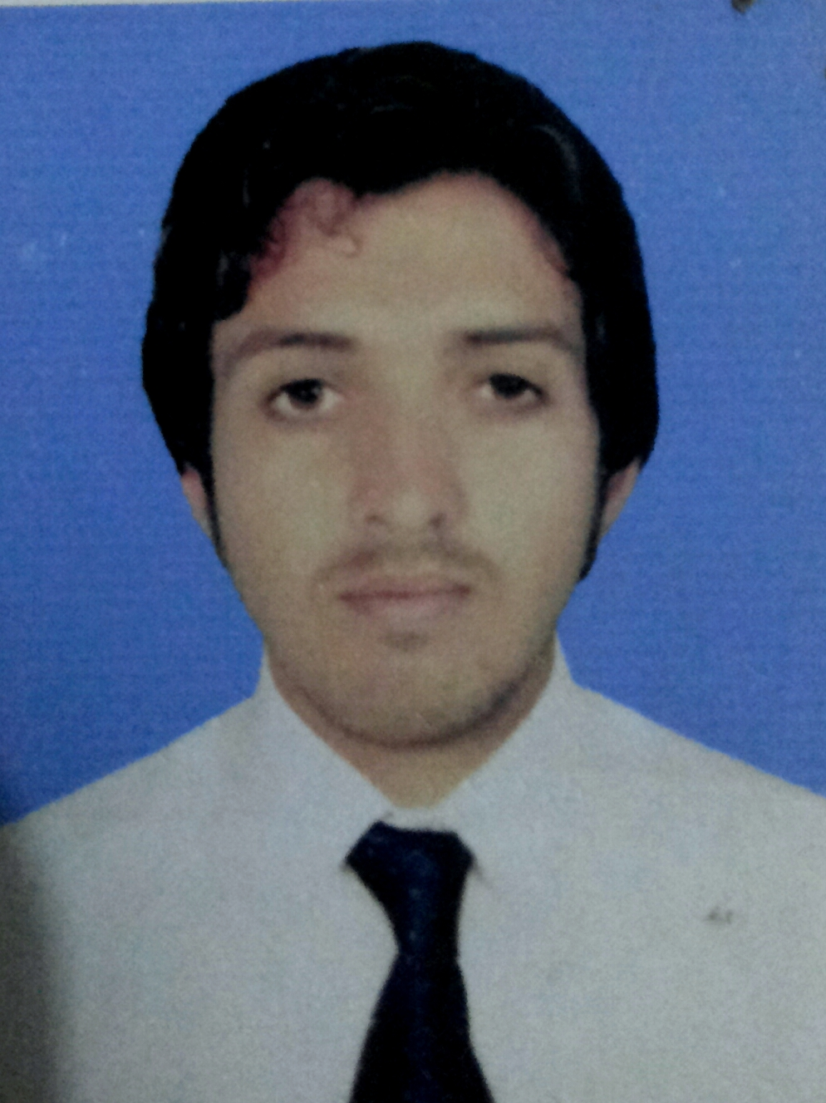 Father Name: Hazrat Khan
NIC # 14301-5439148-5
Contact Address: Bannu Road Muslim Abad Tehsil & District Kohat.
Contact Number: +92333-9633608
Email Address: umarkhan6088@gmail.com
D.O.B: 25th March 1989
Nationality: Pakistani
Religion: Islam
Marital Status: Single

CAREER OBJECTIVE
A competent team leader with good time management, strong work ethics and personal drive. A self-motivated, dependable, hardworking individual who enjoys being in service to others. Seeking a position that provides a challenging team environment where I can fully utilize my skills, efficiency and responsibility: thus facilitating growth of the organization and professionally grow with it.

EDUCATIONAL ACHIEVEMENTS %age CGPA
Pharm-D 64 % 2.61/4.0
Kohat University of Science and Technology (2008-2013)

FSc Pre-Medical (BISE Kohat) 65.09 % NIL
Comp Tech Degree College Kohat (2005-2007)

Matric Science (BISE Kohat) 73.52 % NIL
Fauji Foundation Model School Kohat (2003-2005)

WORK EXPERIENCE
- Alliance Pharma (Pvt) Ltd (30 days Internship).
- DHQ Hospital Kohat (3 months Project Work).
- Production Pharmacist in Rakaposhi Pharma Peshawar as a tablet incharge (1.5 year).
- Currently Working in Heal Pharmaceuticals (Pvt) Ltd Peshawar, Pakistan.

OTHER USEFUL INFORMATION
IT Skills: MS Office Suite, Adobe Photoshop, Composing
Hobbies: Football, Reading Books, Outing, Dinner with friends
Language: English, Urdu, Pashto

Personal Skills:

- Good communication skills both in presentation and discussion
- Flexible and quick learner
- Both self-motivated and team player
- Innovative
- Undertake responsibility easily & confidently
- Solution oriented person, unable to stand problems left un-tackled and left to worsen
- Meeting deadlines

