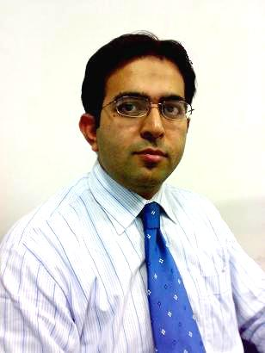
Muhammad Usman
House # 246-B St # 16 Sector G-6/2 Islamabad, Pakistan
House # 506 G-Block Gulshan Ravi Lahore, Pakistan

0092-321-5088501
usman.najam@yahoo.com
usmanyawer@gmail.com

Objective:-
To become a most successful person

PROFESSIONAL PROFILE
Performance driven entrepreneurial marketing professional with 15+ years of continuous advancement and expertise in Pharmaceutical business, sales and marketing and field training.
Proactive self-starter with track record of initiative, personal responsibility, ownership of work and reputation for removing obstacles and making things happens.
Strong leader who effectively motivates others and directs top level strategic corporate initiatives.
Superlative interpersonal communicator, presenter, and negotiator; delivered effective presentations to corporate senior executives; successfully negotiated agreements to avoid litigations.
Creative, dependable and enthusiastic change agent over proven track record in improving efficiencies, reducing costs, and increasing revenues.
Strategic marketer with history of developing brands strategies to reposition and retain brands.

PROFESSIONAL EXPERIENCE
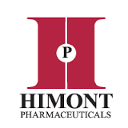
- Marketing Manager
(Cardiovascular & Metabolic Divisions)
Feb 2016 - Continued Himont Pharmaceuticals (Lahore) Head Office Base

Responsible for managing marketing, advertising and promotional staff and activities at a company or organization. Takes steps to measure, enhance, and enrich the position and image of a company through various goals and objectives.

PRIMARY RESPONSIBILITIES
- Plan marketing and branding objectives.
- Prepare marketing strategies alongside other company executives and staff.
- Analyze market trends and recommend changes to marketing and business development strategies based on analysis and feedback.
- Prepare and adhere to budgets.
- Ensure brand messages are consistent.
- Gather and analyze customer insight.
- Nurture and enrich all external perceptions of the company and growth of market share.
- Engage other organizations within the community.
- Collaborate with sales and sourcing to develop strategic partnership activities and implement the execution framework and strategic plan on identified opportunities.
- Develop and lead a marketing team that will develop and execute new concepts, business models, channels and partners to position business as innovator and leader.
----------------------------------------------------------------------------------------------------------

- Business Unit Manager
(Cardio Vascular)
Sep 2005- Feb 2016 Werrick Pharmaceuticals (Islamabad) Head Office Base

- Looking after the whole division of cardiology in all Pakistan and to control the team of 18 (Zonal Sales Managers & Deputy Zonal Sales Managers) 30 Area Managers and 80 Territory Managers (Medical Representatives)
- Develop the Product Eziday (Losartan Potassium), Survive (Simvastatin) & Awardin Plus (Co-Enzyme Q-10) as market leader.
- Group profile is having Monitor (Bisoprolol), Pulse (Atenolol) as well.
- Increased national sales from Pk Rs 17.5 million to PkRs 90.50 million per month.
- Performing the role of arranging Conferences. Managed more than 50 conferences as organizer for the company.
- Having created performance driven culture that ensures accountability and personal responsibility, lead, develop, coach and motivation.
- Supervise and lead creative team in developing and executing integrated marketing programs, including marketing analysis, tactical marketing programs, and lead generation through direct marketing, advertising campaigns and participation in conferences; formulate divisional business plans designed to capturing shares of new / changing markets; created new design styles for sale literatures and trade ads, establishing consistency in pharmaceutical market.
- Make the plans and line of actions to launch new products.
- To get the maximum share from the pharmaceutical market of existing products of company by developing new strategies.
- To make close relations with the hired 41 distributors in all country.
----------------------------------------------------------------------------------------------------------
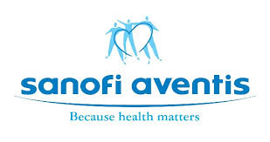
- District Sales Manager
(Anti-Infective)
Nov 2004 - Sept 2005 Sanofi Aventis Ltd. (Central Zones) Lahore + Gujranwala

- Increased regional sales from PkRs 3 million to PkRs 5.7 million.
- Managed 10 Medical Representatives in Lahore and Gujranwala Zone.
- Group profile is having Tarivid, Avil, Novalgin, Clafron, Secnidal, Profenid etc.
- Implemented training course for new representatives for speeding profitability.
- Doing the job of Scientific Product Presenter.
- Officiating District Manager
(Anti-Infective)
2003-2004
Sanofi Aventis Ltd (Centre) Gujranwala Division

- Increased regional sales from Rs 0.25 million to Rs 1 million.
- Tripled division revenues for each sales associate.
- Expanded sales to include mass-market accounts
- Pharma Associate (Anti-Infective)
Mar 2001-2003
Sanofi Aventis Ltd (Centre) Gujranwala

- Expanded territorial sales by 200%.
- Received company’s highest sales award two years in a row.

Education

- M.Sc. (Zoology) 2000
University of Arid Agriculture Rawalpindi

- B.Sc.(Botany, Zoology. Chemistry) 1998
Govt. College Gujranwala

- F.Sc.(Pre medical) 1996
Govt. Islamia College Gujranwala

- S.S.C. Matric (Science) 1994
Govt. A M Islamia high school Gujranwala

- Diploma in Computer Applications 1997
Petroman Institute of Computer Sciences

Professional Training

* Coaching & Counseling * Business Development
* Leadership Style * Customer Satisfaction
* Goal Setting & Performance Excellence * Market Segmentations
* Social Style * Brand/Product Marketing
* Leadership * Full Product Life Cycle
* Recruitment & Selection * Product Life Extension
* Job Orientation * Product Commercialization
* People Handling Skills * Product Marketing
* Selling Skills Teams * Managing Product Development
* Personal Grooming * Marketing Segmentation
* Individual Leadership * Train the trainers
* Selling Skill * Manager Excellence course

- Computer skills specially Microsoft Excel, Microsoft Word, Power Point, Data Basing and others
- Experienced in Induced Breeding of Fish at N.A.R.C Islamabad
- Experienced in Water Quality Analysis at N.A.R.C Islamabad
- Experienced in Hormone Analysis at N.I.H Islamabad
- Experienced in Genetics Lab Techniques at N.I.H Islamabad

