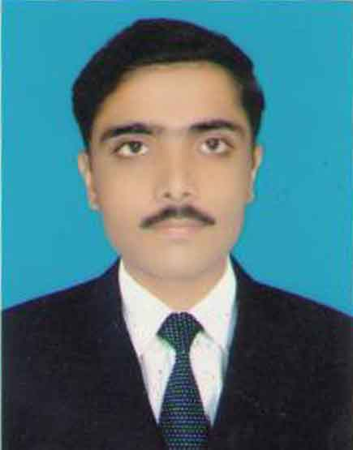
Muhammad Younas

Mohalla Basti Jalalabad Faisalabad road Jhang Sadar
Seeking challenging middle level position in a reputed organization.

CARRIER OBJECTIVES:
To become a professional Pharmacist and join a challenging organization where I can utilize my all professional knowledge and skills for the achievement of the goals and of the organization and to enhance my professional skills by achieving complex and challenging tasks and to serve my homeland till end.

PERSONAL PROFILE:

Father Name: Muhammad Hayat
Date of Birth: 30-12-1990
CNIC# 33202-0674871-7
Religion: Islam
Domicile: Punjab
Nationality: Pakistani
Domicile: Jhang Sadar (Punjab)
Religion: Islam
Mob.# 0332-6982688
E mail address: yyounas45@yahoo.com

ACADEMIC PROFILE:

Degree | Marks | Years | Board/ University
Matric | 687/850 | 2007 | Faisalabad
F.Sc | 738/1100 | 2009 | Faisalabad
Pharm. D | 3.44/4.00 | 2010-2015 | The University of Faisalabad

SKILLS:
- Project management
- Marketing skills
- Personal conversation skills
- Interpersonal skills

COMPUTER SKILLS:
- M. S Office (MS word, MS Access, MS Power Point)
- Proficient in internet and e-mail use
.

PROFESSIONAL SKILLS:
- Communication Skills.

LANGUAGES:
- Urdu
- English
- Punjabi

EXPERIENCE:
- Want to get Experience (Fresh candidate).

REFERENCES:
- Refrences will be served on demand.

