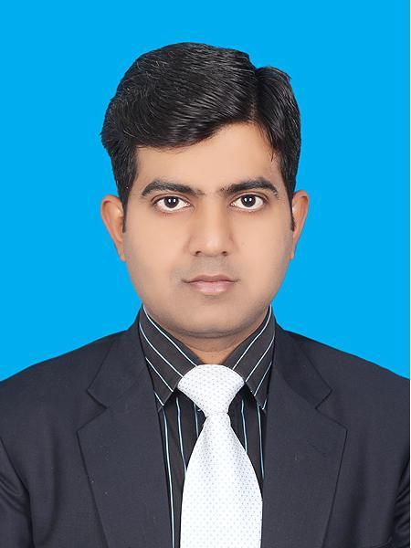
Syed Muzahir Ali
H. No. 1238/8-M, Wallayat abdad # 1,
Back side Naz Cinema
Multan
Cell # +92-333-6128113
Email: muzahir_ali@hotmail.com

OBJECTIVE

I want to succeed in an environment of growth and excellence to meet personal and organizational goals.

QUALIFICATION

MBA: Allama Iqbal Open University Islamabad 2004—2007

B.Sc: BZU Multan 2002-2004

Computer Skills

MS Word, Excel, Power Point

EXPERIENCE

More than Nine years of Management, Administration, Pharma sales and marketing experience.

Current Sanofi Aventis Pakistan

- Working as PA in Sanofi Pakistan (Antibiotic Group)

Previous

(OBS Pakistan MSD Cardio metabolic Group) Jan 2014 –2015 July
PSO

(Hilton Pharma Pvt. Ltd, Cardio metabolic, Gynae, Paeds) May 2009 – Dec 2013
Territory Manager

(Eastern Leather Co Pvt. Ltd) Apr 2007 – May 2009
Assistant Manager
.
RESPONSIBILITIES PERFORMED

- Managing people and labor
- Conflict resolution between people
- Developing Marketing Plans to get maximum market share.
- Responsible for making strategic marketing plan to increase sales in territory
- Checking stock position in distribution
- Making Analysis report every month to evaluate sales against targets
- Making sales presentation quarterly in sales promotion meeting
- Managing labor force for the production in time.

TRAINING COURSES

- Principal Decision Making Sanofi Pakistan
- Managing and Resolving Ethical Dilemmas in Business Sanofi Pakistan
- Initial Training for Marketing Hilton Pharma Pvt. Ltd
- Sales Training Course Hilton Pharma Pvt. Ltd
- Product Training Hilton Phrama Pvt. Ltd
- Product Training OBS Pakistan
- Product Launch Training OBS Pakistan

ACHIEVEMENTS

- 100% YTD Sales in Hilton Pharma
- 105% YTD achievement in OBS Pakistan
- Won 1st prize in quiz at product training
- Won Gold Medal in quiz at product launch training
- Selected as a product trainer at group level

STRENGTHS

- Able to manage people in every condition
- Self- motivated.
- Higher level of stress tolerance, cool under pressure.
- Level of aspiration is always a little higher than achievements.
- Have high competitive spirit & aggressive in achieving goals.
- Enthusiastic person committed to my vision and express this commitment through optimism.
- Believes in actions not in words.
- Results-driven, logical and methodical approach to achieving tasks and objectives.
- Task-oriented - commercially experienced and aware.

PERSONAL INFORMATION

DOB: 27 December 1982
Father’s Name: Syed M. Motahir Jafri
Material Status: Married
Nationality: Pakistan
Religion: Islam

REFERENCE

Reference will be available upon request.

