PERSONAL INFORMATION | NADEEM KHAN
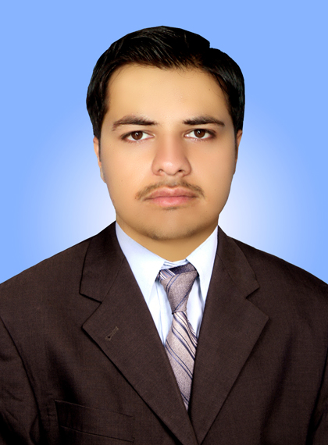 |   House no. 892/1 Nawanshehr Mohalla Qilla Ilyasi Masjid Road Abbottabad Pakistan

+92-332-8935624

nadeemkhan044@yahoo.com

Skype : nadeem_jadoon1
Date of birth 26 July 1989 | Nationality Pakistani
CNIC: 13101-5361975-5

Career OBJECTIVE | A professional, friendly and courteous pharmacy graduate who has a track record of getting projects done in time and to the highest standards. Have taken great pride in own work, as a self-motivated team player able to take responsibility for delivering to tight deadlines. Now Seeking a challenging role in a professional organization, that offers value addition to both the organization as well as my personal profile, fully utilizing my skills and abilities ,in order to justify the post of product Manger

WORK EXPERIENCE

20 July 2012 –10 Sep 2013 | Internee Hospital Pharmacist at Ayub Teaching Hospital Abbottabad KPK(Pakistan)
20 July 2012 –10 Sep 2013 | Responsible for the day to day ward round in male medical ward. Providing a professional  sympathetic and supportive service to patients and identifying the right healthcare solution to meet  their needs.
DUTIES AND  RESPONSIBILITIES | - Supply chain, liaising with a variety of parties including suppliers of Medicine, manufacturers, retailers (for local purchase)  - Coordinate processes to ensure end user satisfaction. An awareness of and strategic response to external influences, such as legislation, medicine costs and environmental pressures, is vital.  - Transportation, stock control, warehousing, and ensuring structures are in place to monitor the flow of medicine, goods and materials.  - Forecasting increasingly complex systems of stock levels, delivery times, transport costs and performance evaluation.
10 OCTOBER2013 —TILL DATE  duties and responsibilities  TRAINING AND SEMINARS  INTERPERSONAL SKILLS | Field Marketing Officer At Bayer Pharmaceuticals  Responsible for Ethical promotion of Derma Brands such as Travocort cream and Advantan brand in Abbottabad Region plus Muzaffarabad belt.  - Generating demand of my Brands  - Organizing Community, health oriented seminars  - Target achievement  - Territory management  - Developing Key Opinion Leaders  - Extensive 18 days Basic sales training from Bayer Pakistan  - 5 days training on unique Selling Skills and How to Handle tough customers  - 2 days training program on Patient focus interaction with HCP’S  - Training programs on Web Designing and Coral Draw.  - Team oriented, Organized and Manage Time well  - Know well about management tools  - Work well under pressure, Flexible and Quick learner  - Possess Leadership skills; Enthusiastic and Assertive  Friendly; have good Presentation skills

EDUCATION

2008–2013  2005-2007  2003-2005 | Doctor of Pharmacy (Pharm-D)  CGPA 2.98/4.00 (78%)
2008–2013  2005-2007  2003-2005 | Department of Pharmacy, Comsats Institute of Information Technology, Abbottabad KPK (Pakistan)
2008–2013  2005-2007  2003-2005 | Physiology, Pharmaceutics, Organic Chemistry, Bio-Chemistry  Pharmacology, Pharmacognosy, Hospital Pharmacy, Community Pharmacy, Dispensing, General Pathology, Bio-Pharmaceutics,  Clinical Pharmacy, Pharmaceutical Technology, Medicinal Chemistry, Pharmaceutical Marketing Management, Forensic Pharmacy  Intermediate (pre-Medical)  820/1100 (75%)  Banat Taleem -ul -Quran high school and college Abbottabad  BISE Abbottabad  SSC Examination  702/1050(67%)  Banat Taleem -ul -Quran high school and college Abbottabad  BISE Abbottabad

PERSONAL SKILLS
Mother tongue(s) | Hindko
Other language(s) | UNDERSTANDING |  | SPEAKING |  | WRITING
Other language(s) | Listening | Reading | Spoken interaction | Spoken production
Urdu | Excellent | Excellent | Excellent | Excellent | Excellent
English | Excellent | Excellent | Very Good | Very Good | Excellent

Computer skills | Adobe Photoshop  Microsoft Office word and Excel.  SPSS  OS : Windows 7 and Later on Installation, Maintenance  Internet browsing.

References | Will be furnished on request.

