NOOR FATIMA
Address: D-35 Marghazar colony, Lahore
0322-2160494
E-mail: noorfatima133@gmail.com
Objective:

Want to work in challenging environment to enhance capabilities under senior persons and esteemed organization. To excel and contribute to the best of my abilities in an organization which offers opportunities for growth. I believe I can be an asset for an organization.

Personal Details:

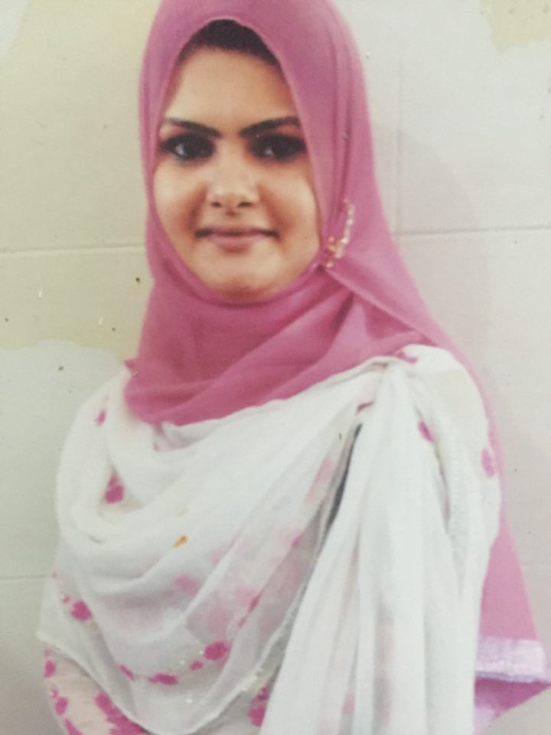
- Father’s Name Khalid Hussain
- Date Of Birth 09-12-1990
- Nationality Pakistani
- Marital Status Married
- Religion Islam
- Gender Female
- ID Number 35202-8262202-8

Academic Qualification:

- MPhil Public Health 2015 University of the Punjab
- Pharm D 2012 The University of Lahore.
- F.Sc Pre.Medical 2007 Govt. degree college for Women, Wahdat Road, Lahore
- Matriculation 2005 Lahore Garrison Grammer School

Experience:
- As Quality Assurance Pharmacist in Dyson Research Laboratories from 21st April 2013 to 30th October 2013.
- Internship in Fatima Memorial Hospital, Lahore from 1st November 2013 to 30th November 2013.
- Internship in Social Welfare Jinnah Hospital, Lahore from 12th August 2015 to 2nd September 2015.

Job Description:

- Keep the quality management system current with good industry practices
- Ensure that appropriate manufacturing in-process controls are implemented
- Ensure in-process controls are performed during manufacturing operations and results are satisfactory
- Drug Manufacturing & Quality control.
- Perform laboratory testing of components, containers, in-process materials, packaging materials and drug product using validated methods against scientifically-derived, fit-for-purpose specifications
- Perform retests or re examine approved components, drug product containers and closures after long storage or exposure to adverse conditions

Skills:

- Excellent Communication& Presentation skills.
- Cooperative.
- Hard working.
- Management Skills.
- Positive thinking
- Task and time oriented
Computer Skills:

- Familiar with Operating systems like Windows XP, Windows 7
- Microsoft Office (Word, Excel, Power Point).
- Internet surfing

References :

- Will be furnished on demannd.

