SAHIB KHAN KHOKHAR 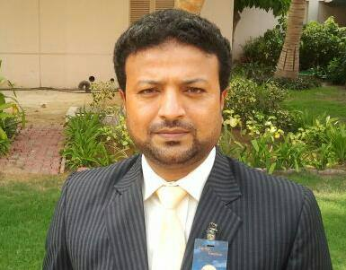

House No: L-90, Gulshane Iqbal block N0:3 Karachi.

- +923003429296 ------03317551777

- sahibkhokhar@hotmail.com,

OBJECTIVE

To get c excellence in the profession utilizing all the skills and experience along with continuous capacity building.

WORKING EXPERIENCE
  - Working as Business Development Manager Ethical laboratories (pvt) Ltd. May 2015 to present
  - Working as Sales Manager Wilsons Pharmaceutical December 2014 to May 2015
Working as Sales Manager South CCL Pharmaceutical from November 2013 to October 2014
  - Working as Sales Manager south (Searle Pakistan limited), From July 2010 to October 2013.
  - Worked as Regional Manager Sukkur (Searle Pakistan limited), from 2005 to June 2010.
  - Worked as Medical Representative Larkana (Searle Pakistan limited), From July 2001 to 2005.

Regions Worked in

Karachi.
Hyderabad
Sukkur
Bahawalpur.
Quetta.

ACADEMIC QUALIFICATIONS

Qualification | Institution | CGPA/% / Div. | Year
MBA (Marketing) | SALU, Khairpur | 3.3 | 2009
MA (Economics) | SALU, Khairpur | 2nd class | 1999
BSc (Biology) | SALU, Khairpur | 2nd class | 1997
SKILLS

Problem solving and decision making training by Rameez Allawalla
Excellence in sales management by Dr. Aamir Khan (Dean of Lahore School of Economics)
Sales summit (Selling’s Skill course) by Searle Pakistan Limited.
Basics in Management (Management Skills) provided by CMB “AR Purri”.
Manager Skills Summit (Management skills) by NAVITUS.

PERSONAL INFORMATION

Father Name | : Mohammad Ramzan Khokhar
Date of Birth | : 1/3/1976
Gender | : Male
Domicile | : Larkana
N.I.C No | : 43203-1578573-5
INTEREST

Reading Books ( Religious , Literary , Marketing )
Writing Articles my blog is http://wwwsahibask.blogspot.com/

