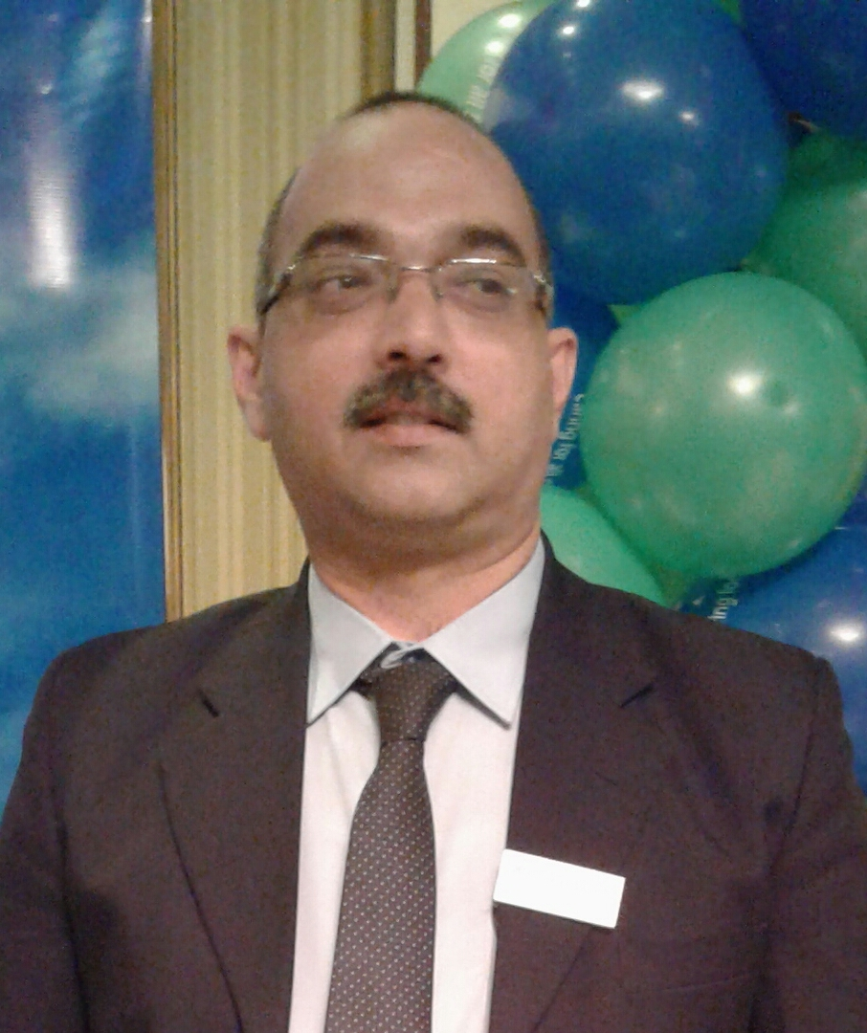
Sameer Ahmed Malik
274/3, Sharfabad Street 18, Karachi
Postal code: 74800. Pakistan
Cell No: 03360221108
Tel Res.: 021-34931453
Email add:
maliksameer07@gmail.com

Objective:.
To be an integral part of high paced pharmaceutical marketing team.
Professional Experience:
5 1/2 years of experience in Product Management.
7 years in Pharmaceutical sales.
2 years of managerial experience in sales.
More than 2 years as hospital pharmacist performing different roles.
- Leader with strong organizational skills, project orientation, and the ability to manage daily operations & work effectively under pressure and stress.
- Motivated to work efficiently without direct supervision in busy environment, handling many tasks simultaneously; able to prioritize workload and multi-task. Consistently "get the job done" and exceed expectations.
- Effective communication/interpersonal skills and a team player; interact positively with a wide range of people, and establish relationships based on respect. Generate spirit of enthusiasm in personnel, prompting ready implementation of recommended processes.
Education Details:
- Business Communication Course attended in 2005 from IBA evening campus.
- Executive MBA 10 courses attended in 2004 from Preston University.
- Bachelor of Pharmacy, 1996-2000 from University of Karachi.
- Pre-Med/Pre-Pharmacy, 1993-1995 from National College.
- Secondary school examinations, 1990-1992 from Gulshan Cambridge School.
Professional Membership: Registration and Licensed: Pharmacy council of Sindh and District Health
Sr. Product Manager & Sales Manager Pharmatec
Join Pharmatec on dated 07/03/2016.
Responsible for Product Management and sales Management of given portfolio (Fastum Gel), considering the maximum profitability and managing resource for productive output.
Sr.Product Manager Cardio Metabolic Group Helix Pharma.
Join Helix on dated 1st Nov- 2013, till 07/03/2016.
Responsible for portfolio of Cardio and Metabolic Products.
Metabolic Portfolio Includes Glimipride and Sitaglipton + Metformin
Cardio Portfolio Includes Clopidogrel, Candesartan, Rousavastatin, Amlodipine + Valsartan, Carvidilol.
Ongoing Campaign IQRA.
Product Manager Atcolab Derma team Jul 2012 till October 2013.
To maximize product profitability by efficiently managing the given portfolio.(Scabion, Betagenic,Acdermin Jel, Terbiderm...)
Responsibilities:
- Manage the products/brands growth as per market and segment growth.
- Launch plans of products.
- Responsible for developing packaging, labeling and other components.
- Efficient utilization of human, financial and material resource by proper allocation both geographically and potentially.
- Manage cooperate short and long term objectives/ goals.
- Searching or developing product in new market.
- Improving and extending existing market.
Area of Competencies
- Products/ Brand knowledge.
- Market and segment knowledge.
- Gathering competitor's data and developing counter strategies.
- Vision for opportunities, competitors.
- Handling potential and present threats.
- Minimum supervision, maximum initiative.

Assistant product Manager Atco lab cv team 15/09/2011-Jul 2012.
Portfolio: Dioplus, Cardnit, Merol.
District sales manager Atcolab cv team 4/10/2010 till 14/09/2011.
Team of 7 spos,
Dioplus launch in Karachi,
Exhibit and train each spo according to the developmental plan.
Staff Pharmacist. Memon Medical Institute (14 dec 09 till oct-2010)
Pharmacist. South City Hospital Clifton (20 Mar 09 till 24  09-09).
Pharmacist. Dr. ZIAUDDIN HOSPITAL (19 March 08- 20 Mar-09)
Achievements:
- I.V room supervisor at ziauddin hospital
- Initiated extemporaneous compounding services.

Product Manager Elko Organization (June 05, 2007 till January 23, 2008)
Achievements: 3 product launches. 6 new product plan, registration, pack design, labeling and promotional mix. Region wise Product training. Training Manuals for all Products.
Matrix Pharma (01 April 2005  07 April 07)
- Worked as Regional Business Manager Karachi.
- Responsibilities as Manager
- To manage and grow sales of Karachi city.
- Identification and selection of customer (doctors) according to product offered.
- Hire, supervise, control and lead the activities of medical sales officer (representatives).
- Identification of new areas for business growth.
- Visit customer (doctor) with medical sales officer to resolve queries, concern, communicate company policies, fulfillment of request (any services).
- Supervise and coach for pre sales call and post sales call.
- Conducting weekly and monthly sales identifying gaps in implementation, strategy and in planning.
- Concluding and giving action plan for sales growth to higher management and to the team.
- Visit pharmacies with medical officer to take accurate feedbacks of competitor and company product.
- To help and facilitate medical sales officer to include product in pharmacies.
- Plan and organize medical sales officer visit to different assigned area.
- Plan and supervise customer (doctor) frequency visit.
- Plan monthly and weekly customer (doctors) and pharmacies to give increment in sales and to build company image by implementing product or company strategy.
Achievements: Best Regional Manager for 2 years.
Promoted as Assistant Product Manager in Dec 2006 till April 2007
Merck Sharp & Dohome (1 Nov 2001- 31 Mar 2005)
Therapeutic Group, Cardiology. Worked as Professional Sales Officer in promoting research brands like cozaar, hyzaar and fortzaar (losartin potassium).
Ali Gohar Pharmaceuticals (16 Mar 1998  Oct 29 2001)
Worked in Ali Gohar Pharmaceuticals Pakistan as medical sales officer and promoted as senior sales officer in July 2000, resigned on same designation
Responsibilities as sales representative.
- To achieve 100% targets quarterly and annually.
- To plan and make efforts for sequenced growth in assigned territory of Karachi city.
- To understand customer (doctor) prospective in assigned territory.
- To define product distinctive values to the selected audience.
- Concentrate on the selected audience and behavior.
- Shape the customer perception.
- To make sure that implementation is well integrated, effectively and efficiently.
- To re-track results and make corrective measures.
- To visit pharmacies regularly for inclusion of products in hospitals.
- To build relations with key opinion leaders and early adopters.
- To resolve concern of customers by providing authentic references.
- To handle objections of customers (doctors).
- To provide services of company regularly and timely.
- To arrange and conduct round table discussions.
- To share achievements with colleagues.
- Help colleagues resolving concern arise in their territory.
- Share product knowledge with colleagues in weekly meetings and through presentations.
Achievements: 120% achiever against sales target. In 2001 winner of Bangkok tour. Promotion in 2 years of service as senior medical officer also designated as assistant district manager for 1 month. Company offered courses in Professional communications skills 1&2 and micro marketing.

Personal Details:
- Father Name: Abdul Malik (Late)
- Date of Birth: 16th March 1977
- N. I.C. No: 42201-7409352-1
- Marital status: Married.
- Religion: Islam (muslim).
- Gender: male.
- Nationality: Pakistani.
- Passport detail: issue date:02may2006 exp:01may2011

