Muhammad Yasir Ubaid 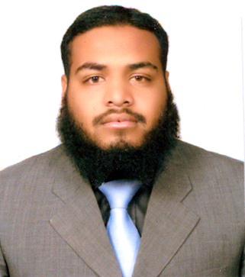

Career Objective
To obtain a position in a progressive organization which effectively utilize my analytical skills and commitment,
to achieve quality work and also offers opportunities for advancement.
Education
Degree | Board / University | Div / Grade
MBA. (Marketing) | Virtual University | In Progress (Evening)
B.Sc. (Math A & B Course, Physics) | Punjab Univ. | 2nd Div
F.Sc. (Math, Chemistry, Physics) | FBISE | ‘B’ Grade
Matric (Science) | FBISE | ‘A’ Grade

Work Experience
Divisional Field Manager (D.F.M.)
Sami Pharma August 2011 to date

Achievements
- I have joined Sami Pharma as a Manager and looking 4 groups regarding sales
- I am achieving 100% targets from almost 3 years.
Senior Territory Manager
Abbott Laboratories August2006 to August 2011

Achievements
- I completed my Initial training program of one month and got certificate.
- I completed my TOPS (Technique of persuasive selling) program.
- I completed my Focus on selling program.
- I received recognition letter from head office for best performance on SFA (Field Force Automation Program).
- I am achieving my targets annually 100%.
- I was the best achiever of year 2009 from Rawalpindi district and got best in best TM award in Bangkok during Annual conference.

Hilton Pharma November2005 to August2006

Achievements
- I completed my Initial training program of 15 days.
- I achieved my targets 100%.
- I got 3rd prize on the best sale of product ESORID(Esomperazole) all over Pakistan

Computer Skills

- I have three months certificate of basic computer course (Word, Excel, Power point etc).
- I can easily use internet includes voice and video chat etc.

Contact Information
Address: | House # 314, Street# 19,  Sector I-10/2.  Islamabad, 46000  Pakistan
Phone: | +92-333-5577660
E-Mail: | yasirubaid2009@yahoo.com

Personal Information
Father’s Name: | Ubaid Ullah
Domicile: | Rawalpindi (Punjab)
NIC#: | 37405-9474464-1
Date Of Birth: | 28-10-1984
Religion: | Islam
Marital Status: | Married

