Curriculum Vitae

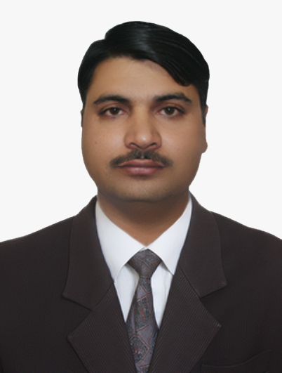Curriculum Vitae

WwaW+

SAYYED FAZAL ELAHI
fazalkhan_sayyed@yahoo.com
+92-3005862676 +92-335-1379828

Father’s Name: Sayyed Iqbal Shah
Date of Birth: Jan, 21 1982
Domicile: Charsadda
Province: Khyber Pukhtoon khawa.
Nationality: Pakistani
Religion: Islam
N.I.C. No: 17102-4110067-9
Permanent Address: Village & post off. Dhakki, Tehsil Tangi District charsadda

Present Address: Flate no, s 5 Amir Plaza, sardar Ahmed Jan colony Peshawar
.

Every individual dream to reach the top but the people marks it, when they perform their task
with great deal of determination and loyalty. Vision is to get a managerial position with an
opportunity to handle challenging tasks with compelling ambition for learning. I seek a challenging
career that gives me a chance to prove my intellectual abilities of Management, Sales & Marketing
strategies to achieve the organizational objectives efficiently and effectively.

ExaminationYearMarks/OBT Board/UniversityS.S.C (science)1997/1998 623/850 G.H.S DhakkiFSc(Pre-Medical)1999/2000649/1100 Govt.College. PeshawarBA (Law pol science)2001/2002262/550 University of Peshawar

LanguagesReadingWritingSpeakingPashtoExcellent ExcellentExcellentEnglish ExcellentExcellentExcellentUrdu ExcellentExcellentExcellent

Presentation
Selling skills
Good Relation

Total Pharma Experience Ten years
Worked as S.M.I.O in Asian Continental (Pvt) Ltd for 8 years
Working as a A.F.M in Amarant Pharma (Pvt) Ltd Karachi based Peshawar.
Worked in Peshawar Mingora Timergarah

PERSONAL INFORMATION:
gffggdg

OBJECTIVE

ACADEMIC QUALIFICATION:

LANGUAGE PROFICIENCY:

SKILLS:

EXPERIENCE:

0000000000000

`

