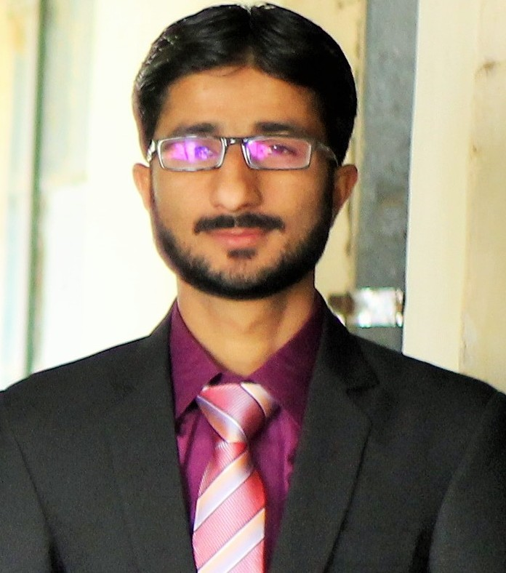
SHAFQAT ALI JAGIRANI
POSTAL ADDRESS : B-423 Gulshan-e-Hadid Phase2 Bin Qasim Karachi
EMAIL@ : meershafqat83@gmail.com
CONTACT # 0331-3425546

GOALS & OBJECTIVES :
To join a well reputed and hyper growth organization, specially a corporation for business / education, through my qualities, inherent skills & work- experience I would like to enhance status of the organization along with polishing my crude skills and abilities.

PERSONAL INFORMATION :
- Father’s Name: Akhtiar Ali
- Date of birth: 03-03-1992
- PRC / Domicile: Kamber Shahdad kot@Kamber (Rural)
- Gender Male
- Religion: Islam
- Nationality: Pakistani
- Marital Status : Single

ACADEMIC QUALIFICATION :
DEGREE | BOARD / UNIVERSITY | YEAR | GRADE
Pharm- D | University Of Sindh Jamshoro | 2015 | Pending Result
Intermediate | B.I.S.E Larkana | 2009 | B Grade
Matriculation | B.I.S.E Larkana | 2007 | A Grade

OTHER SKILLS :
- Regular, Punctual & Good Communication Skills.
- 3 Months Short Course in Computer.
- 1 year English Course
HOBBIES :
- Reading Newspapers & Watching News Channels.
- Reading Islamic and Historical stories books.
LANGUAGES :
- Good in Speaking, Reading and Writing in English.
- Excellent in Speaking, Reading and Writing in Urdu.
- Excellent in Speaking, Reading and Writing in Sindhi.

