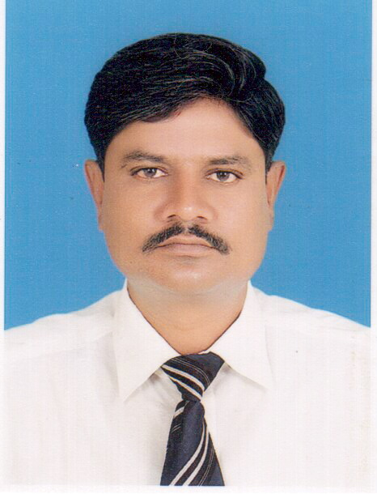
Shahid Ali Magsi 0331-3458001
Regent Cinema Saleem Colony, Near Baba Gulab Shah Sukkur smrkali@gmail.com

Professional Profile
Working In Pharmaceutical Field since 2002, with excellent track record. A confident and supportive leader and presenter with excellent interpersonal and communication skills. Strong development skills through effective rapport building both inside and outside the office environment. Focused achievement drive through goal setting.

Professional Experience

Working in Geofman Pharmaceuticals as Z.S.M Based @ Sukkur Since Nov 2015

Achievements:
- Best Launching Sulbamox.
- Best Launching Geofbac Inj 1gm & 2gm.
- Best Launching Ipratec Solution.
Responsibilities:
- Managing a team of Two Mangers and Eight Representatives based at different stations
- Team Hiring and retaining
- Developed new markets, set targets & appointed the distributors
- Managing Eight distributors.
- Team Development, Coaching and Motivation
- Building relationship with key customers
- Designed sales activities in conjunction with the Marketing department to support various product campaigns during the course of the year

Working in Scotmann Pharmaceutical as A.S.M Based @ Sukkur Since Jan 2015 to Oct 2015
Achievements:
- Best Achievement for Essoscot.
- Highest growth in Nitroscot.
- Highest Sales of Emkay D
Responsibilities:
- Managing A team of Two Representatives based at different stations
- Team attaining and retaining
- Team Development, Coaching and Motivation
- Building relationship with key customers
- Designed sales activities in conjunction with the Marketing department to support various product campaigns during the course of the year
- Developed new markets, set targets & appointed the distributors
Highnoon Laboratories Ltd. as D.F.M Sukkur Since Nov 2013 to Dec 2014

Achievements:
- Best Achievement for Tagipmet 2013.
- Highest growth in Rosulin.
- Highest growth in Tagipmet.

Responsibilities:
- Managing A team of Four Representatives based at different stations
- Team attaining and retaining
- Team Development, Coaching and Motivation
- Building relationship with key customers
- Designed sales activities in conjunction with the Marketing department to support various product campaigns during the course of the year
- Developed new markets, set targets & appointed the distributors
- Managing Five distributors.

Otsuka Pakistan Ltd. as F.M C.N.C Sukkur Since Jan 2010 to Nov 2013

Achievements:
- Best Team for Q2, 2011.
- 3rd Position in Pakistan 2011.
- Best Team for Q1, 2012.
- Best Team for Q2, 2012.
- Best Team for Q3, 2012.

Responsibilities:
- Managing A team of Five Representatives based at different stations
- Team attaining and retaining
- Team Development, Coaching and Motivation
- Building relationship with key customers
- Designed sales activities in conjunction with the Marketing department to support various product campaigns during the course of the year
- Developed new markets, set targets & appointed the distributors
- Managing a distribution network of 18 dealers in the area.
- Monitored and reported all Field Sales activities through active measurement of productivity & profitability.

Otsuka Pakistan Ltd,
March 2004 – Dec 2009
Sr. Product Promotion Officer Based @ Sukkur
Achievements:
- Quarterly Sales Incentives
- Best Team Leader in new product launch training
- Top Achiever 2007 in Pakistan
- Q1 and Q2 top achiever 2007 won Motor Bike
- Certificates of Interpersonal Skills, Leadership, on Time Projects completion.
Responsibilities:
- Product Promotions to select customers as per company strategy
- Monthly and Quarterly Targets achievements.
- New customer development
- Building relationship with key customers

NabiQasim Pharmaceutical
Feb 2003 to March 2004
Territory Manager Based @ Sukkur
Achievements:
- Increased Regional Sales
- Won quarterly and yearly incentives

Pacific Pharmaceutical
Feb 2002-Feb 2003
Sales Promotion Officer Base @ Sukkur
Achievements:
- Received award in first sales conference.
- Successfully launched new products

Other Skills
Skilled at using office applications like MS Word, MS Excel, & Power point. Attended several training courses on Management, Selling Skills, Recruitment & Selection, Communication etc.
Personal Information

Name : Shahid Ali Magsi

Father’s Name : Ghulam Mohammad

Date of birth : 09-12-1977

N.I.C # : 45504-9097775-5

Education : Bsc (Pre-Medical) 1999
HSc(Pre-Medical) 1996
SSc 1993

Address : Regent Cinema Salim Colony
Tomb Baba Gulab Shah Sukkur.

Territory Exposure
- Sukur District
- Khairpur District
- Ghotki District
- Jacobabad District
- Shikarpur District
- Larkana District
- Dadu District
- Quetta
- Rahim Yar Khan

Education
Shah Abdul Latif University, Khairpur
B.Sc (Pre-Med) 1999-2000

