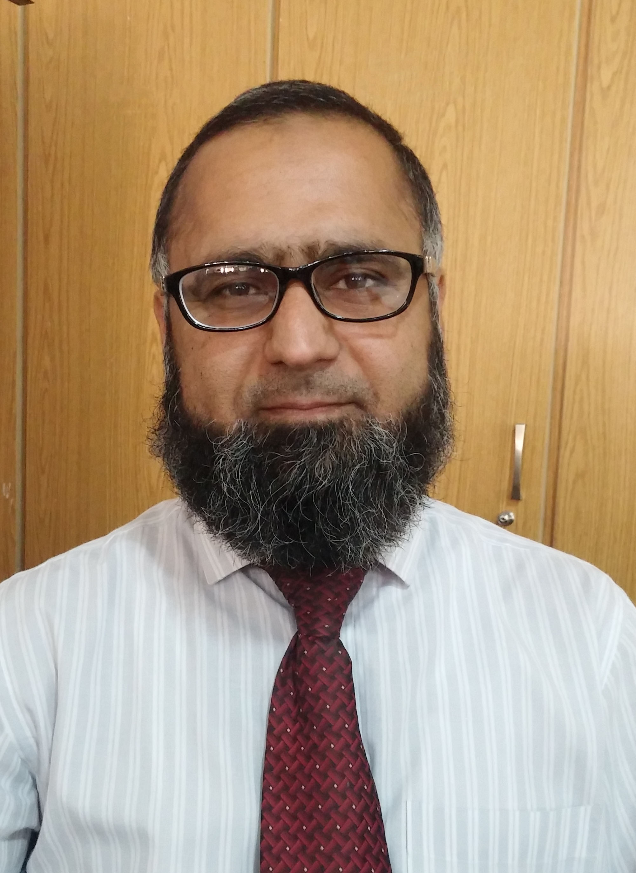
House#340,Street#1, National Housing Scheme No.1
Adiala Road Rawalpindi.
Cell#0321-5168313
0324-5115654
E-mail:amjad.shaigan@gmail.com

AMJAD HUSSAIN

Education

MBA Marketing 2001
(Preston University Rawalpindi)

Bsc 1997
(Sir Syed College Saddar Rawalpindi)

Fsc 1995
(Sir Syed College Saddar Rawalpindi)

Matric 1993
(F.G Quaid-e-Azam Model School Rawalpindi) Employment
1.SHAIGAN Pharma
Product Manager

2.Helix Pharma
Sales Manager North
3.HILTON Pharma.
Area Sales Manager
4.Pharmacia Pakistan (Pvt)Ltd.
Oncology Associate
5.ICI Pharma.
Territory Manager.

Pertinent Responsibilities.

- Strategy and planning of assigned products.
- Marketing plan preparation.
- Follow up for marketing plan or activities execution.
- Responsible for creating a product and company image in front of customers by means of their personal and professional cares.
- Resposible for the Team building and ensure SOPs compliance.
- Ensure per man productivity.
- Responsible for arranging different educational activities like Live Video Conferences,Symposiums,RTDs and PGMs to promote knowledge about the specific indications of the products.

- Responsible for providing the latest updates about the products of the consultants.

- Responsible for looking after and handling the queries of the consultants.

- Responsible for developing Key Opinion Leaders(KOLs)on my products.

- Responsible for developing speakers(Consultants)of the products.

- Responsible for traveling with the speakers in different areas of the territory for products and disease awareness.

- Implementation all the strategies and policies of the company in the field according to the needs of time.

- Responsible for new launches of the products.

Achievements
1. Achieving highest sales figures of the North region in Helix Pharma.

2. Achieving leading position on national level in key products of Helix Pharma.

3. Best Oncology Associate in Pharmacia.

COURSES

- Hiring and interviewing process.

- TWIST & BET in Helix Pharma.

- Strategic & Time Management course in HILTON Pharma.

- Team hiring course in HILTON Pharma.

- Oncology products trainings in Pharmacia Pharma.

- Initial training course in Pharmacia Pharma.

- Selling skills training course in ICI Pharma.

- Initial training course in ICI Pharma.

