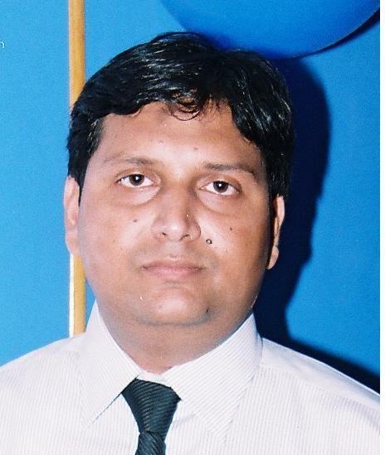
SALMAN HUSSAIN

Contact #: 0334-3229921
E-mail: salmanhyd_pk@yahoo.com

PROFESSIONAL OBJECTIVE
A motivated, results-focused Human Resources professional, seeking an opportunity to utilize career experience, skills, and education to contribute to employer objectives, profitability, and success with a company offering potential for challenge and growth.

EDUCATION

- MBA Specialized in HRM at University of Sindh (2.96 CGPA)
- Bachelor of Commerce at University of Sindh (2nd Class)

CERTIFICATION
- Attend Fire Fighting & First Aid Training in Karachi.
- Attend Fast 7 Training in Karachi (Windows 7 Plus MS Office 2010).
- Attend Ms Excel Advance Training in Aptech Hyd.
- Attend Time and Territory Management Workshop in Hyderabad.
- Attend Sale Force Performance Indicator Workshop in Karachi.
- Attend SAW Training in Karachi.
- Attend Team Skills & Leadership Workshop in Karachi.

Human Resource Generalist
Human Resources Professional with a Degree in HRM* offering 11-years HR career distinguished by commended performance and proven results.
Extensive background in HR generalist affairs, including experience in talent acquisition, Learning and Organizational Development, retention, staff development, succession planning, conflict resolution, Disciplinary, HR records management, HR policies designing and management, legal compliance, Compensation and Benefits strategies, Performance Management system etc.

HR Skills
HR Department Startup  Disciplinary Procedures  HRMS Implementation  Talent Acquisition  HR Systems Management | Employee Relations  Comp & Ben Survey & Analysis  HR Program/Project Management  Succession Planning | Orientation & On-Boarding  Performance Management  Organizational Development  HR Policies & Procedures  Exit Survey Analysis, L & OD
EMPLOYMENT DETAILS
Sanofi Pakistan Ltd  HR & Administration Officer Apr 15, 2004 - to date
Responsibilities Industry: Pharmaceutical
- Responsible for all Key Domains of HR functions, including: Strategic planning, organizational development, staffing, training, benefits administration, Employee Relations, Management Development, and Performance Management.
- Management training, employee relations and communication.
- To carry out orientation of employees of junior and senior management staff.
- Use social media and other technical means to source candidates for open jobs.
- Developed CV databases to track safety data of external candidates.
- Event Management like arranging Seminars/Symposia/Round table meetings & Assessment Centre.
- To manage and control general office Administration
- Supervision of admission, staff administration, budget compliance.
- Oversee and negotiate employment, compensation and benefits.
- Effective Cross functional communication & coordination.
- Dealing with service / utility agencies (EOBI, Allianz, SESSI).


Drug Channel Assistant Manager Nov 01, 1998 – Apr 14, 2004
Responsibilities Industry: Pharmaceutical
- To manage talent acquisition process and life-cycle, applicant tracking system, talent planning including assessments, interviews, offers etc.
- Manage follow-ups, parties’ payment & client’s portfolio.
- Design Booking & Supply Schedule for local city and upcountry for distribution house and sister concern branches.
- Supervise the shipping and receiving functions coordinate with companies supply chain personnel for in transit invoices.
- Prepare stocks orders with the help of inventory replenishment plan.
- Market survey, its analysis & consequent strategy plan making.
- Plan and control local A&P expenditure, ensuring cost-efficiency at all times and particular focus on controllable expenses.
- Staffing the Distribution House and manage & harmonize the employees.
- Dealing with telephone and email enquiries.
- Ensure timely execution of sales claims & coordinate with respective personnel.
- Provide leadership, direction and motivation for sales team to ensure full customer satisfaction.

COMPUTER SKILLS:
- MS Office
- Office Outlook
- ERP
- HRIS
Activities

Freelance HR Consultancy particularly for Recruitment and Selection and Performance Management
Study innovative HR techniques and concepts
Develop strong networking with HR Professionals

REFERENCE

Reference will be furnished upon request.

