House # 31, Street # 5, Tariq Bin Ziad Colony Sahiwal. | Cell # O321-7248421  Cell # 0334-7673744  Email:nazeels@yahool.com |  | 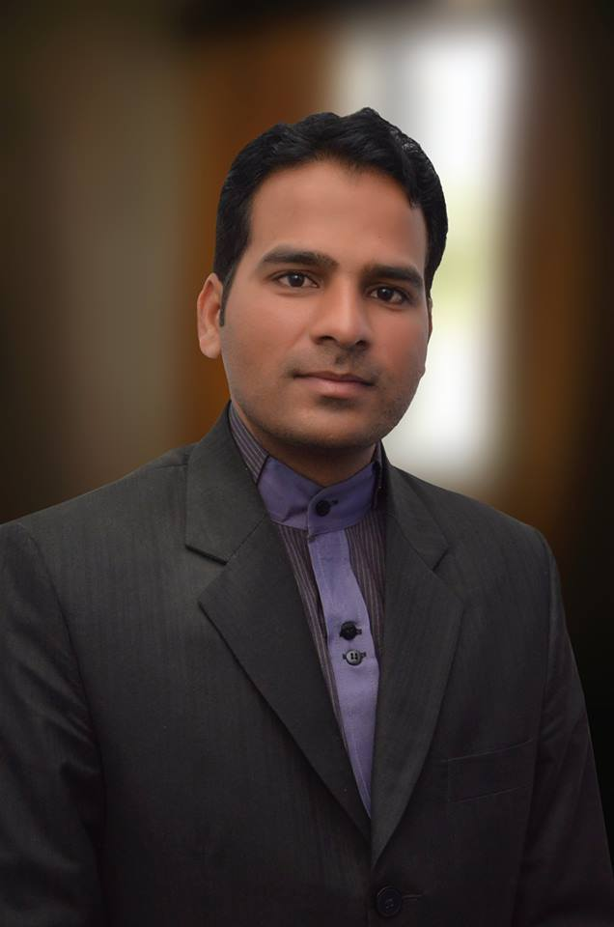
Shamas Nazeel
Objective | To Counter the New Challenges in Sales & Marketing in this Competitive Environment to prove my Skills.
Experience | 1Sept 2005 To Oct. 2008 Health Care PHARMACEUTICALS Lahore  Sales Promotional Officer .  - Dealing with all products management and Sales of Health Care Pharma in Gastroenterology.  - Successful launch of Gestro Products .  - Making Zee(Azithromycin) Tablet and Tab Danopram (Escitalopram) Brand Leader in Sahiwal.  - Taking the sales of Health care from 0 Lac a year to 16 Lac Rupees a year..  Jan2009 to Sep. 2012 Mascon PHARMACALS (Pvt) Ltd Lahore  Area Sales Manager  - Promoting Gastro products, and general products.  - Conducting Meetings, Seminars, and Doctor Conferences.  - Taking the sales of Mascon Pharma from 0 lacs to 8 lacs/ month in Multan Sahiwal and Okara.  - Complete Area knowledge with sound grip on potential customers and chemists.  - Developing References, Promotional Plans, Strategies, and activities for the launching of new products
October 2012 to till MIND CARE PHARMACEUTICALS Islam Abad
Area Field Manager
- Taking the sales of Mind care from 2 Lacs/ month to 15 Lacs/ month.
- Complete launch campaign of Gastro and psychiatry products.
- Successful launch of Gastro and psychiatry Products and putting them on smooth sales.
- Developing relations with potential Gastroenterologists, Psychiatrists and G P’s.

Education | 2003-2005 ( B.Z.U ) Multan  Bachelors in Arts  - Major Subjects Economics, Education and Sociology.  2001-2002 B.I.S.E Multan  Faculty of Arts .  - Major Subjects Economics, Punjabi and Education.  2000 B.I.S.E Multan  Secondary School Certificate  - Major Subjects Mathematics, Physics, Chemistry, Biology.
Professional  Skills | Have sound Knowledge on MS Office.  - Can work on Coral Draw 09,10,11.  - Have a Sound Knowledge to psychiatry and General Products.  - Have sound knowledge of Gastro products and Anti- Inflammatory products.  - Well Versed to read and work with IMS Data and Developing products complete launch campaign, target building and successful execution of planning and target achievement with specialized performas and chemist surveys.
Personal  Information  Language | Name Shamas Nazeel  Father’s Name Samson Nazeel  I D Card # 36502-3527642-9  Religion Christian  Place of Birth Sahiwal  Nationality Pakistani  Date of Birth 31st Oct., 1984  Marital Status Married  Dependents Wife  Daughter  Sister  Parents
Urdu, Punjabi, English

Remarks
I am grateful for the time you have spent to go through my CV, and will always remain thankful to you for this kindness.

