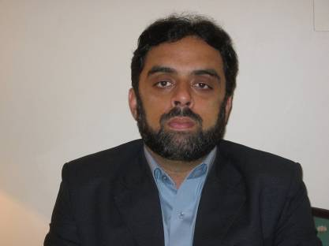
Home Address: H/No: 1,Street: 13, Haji Camp Sethi Town
Peshawar, Pakistan.
Mobile 03449254910
Email shuaibkhan2002@yahoo.com

MUHAMMAD SHOAIB KHAN

OBJECTIVES

To acquire a challenger position in an organization where the organizational culture emphasizes of continuous learning, motivation and self respect for each and where I can exploits my knowledge and utilize my analytical, interpersonal and communication skills, while providing opportunities for growth, resulting in a mutually beneficial relationship

QUALIFICATIONS

BSC 343 A Grade 2005
FSC 674 B Grade 2003
SSC 527 B Grade 2001

PROFESSIONAL EXPERIENCE

1th oct 2015 Till date working in Macter International Karachi AS A RSM.
1th dec 2013 To 1st oct 2015 working in Indus Pharma Karachi AS A Field Manager.

21th May 2006 to 30nov 2013 working in SANOFI-AVENTIS as Field Executive

2005 to 2006 worked in NOVARTIS PHARMA as Medical Information Officer.

.
PROFESSIONAL COURSES

Basic Training Course in Novartis Pharma

Initial training course in SANOFI-AVENTIS

Communication Skill Course
New sales model of world Sales Force Excellence (Selling Skills)

ACHIEVEMENT

Ach 2008 148%

Win best Pharma associate award of 2008 And win the tour of Paris with spouse.

Ach 2009 At 104 %
Ach 2010 At118 %
Ach 2011 at 116%
Ach 2012 at 102%
Ach 2013 at 89%

INTER PERSONAL SKILLS

Ability to work both effectively and confidently under pressure

Flexible and Respective to new ideas

Good communication skills

Team Player

INTEREST

Reading good books, Traveling, Computer & Internet.

LANGUAGES
Languages
English
Urdu
Hindko
Pashto
Punjabi

COMPUTER SKILLS

Proficient in using the following computer soft wares:

Microsoft word, Excel, PowerPoint
Data Base Hardware & Software

Internet communication packages including leading search engines.

PERSONAL Father’s Name: Noor Ahmad (Late)
Date of Birth: 12 October, 1985
N.I.C: 17301-1422903-9
Address: H/No: 1, Street: 13, Haji Camp Sethi Town
Peshawar, Pakistan.
Mobile 0344-9254910
Email shuaibkhan2002@yahoo.com

