 | SIDRA TAYYAB  Date of Birth : 11th-February-1991  Residential Address: A,304-saima classic, Gulshan-e-Jauhar, Karachi  Mobile: + 92-321-2882978  E-Mail : dr.sidraa@hotmail.com
  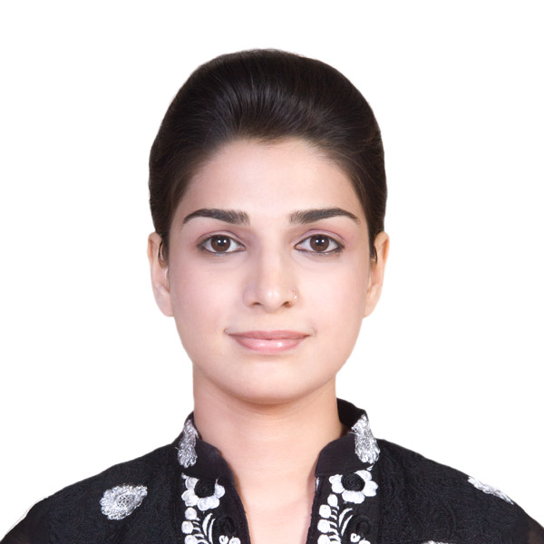

Personal Statement | To boost my career as a pharmacist by association with a reputable pharmaceutical company that would provide a platform to build upon my steep knowledge and utilize my professional learning.
Education
  Qualification | Majors | Year | Institution
  BACHELORS | Pharm-D | 2011-2015 | Jinnah university for Women’s, North Nazimabad, Karachi.
  INTERMEDIATE | Pre-medical | 2008- 2010 | Meritorious science college
  O-LEVEL | Pre-medical | 2006-2008 | Toronto school of academic excellence
Certifications | - Attend “1st national conference on pharmacy profession-a success tool for health care system” held at Dow college of pharmacy, Dow university of health sciences.  - Attend workshop “pharmacovigellance” held at Zia Uddin lecturer hall, Karachi.  - Contribution & participate in organizing “industrial manufacturing model exhibition” 2014.  - Seminar on “freeze drying process and its latest studies and its application in aseptic products manufacturing “
Professional Experience
  Organization | Position | Work profile | Time period
  Searle Company limited, site area(internship) | Internee | Quality Control , Quality Assurance, Research and Development  Packaging &Production Department. | June 2015-  July 2015
  Abbasi Shaheed hospital, North Nazimabad,  Karachi (internship) | Internee | Monitored drug therapy regimens for contraindications, Drug interactions and drug food interactions,  Provided drug information to patients and their families, Documented all clinical | Jan2015 - Feb 2015
Technical Skills | - Dexterity in handling all pharmaceutical equipment in controlled environment.  - Hand on experience in pharmaceutical preparation in laboratory.  - Have a critical understanding of dispensing.  - Dexterous at dose calculations  - Self-confident and mature having constructive point of view with highly positive, polite  Yet professional attitude.  - Prompt and result oriented having determination to achieve all aims and objectives.  - Have ability to accept challenging tasks.  - An active individual and eagerly took part in organizing all professional and co-curricular activities.
Interests & Soft Skills | - Analytical and organized in approach  - Teambuilding and effective communication skills  - Excellent report writing and presentation  - Admirable and practical interpersonal and soft skills.
Electives | - Industrial Pharmacy  - Pharmaceutical Technology  - Pharmacology  - Clinical Pharmacy  - Marketing.
Co-Circular Activities | - Position holder at Spelling bee competition  - Position holder in Quiz competition  - Honor Roll student  - Participant in sports activities  - Fascinated in watching movies, Writing poems, Effective in Presentations
Area of Interests | - Quality assurance  - Regulatory affairs  - Quality control  - Research and development

