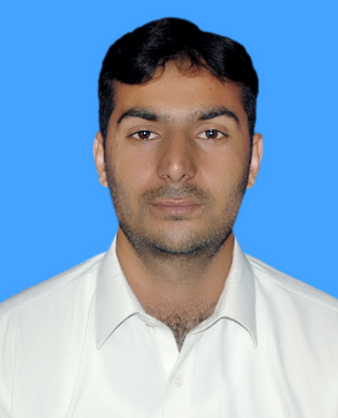  Contact:  Mobile No:  +92-315-9958971.  E-mail :  sultanniaz1991@gmail.com  Skype ID:  Armankhan142.  Present Address:  SC-7 Salman farsi society malir halt Karachi.  Permanent Address:  Village Tetai wala (Alabad) Tehsil charbagh District Swat KPK.  Mailing Address:  Same as permanent address.  Other Information:  Date Of Birth :  2nd of November 1991  Marital Status:  Single  CNIC #:  15602-9338434-9.  Religion:  Islam.  Gender:  Male.  Nationality:  Pakistani.  Domicile:  Swat. | Sultan Niaz  Objective:  To build a foundation of my career by working with a reputed Organization where I can gain the relevant experience and expertise to enable me to deliver in the Organization. I want to come up to the expectation of the Organization. Being a devoted individual I want to achieve my aims with hard work and sincere efforts.  Academic Qualification:  - 2011-2015 3.82 CGPA ( Pharm-D )  Hamdard University Karachi  - 2008-2009 F.Sc (Pre-Medical) 78.8%.  Intermediate board of Karachi Pakistan.  - 2007 Matriculation 79.9%.  BISE swat, KPK Pakistan.
  Field Related Experience:
  45 days Internship training in SHAHEEN PHARMACEUTICALS (swat).
  Computer & Other Skills:
  - Microsoft Office
  - Good Knowledge of Email
  Language Skills:
  - English (fair)
  - Urdu (good)
  - Pashtu(v.good)
  Strengths:
  - Good Communication skills
  - Keen observer
  - Fast learner
  - Good listener
  Certification:
  - Certificate of participation in the seminar on Role of Drug and Poison Information Center in Addressing Public Health Issues on October 30th, 2014.
  - Certificate of best presentation on vitamins in MEDICINAL CHEMISTRY (2014).
  - Internship certificate (200 hours) at ABBASI SHAHEED HOSPITAL year 2015.
  References:
  - References on Demand.

