BIO- DATA

SYED ADNAN SHAHID

OBJECTIVE I always seek for growth and tried to give my best.
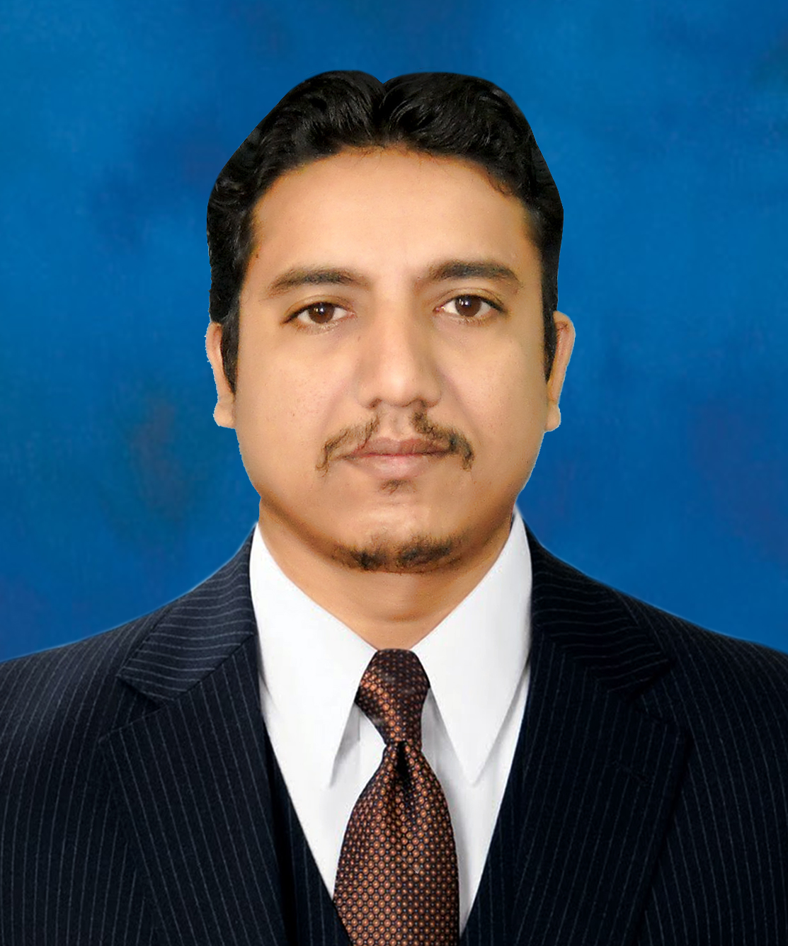
EDUCATION M.B.A (Marketing) 2007
B.A (Education) 2002
F.Sc (Pre- Engineering) 1999

Matric (Science) 1996

OTHER
QUALIFICATION DIPLOMA IN DISPENSER
(Sindh Medical Faculty)

INFORMATION TECHNOLOGY
(06 Months Certification Course)

PROFESSIONAL HTV
EXPERIENCE (Manager Sales Pharma and Events)
09th March, 2015 to till date

MAXIM INTERNATIONAL
(ME PHARMA), KARACHI
(SALES MANAGER)
04th July, 2011 To 06th March, 2015
AREA: SINDH REGION
Job Description:
- Company Launching and Team Building
- Leading & Managing 04 DSM’s team
- Marketing, Planning, Branding
- Forecasting and Budgeting.

EAST WEST PHARMA
(ZONAL SALES MANAGER)
02nd Sept., 2008 To 12th June, 2011
Area: Karachi, Multan, Bhawalpur, D.G. Khan, Khanewal
Job Description:
- Supervising 03 District Managers
- Brand Management, Brands Launching
- Sales Targeting, Planning, Forecasting
- Obligation activities
- Exploring new territories
- Hiring of Professional and Fresh Sales Team
- Distribution allocation in different cities
- Demographically touring for the business

BEX PHARMA (BEXIMCO)
Asst. AREA SAES MANAGER
(01st June, 2003 To 30th Aug, 2008)
Area: Karachi, Hyderabad
Job Description:
- Starts career as MIO
- Achieving targets and get incentives
- Outstanding performance certificates
- Institutional working, products inductions in institutes
- Permoted as Group Leader

PERSONNEL
INFORMATION Father’s Name: Niaz.A.Shahid
D.O.B: 30th April, 1980
Religion: Islam (Sunni)
C.N.I.C# 42401-6506998-5
Passport# XU5149981
Martial Status: Married
Address: H-402-A, C-2, PAF Base Masroor,
Maripur Road, Karachi, 75750
Contact: +92-300-2359064,
+92-313-2176054
e-mail: shahjii80@gmail.com
shahjii_80@hotmail.com

Reference: will be submitting as per requirement.

