RESUME

SYED ADNAN SHAHID

OBJECTIVE Be Positive. Remain Positive. Always available for learning and try hard by heart for growth.
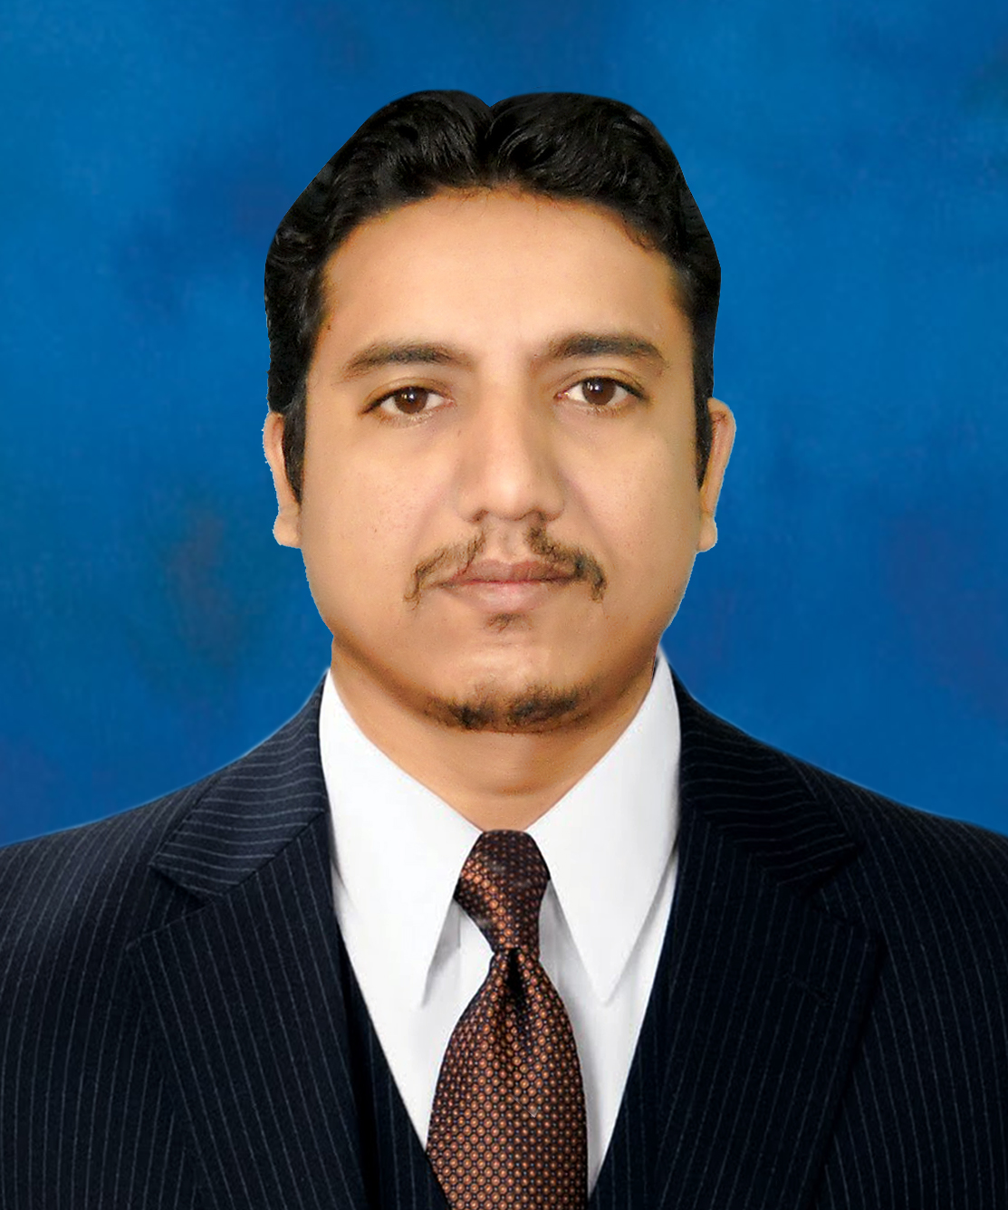
EDUCATION
M.B.A (Marketing) 2007
B.A 2002
F.Sc 1999

Matric 1996

OTHER
QUALIFICATION
DIPLOMA IN DISPENSER
(Sindh Medical Faculty)
DOW Medical College, Karachi

INFORMATION TECHNOLOGY
(06 Months Certification Course)
Sindh Board of technical education, Karachi

PROFESSIONAL EXPERIENCE


PARADIGM GROUP
(Project Manager/ Assistant Product Manager)
06th May, 2016 till now

JOB DESCRIPTION

- Business development (Nutraceutical and Pharmaceutical)
- Coordination and Assistance in product launch plans.
- Market Research
- Coordinate in Pricing Strategies.
- Understand targeted customers and Needs
- Brand management and developing marketing strategies to build them the brand
- Responsible for New Product launching
- Planning and designing promotional materials, tools to support the sales team
- Joint working with the field force to understand the market dynamics and demand, identifying market opportunities for brand building
- Monitor campaigns for sales promotion
- Train, motivate and guide the field force to ensure the continuous growth of the brand
- Sending regular motivational circulars to the field force
- Exploring new customers and areas on National level
- Organizing CME’s, Seminars, Media Marketing
- Event Management for cooperate and commercial clients
- Preparing survey reports


(Manager Sales Pharma and Events)
09th March, 2015 to till 05th May, 2016

AREA: National Level

JOB DESCRIPTION

- Open new segments in the field of ATL/BTL/TTL Mediums
- Health awareness programs and Public service messages recording from all over the Pakistan from opinion leaders
- Customer relation building with corporate/commercial clients
- Design different Proposal according to the clients
- Drive customers of Pharmaceutical and Nutraceuticals to the option of electronic, digital(social media) marketing
- Do CSR activities
- BTL activities (symposiums, seminars, CME’s, National and international conferences)
- TTL activities
- Took on board Top national and multinational companies
- Live and recorded shows, Testimonials, corporate documentaries, short motivational videos…etc
- Brand integration and endorsements strategies also product placement(Nutra/ Herbal)
- Customize branded LIVE shows on different “World Health awareness days”
- Part of 01st live transmission of Htv in Ramzan, 2015

ME PHARMA
(Sales and Marketing Manager)
04th July, 2011 To 06th March, 2015

AREA: SINDH and PUNJAB

JOB DESCRIPTION

- New Company Launching and Team Building
- Leading & Managing 04 DSM’s and SPO’s team
- Marketing and Planning
- Customers identification
- Distributions networking
- Supply chain management
- Salaries structures, incentive policies, increments policies, promotional materials, other marketing tools budgeting with cost effectiveness)
- Forecasting and Budgeting.
Note: It was a Franchise setup and third party manufacturing company. In this company I played openly and tested my skills and capabilities and gradually grow with the company.


(Zonal Sales Manager)
02nd Sept., 2008 To 12th June, 2011

AREA: Karachi, Central and South Punjab

JOB DESCRIPTION

- Supervising 03 District Managers
- Brand Management, Brands Launching
- Promote innovative and research Brands
- Sales Targeting, Planning, Forecasting
- Medical camping’s
- Exploration of new territories and identification of Customers
- Hiring of Professional and Fresh Sales Team
- Distributions Networking
- Demographically touring for the business


Asst. Area Sales Manager
(01st June, 2003 To 30th Aug, 2008)

AREA: Karachi, Hyderabad

- Started career as MIO
- Promote innovative and research Brands
- Promoted as Group Leader
- Achieved targets and get incentives
- Outstanding performance certificates
- Attend training programs on Sales Management
- Attend self-grooming workshops
- Institutional working, products inductions in institutes
- Promoted as Asstt. Area Sales Manager

INTER-PERSONAL SKILLS

- Honesty, Sincerity, and Loyalty
- Leadership
- Team Building, Team Player
- Self-Motivation, determination and good Motivator
- Strong communication (Negotiator and good listener)
- Decision Making
- Conflict Management
- Flexible and creative
- Persistence and will power
- Result oriented
- Well aware of Cultural, social values, and customs
- Regard and own internal and external customers
- Strong Follow-up
- Good learner

PERSONNEL INFORMATION

Father’s Name : Niaz.A.Shahid (Late)
D.O.B : 30th April, 1980
Religion : Islam (Sunni)
C.N.I.C # 42401-6506998-5
Passport # XU5149981
Marital Status : Married
Address : M-II, F-253, Hajji Rauf building,
SITE area, Shershah road, Gulbai village, Karachi
Contact : +92-300-2359064
E-mail : shahjii80@gmail.com

