SyedBilalKazim

Mob: +92333-2352148; Email: bilalkazim@yahoo.com
Areas of Expertise  - Customer Service  - Sales & Marketing  - Operations Management  - Business Development  - Team Player and target achiever.  - Training  - Documentation  - Team Management.  - Marketing  Personality Traits  - Persuasive Communicator:  Effective communication ability; can achieve clarity and persuasively secures buy-in and commitment.  - Strategic Thinker:  Proven ability of developing insightful strategies, focusing on capabilities and converting potential into opportunities.  - Committed and Positive:  Positive Thinker; overcomes rejections. Committed in achieving results with dedication and passion to work hard.  Education  - MBA – International Business, University Wales Institute of Cardiff (UK) 2008-09  - BS- Computer Sceince, PIMSAT 2000-03  Languages  - English – Fluent  - Urdu/Hindi – Native |  | Sales and Marketing Professional  Professional Summary:  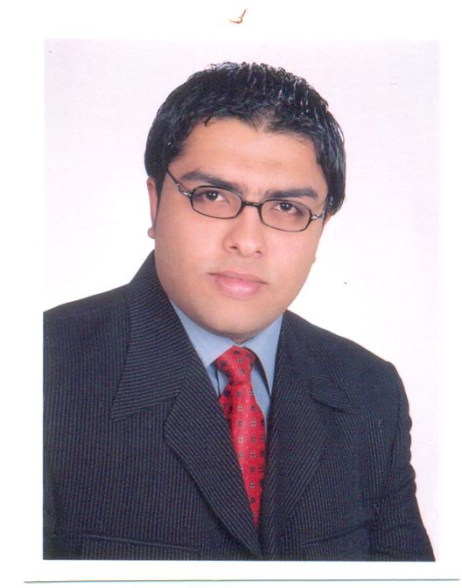  A sales & marketing professional with 8 years of diversified occurrence in managing key sales initiatives for leading corporate entities in the Pharmaceutical industry with innovative marketing tactics, I’m a business Post graduate with a ‘Can Do’ attitude. Having outstanding filing and organizational skills. Eagerness to productive work, handle to work in pressure and punctuality are my key skills. Good communications skills, easily interacts with executives, clients, staff and always ready to take challenging assignments.  Functional Skills  Client Relationship Management:  - Focusing on maximum customer satisfaction by closely interacting with the customers to understand their requirements and delivering high-value services.  Sales & Marketing:  - Overseeing sales operations for achieving increased growth profitability.  - Driving sales efforts involving effective promotional activities, product awareness with high potential clients for growth and profitability.  - Tracking competitor activities and providing valuable inputs for fine tuning the selling and the marketing strategies.  - Development of new brands with innovative launches, analytical sales planning, designed sales development tools, marketing tactics, increase productivity, thereby improve profitability  Operations Management:  - Suggest and Implement policies & procedures for assigned business unit within the framework of corporate policy.  - Provide support to any number of projects.

Career Accountabilities

Medicraft Pharma Pvt Ltd

Assistant Product Manager – (Oct 2009 to till date)

Key Result Areas: Customer Handling ~ Time Management ~ Team Management ~ Operation Management ~ Strategic Marketing~ Portfolio Management

- Head a team of 6 sales representatives.
- Managing antibiotic and general portfolio.
- Responsible for the antibiotic / general products i.e Bactirid (Cefixime/ suspension), Esobest (Esomeprazole), Ctzine (Cetirizine) and Nap (Naproxen)
- Ensuring the qualitative and quantitative objectives by achieving the monthly, quarterly and yearly targets through the strategies and marketing support by the company
- Mainly responsible for increasing the volume of business, planning of sales and marketing strategy, monitoring sales officer activities.
- Delivered a high quality and efficient service to the customers in order to build Relationships and increase profit of the company.
- Prepared and executed marketing strategies and monthly marketing budget plans.
- Developed advertising and promotional activities of consumer as well as Pharma portfolio.
- Engaged in developing and implementing the company's corporate strategy and operations in assigned segments, both from a business, sales and technical perspective.
- Managed the production and distribution of marketing materials.
- Developed leaflets, posters, table talkers, newsletters and e-newsletters.
- Conducted market research using communication tools such as customer comment cards and internet networking websites.
- Evaluated marketing campaigns; Monitored competitor activities.
- Evaluation of ROI; Supported the Director in business development projects.
- Monitored complete aspects of external events including branding, placement of holdings, wobblers and sign boards.
- Managed and developed promotional activities of internal monthly events, including incentives, bonus and distribution network.
- Solely responsible for managing the privilege card programs, managed the customer feedback programs.

EXPERIENCE AS FACULTY

Visiting Faculty, Faculty of Management Sciences in Khadim Ali Shah Bukhari Institute of Technology, Karachi, Pakistan….. November 2014 - To Date

METHODS OF TEACHING & RESEARCH

- Providing students a pragmatic exposure of academic measures through class discussions, guest speaker sessions, corporate visits to reputable personalities and business sites.
- Providing local exposure of corporate sector in Pakistani environment
- Supervising students’ projects for MBA, MS and MPhil levels with special concerns and strict monitoring of plagiarism.
- Making well responsive, social and professional relationship with the students and coworkers.

COURSES TAUGHT

- Principles of Management, (MBA)
- Introduction to Business, (MBA)
- Seminar in Marketing (MPHIL, MS)
- Principles of Marketing (MBA)

- PIZZA HUT (UK)

Support/Shift Manager (July 2006 to June 2009)

02 Year & 11 Months

Key Result Areas: Customer Handling ~ Time Management ~ Team Management ~ Operation Management
- Responsible for restaurant operations during assigned shifts, including opening & closing restaurant.
- Monitor and Manage cash management issue.
- Monitor and control the FOH and BOH operation.
- Follow the procedures for cash reporting, inventory control, FOH & BOH staff scheduling.
- Follow the food storage procedures (MRD) during shift.
- Directed, trained and motivated team members during shift.
- Comply with compliance of government regulations, food safety, National Security Policy, operational policies and procedures relating to all activities in the restaurant during the shift.
- Ensure customers aware of offers on our deals.
- Delegated in a way that encouraged team to work together during shift to ensure the restaurant operates to company standards.

- WARID TELECOM (PVT) LTD – (Pakistan)

Sales & Marketing Executive – (March 2005 to May 2006)

01 Year & 02 Months

Key Result Areas: Customer Service ~ Sales ~ Business Development Management ~ Marketing ~ Training & Development

- Was mainly responsible for increasing the volume of business, planning of sales strategy, monitoring sales team.
- Delivered a high quality and efficient service to the customers in order to build Relationships and increase profit of the company.
- Negotiating and convincing the customer by giving them suggestions, different options and discounts.
- Finalized the deals and feed necessary details in the system.
- Directed all sales and marketing activities, including lead generation.
- Contributed to the effective work of team through communicating and sharing information to build Successful working atmosphere.
- Head a team of 6 sales staff.
- Prepared performance reports of Sales Team member.
- As a team leader oversaw a corporate and individual sales.
- As a team leader planning of sales strategy, monitoring sales team. Increasing the volume of business by initiating and finagling sales deals.
- To develop new customized packages/ marketing strategies in order to cater the dynamics of the market.
- Designed and Implemented new policies for the assigned Business Unit.
- To contact fresh and freeze customers for the enhancement of sales activities and targets.
- Coordinated and Reported to Senior Manager for day- to-day management of different tasks.
- Provided orientation and training to the new hires.
- As a team leader arranged the brainstorming and motivation activities.

Specialized Skills

- Excellent data, time and task management abilities
- Ability to work efficiently and multi-task in pressured environment.
- Excellent Interpersonal, Communication and Customer Service Skills

Punctual and Flexible to work in shifts
- Technically proficient in MS Office and good command over Windows Applications and Internet
- Motivational and Development Skills.
- Presentation and Communication Skills.

Training & Workshops

- Strategy development & Brain Storming Sessions.
- Time Management.
- Project Management.
- Planning Management.
- Attended many training sessions related to improving Communication & Marketing skills.

Personal Information

- Date Of Birth: 01-Nov-1980
- Nationality: Pakistan

References can be furnished upon request

