Dear Sir,

Greetings,

My career outlined in the enclosed CV is marked by abilities and skills developed by the strong work ethics based on the diversified culture working environment that lead to an additional career growth, where professional prowess can be unleashed for value addition in the organization.

An enthusiastic, self-motivated, multitasking with leadership qualities in 35years, an MBA majors in Marketing from leading business school Iqra University. Around Sixteen (16) years of professional experience of Sales & Marketing (with companies like EPLA Labs, UDL Group, HIMONT Group & Uniferoz, Bioderma) makes me professionally sound and considerate value addition for the company.

An experience, which gives me an in-depth understanding of diversified industry’s sales management, brand & product management, business operations, channel management, trade marketing, POS, merchandising, time management, contracts or contacts management, human capabilities and its limitations, have worked in all the major cities of Pakistan with extensive traveling, contributed from annual budgeting to tactical goals achievements.

Attended training that helped to develop & nurture both professional & personally.

- Sales & Relationship Building By Speaker Baseer Sami (UNIFEROZ) AUG-2015 KARACHI
- Selling Skills & Coaching Training & Workshop By Innovara (BIODERMA) AUG-2015 KARACHI
- Brand Manager’s Training & Work Shop (BIODERMA) FEB-2015 ABU DUBAI
- Brand Manager’s Training & Work Shop (BIODERMA) JULY-2014 DUBAI
- Impact Of Communication By Speaker Baseer Sami (UNIFEROZ) OCT-2014 LAHORE
- Culture Of Execution By A Motivational Speaker Puri (HIMONT ) JULY-2013 LAHORE

Seeking to be a part of an organization’s Marketing Team, works for the community development that is driven to excellence and promote professional development based on an employee’s dedication, team commitment, adaptability and professionalism.

At your convenience, we can discuss things across the table like highly effective people and can create win-win situation.

Thank you in advance for the professional courtesy in reviewing my profile.

Looking fast forward to hearing from you.

Truly yours,

Syed Farhan Ahmed,

Karachi, Pakistan
+92-301-8221724 (official)
+92-344-2557032 (private)

Email : syed_farhan80@hotmail.com
Skype : farhanahmed_786
Web : http://www.linkedin.com/profile/view?id=10666583&trk=tab_pro

To Contribute & Add Value in the Growth and Success of the Organization

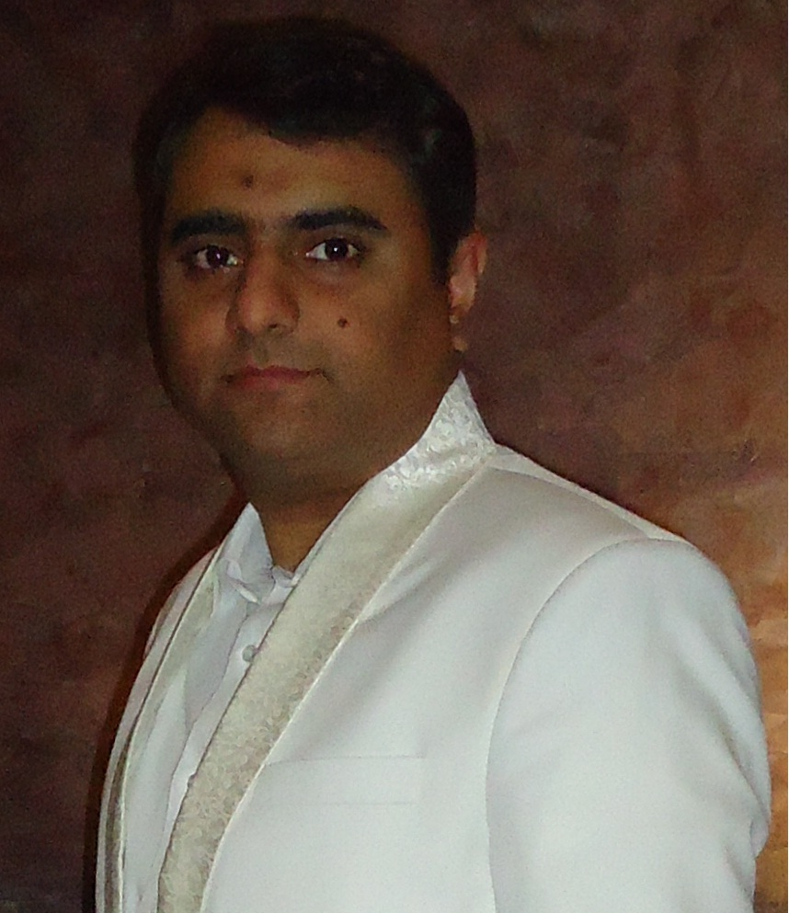
Name | SYED FARHAN AHMED
Age / DoB | 35 Years / October 16, 1980
Marital Status | Married, Two Daughter
Address | Marium Heights, Flat.102, Plot.Z-10 KMCHS, Karachi
Mobile | +92 -344-2557032 / +92-301-8221724
E-mail address | syed_farhan80@hotmail.com

Professional Experience

Concern | Period |  | Duration | Designation
Concern | From | To | Years
UNIFEROZ Pvt. Ltd,  Karachi, Pakistan www.uniferoz.com | 05-Dec-13 | To date | 02+ Years | Business Manager  (Skin Care Division - Bioderma)
HIMONT Group  Lahore, PAK  www.himont.com | May-2012 | Sept-2013 | 2 Years | National Distribution  & Trade Sales Manager
UDL Group  Karachi, PAK  www.udld.biz | Mar-2009 | May-2012 | 3 ½ Years | Business Manager
EPLA Laboratories (Pvt.) Ltd. Karachi, PAK  www.epla-labs.com | Jul-2006 | Mar-2009 | 9 ½ Years | National Sales Manager
EPLA Laboratories (Pvt.) Ltd. Karachi, PAK | July-2004 | June-2006 | 9 ½ Years | Sales Manager
EPLA Laboratories (Pvt.) Ltd. Karachi, PAK | July-2002 | June-2004 | 9 ½ Years | Assistant/Area Sales Manager (ASM)
EPLA Laboratories (Pvt.) Ltd. Karachi, PAK | Jan-2002 | June-2002 | 9 ½ Years | Medical Rep. / SPO
EPLA Laboratories (Pvt.) Ltd. Karachi, PAK | Sept-1999 | Dec-2001 | 9 ½ Years | Trainee Sales Officer / Medical Rep.

ACADEMIC CONFERRED IN

☞ M.B.A. in Marketing from IQRA University, KHI - PK May – 2007
☞ Bachelor in Commerce from University of Karachi, KHI - PK Aug – 2001
☞ Intermediate in Commerce from Premier Govt. Coll. KHI - PK July – 1998
☞ S.S.C from Little Folk’s School, KHI - PK Mar – 1996

= Uniferoz Pvt. Ltd., Karachi =

Working on a National Level as BUSINESS MANAGER (Head of Sales & Marketing) for Skin Care Division along its Sales Management, Brand & Product Management on National Level for the last approximately 2 ½ years.

BIODERMA, FRANCE (Skin Care Products) is a strategic business partner with UNIFEROZ in Pakistan.

In 2014, Launched Bioderma (skin care products) from the platform of Uniferoz Pharm in 2014, and working as BIODERMA TRAINED BUSINESS MANAGER & leading Sales & Brand Activities, POS, MERCHANDISING for the specialized division and interaction with over 150 KOLs/Consultants in Skin Care/Dermatology across the country particularly in Karachi / Lahore / Islamabad.

Engaged with Consumer team for IMTs & LMTs better penetration in the consumer segment as well with presence of Brand Ambassadors (as Beauty Advisors) placed on leading stores on leading stores.

Also actively engaged in Digital Marketing & Social Media Activation, Brand Management, Sales Management, Beauty Advisor’s Project, Merchandizing, POS activation, KOL Management & Development, Leadership, Team Building, Value addition in business processes are the Key Performance Indicators (KPI).

Projects in Placed
- Monitoring Beauty Advisor Project (In Shop Promoters).
- Social Media & Digital Activation on Facebook
- Leading project “Optimization Consumer Connect”
- Developing & Monitoring POS & Merchandizing.
- Executing Skin Awareness Campaigns

= BIODERMA TRAININGS ATTENDED IN 2014 & 2015 =

- SELLING SKILLS & COACHING TRAINING WORKSHOP BY INNOVARA INC (BIODERMA) AUG-2015 KARACHI
- BRAND MANAGER’S TRAINING & WORK SHOP (BIODERMA) FEB-2015 ABU DUBAI
- BRAND MANAGER’S TRAINING & WORK SHOP (BIODERMA) JULY-2014 DUBAI

- Awarded “Bioderma Most Dynamic Team” in 2014 by BIODERMA LABORATOIRE, FRANCE
- Awarded “Bioderma Country Launch Evolution” in 2015 by BIODERMA LABORATOIRE, FRANCE

= Himont Pharmaceutical Group =

Worked for Himont Group (www.himont.com), managed Sales Team, Distributed Sales Team, Merchandizing Team (FMCG Brands), Customer Services, Distribution Demand Planning, Logistics handling, Inventory Controlling, Key Account Management, Pre & Post Product Launch activities, Branches Sales & Operations, Sales Force Effectiveness, Market Research, Sales Analyzer, Human Resource Talent Management, Cash flow management & value addition in business processes.

To achieve Sales targets with extensive product availability/visibility and generate business from existing sales pockets and create new pockets of business in close coordination with Sales Team (SPO/ DSM / SM / GM).

Plan, prioritize and schedule the Merchandizing Team activities for FMCG/OTC Brands so that resources are used effectively and that work schedules and targets are met. Responsible for planning, organizing, developing, directing & controlling the merchandizing division for BRAND ACTIVATION, its ATL & BTL activities by collaborating with the principles.

Gather Market intelligence and vigilance by frequently visiting the market in order to detect and prevent any sort of infiltration and conflicts in the sales functions.

Strongly Liaise with other organizational functions to ensure Distribution & sales administration activities are integrated with other parts of the business and appropriate for current and future sales activities.
Monitor the status of sales administration activities to identify problem areas and adapt procedures to improve the overall performance of the system & team.

I travelled extensively i.e. 60% of the month in this role across the country and have regular and frequent follow up with Sales Team, Merchandisers, and Regional Distributors, Business Partners.

Member of Cross Functional Teams:
- Member of Production Planning Committee
- Member of Executive Sales Review Committee
- Member of Synergy Meet. (all SMs/NSM/NDM/GM/DM)

= UDL Group of Distribution & Marketing (Pvt.) Ltd, Karachi - Pakistan

Managed Pharma business portfolios of KEY ACCOUNTS B|BRAUN Pakistan Ltd., / ICI Life Sciences / Morinaga Infant Milk / Sante Pharma Pvt Ltd/ Highnoon Labs Pvt Ltd, at UDL Pharma Distribution & Marketing Group on National Level. Sales, Branch Operations, Procurement, Inventory & Cash Flow Management of all above accounts.

Managed & Lead Sales Force & Supply Chain Team, commercial activities with RETAIL, WHOLESALES & HOSPITALS/ INSTITUTIONS, Regional Distribution in strong liaison with above Principal’s Sales Team for effective & efficient execution of Sales Plans, Promotional & Merchandising activities for the accomplishment of the Company’s Targets & Objectives.

Coordinated with other company’s Departmental functions i.e. 20 Branch Offices, Operations, Treasury, Accounts, Finance, Logistics providers & clearing agents.

Delivered best practices in the area of expertise in Sales management, Supply Chain, Accounting, Logistics effectiveness, Cash flow management and reported to Director Sales.

= EXPERIENCE @ EPLA Laboratories (Pvt.) Ltd, Karachi - Pakistan

- Managed, Lead & Controlled SALES TEAM of Medical Raps and Area Managers/Field Managers.
- Promoted products in the segments of Gastroenterology, Pulmonology, Dermatology, Gynecology, Psychiatry, Diabetology & Rheumatology.
- Focus on product's promotion & keep in touch with KOL for prescription generation
- Explored, managed & developed the Key Sales Accounts with KYC strategy (consists of Private / Public / NGO’s / Govt/Defense organizations & maintained good cordial business relationships with the decision makers/consultants/departmental heads. Handling Tender business.
- Actively participated in organizing events like CMEs, RTMs, conferences, symposiums, and seminars.
- Planned, prepared SKU wise budgets with great understanding to execute it with excellence to meet objectives.
- Negotiating Local Purchase contracts & tender business details, manage the efficient performance of the contracts binding.
- Launched a FMCG brand in the new & unique mosquito repellent category (patented product, imported from Italy) in Pakistan and extensive efforts put in for the effective brand activation thru ATL & BTL activities.
- Engaged, developed and implemented successful sales promotional strategies, advertisements & promotional plan and managing them successfully. Kept close eye on the competitive activities to evaluate brand performance.
- Traveled extensively within the geographical boundaries of the country.

= MARKETING SERVICES =
- To assist Sales & Marketing Head and to cooperate all his colleagues for smooth functioning of Marketing & Sales Department.
- To visualize promotional materials in a manner which match the product with the market segments. Also to provide detailing strategies and instructions to the Field Force so that a national detailing pattern is evolved which ensures promotion in the targeted segment of Doctors.
- To evaluate Field Force performance & propose corrective measures to Sales & Marketing Manager.
- To evaluate product performance & behavior in the field visa-avis promotional materials.
- To formulate survey protocols, conduct market surveys, compile survey results, comment on these, to give observation and suggestions.
- Focus on product's promotion & keep in touch with KOL for prescription generation.
- To arrange & organize Business Meetings, Sales Conferences, Symposia and Inter Departmental Meetings, duly intimated with the need & time.
- To forecast sales objectives and budgeting of promotional expenses in consultation with Sales & Marketing Head.
- Also to assist S&M Head in the preparation of Plans & Workout on Annual/Half Yearly/Quarterly unit wise forecast and sales of the assigned forecast.
- Engage in the deployment & implementation of the successful Sales Promotional Strategies & Promotional Plans.
- To coordinate with Material Manager, Production Manager regarding Production Planning, Sales, Samples Stock requirements, and SKU Stock inventories as per corporate policy.
- Traveled extensively within the geographical boundaries of the countries.

= ACKNOWLEDGEMENTS=
  - Awarded “Bioderma Most Dynamic Team” in 2014 by BIODERMA LABORATOIRE, FRANCE
  - Awarded “Bioderma Country Launch Evolution” in 2015 by BIODERMA LABORATOIRE, FRANCE
  - Achieved 97% Sales Target for the Financial Year 2007-2008.
  - Received Letter of Appreciation in July 2007 on the achievement of 100% sales target of FY 2006-2007.
  - Received Letter of Appreciation in July-2004 (FY 2003-2004) on the outstanding 100% result oriented performance with high spirit, professional attitude and mutual cooperation.
  - Received Letter of Appreciation in April-2004 upon conducting the successful armed forces (DGDP-Army) inspection of the plant with effective communication & strong coordination.

- Rated highest over the period of time in the segment of :
(1) Quality of Work
(2) Communication
(3) Resourcefulness
(4) Initiatives
(5) Job related skills
(6) Decision Making
(7) Time Management
(8) Interpersonal relationships.

= PROFESSIONAL ACHIEVEMENTS=

- Training Coordinator-Sales: Conducted Training Sessions for Sales Force / Medical Representatives.
- Team Leader - Supply Chain Management: Selected & worked as a team member on behalf of the Sales & Marketing Department in the implementation phase of SCM System in the company.
- Regulatory Affairs (MOH), dealt with company’s regulatory matters at EPLA Lab, Pvt Ltd., Karachi Pakistan
- Training attended: Bioderma Brand Managers Meet in Abu Dhabi in 2014.
- Work Shop attended on 5 subjects in 2014 in Abu Dhabi.
- Training attended : Beauty Advisor Project (Sleeping Beauty), POS Implementations, Digital Marketing, Brand Management in Rasul Khaimah, DUBAI Feb-2015.

=COMPUTER SKILLS=
- Worked in ERP environment of ORACLE.
- MS Word, MS Excel, Power Points & MS Outlook, Window based operating system.
- Well aware & operated in the environment of researched based software of SCM by Sidat Hyder/Consultant.

=PRINCIPLES OF LIFE=
- Integrity
- Truthfulness,
- Honesty
- Sincerity & commitment to work
- Flexible & adaptable

= INTERESTS & HOBBIES=
- Newspaper (current affairs/politics/economics/commerce & business/entertainment)
- Social Networking & Blogging
- Researched Articles/Talk shows/Global evolution
- Magazines (commerce /economics /politics)
- Economic Survey reports and its impact on the region.

= TRAINING ATTENDED IN 2014 & 2015 =

- Sales & Relationship Building By Speaker Baseer Sami (UNIFEROZ) AUG-2015 KARACHI
- Selling Skills & Coaching Training & Workshop By Innovara (BIODERMA) AUG-2015 KARACHI
- Brand Manager’s Training & Work Shop (BIODERMA) FEB-2015 ABU DUBAI
- Brand Manager’s Training & Work Shop (BIODERMA) JULY-2014 DUBAI
- Impact Of Communication By Speaker Baseer Sami (UNIFEROZ) OCT-2014 LAHORE
- Culture Of Execution By A Motivational Speaker Puri (HIMONT ) JULY-2013 LAHORE
- Supply Chain & Distribution Meet (B.BRAUN) FEB-2011 EGYPT
- Supply Chain & Distribution Meet (B.BRAUN) FEB-2010 UZBEKISTAN
- Selling Skills (EPLA) JUNE-2002 PAKISTAN

=PERSONAL REFERENCES=

Reference would be furnished upon request.

