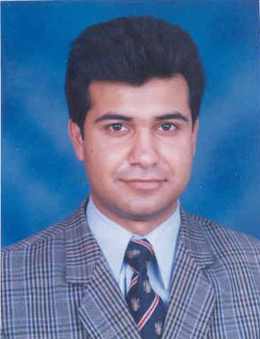
SYED ZAFAR ALI SHAH
0321-4034007,0345-4119006
House No.492-A, Eden Lane Villas II, Defence Road, Lahore.

PROFESSIONAL OBJECTIVE

Growth oriented position where abilities, education and potential can be most productively utilized toward achievement of company and personal goals. To purse a decision level position in the field of marketing and management in a reputable organization.

SUMMARY OF QUALIFICATIONS

- Bachelor of Commerce 1994 (University of the Punjab, Lahore)

COMPUTER LITERACY:
Have Reasonable Knowledge of

- Ms Word 2000.XP
- Ms Excel 2000. XP
- Ms Windows 2000 professional, XP
- You can better utilize my services under
your special instructions.

PROFESSIONAL EXPERIENCE

August 1997 to April 2000

Worked with M/s Digital Radio Paging Ltd., Lahore as Service Coordinator.

Responsibilities:

Coordinate with customers on phone and solve their problems.

May 2000 to March 2007
Worked with M/s. Balcom (Pvt.) Ltd., (Citi Call), Lahore as Cash Recovery Officer.

Responsibilities:

- Recovery of cash.
- Marketing.
- Card sales handling.
May 2007 to April 2015

Worked with M/s Star Laboratories Private Limited (Pharmaceutical Company) as
Area Sales Manager Lahore.

Responsibilities:
.
. Supervising the team of “Sales Promotion Officers “as well as achievement
of individual sales targets.
. To assist Regional Manager in monthly reporting and decision making
process.

April 2015 till Date

Working with Titlis Pharmaceutical Private Limited as District Field Manager Lahore

. Head of the Lahore Team of Sales Promotion Officers
. Launching new Products

PERSONAL INFORMATION

Father’s Name : Syed Anwar Ali Shah (Late)
Date of Birth : 23rd May, 1973
NIC No. : 35202-3565953-9
Domicile : Lahore
Religion : Islam
E-Mail Address : zafar_shah54@yahoo.com
ZafarAliShah5@gmail.com

