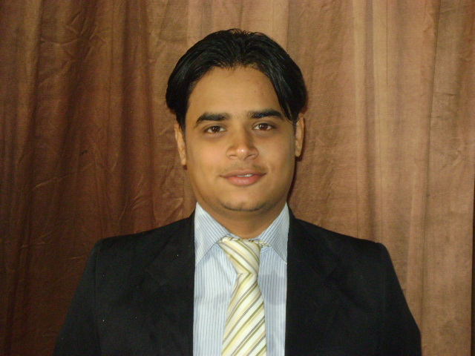 Curriculum vitae

UZAIR AHMED
Mobile: +923041920698
E-Mail: Uzair.freshmail@yahoo.com

FOR THE POST TRAINING MANAGER:

Respected Sir/Madam,

With due respect I have come to know through a reliable source that the position of Product Manager is lying vacant under your kind control. Therefore, my particulars are as under.
CAREER OBJECTIVES:

A position in the Field of Marketing, Product management where I can use my exceptional Marketing skills with innovative ideas, contemporary trends and best practices that create the significant difference in front of customers.

By using my ability to understand and convey complex information, self-motivation, entrepreneurial spirit and results driven work Trainings which ignite market share and grow a career in an organization.

MASTERS IN BUSINESS ADMINISTRATION
FROM
Iqra University
With MARKETING MAJOR -
With exceptional performance in

Marketing Management
- Strategic Management
- Channel and Distribution Management
- Advertising & Brand Management
- Supply chain Management
- Strategic Marketing Management

EDUCATIONAL ATTAINMENTS:

- Graduation : (Bachelor of Science) Year 2007-08.
University of Karachi, Pakistan.-
SUBJECT: STATISTICS
- Intermediate : Intermediate science Year 2004-05
Board of intermediate Karachi
Pre-Engineering

COMPUTER LITERACY:

- SPSS (Statistical Package for the Social Sciences) (Quantitative Analysis software)
- Minitab (Statistics Package)
- Having good hand on Ms Word, Excel, and Power point.

EMPLOYMENTS HISTORY



MERCK SERONO Pharmaceutical (PVT) LTD. As a Medical Information Executive

Position: Medical Information Executive (M.I.E).
Period: Nov 2009 to present.

JOB DESCRIPTION MERCK SERONO
- Responsible to promote products to the targeted doctors.
- Sales analysis on territory levels and on micro levels & sales presentations
- To establish maximum prescriptions of our targeted products.
- To arrange product group meeting with doctors to discuss product detail.
- To strong follow up all weekly as well monthly work plan.
- Daily planning and schedule maintenance as well as competitors updates
- To planning and implementing sales promotion Activities.
- Application of UPACA and GROW and OSCAR models
- To assure positive growth compare to last year as per policy and as per yearly objectives
- KOL’s development

ACHEIVEMENTS:
- Best MIE Runner up prize on highest growth with achievements setting new milestones in 2012
- Get an appreciation latter upon highest performance in Karachi achieving new heights in 1st quarter 2012
- Get an appreciation on continuous growth on prime brand at Bangkok
- Get an appreciation on continuous feedbacks and competitors’ activities to the marketing department 2010
- Get an appreciation on suggestion on promotion ,many suggestion are practically applied by management
- Get an appreciation latter on my work from MERCK SERONO in a just sixth month of my career.
- Get first prize on detailing , best communicator competitions at quarter 1,2 2011 and quarter 2 2012
- Get first prize on detailing , best communicator competitions at quarter 1,2 2011 and quarter 2 2015
INTEREST:

- To read Books, Articles, Newspapers on Verity of Topics
- To browse web pages on relevant professional information
- Current Affairs, International Affairs and History.
- Training and Development
- Human psychology, Business processes reengineering studies

PERSONAL AND PROFASSIONAL SKILLS:

- Effective and efficient in managing resources and people
- Confident – Excellent verbal communication skills and good interpersonal skills.
- Persuasive with strong presentation skills.
- Innovative and target oriented with good marketing mind
- Ability to Transform my competencies ,knowledge and skills
- A capable to mold under any circumstances

PERSONAL INFORMATION:
- Date of Birth : 22-09-1987
- Father Name : Gulzar Ahmed
- Marital Status : Single
- Nationality : Pakistani
- Address : F-18 Alnaseer square F.B.Area Block 1 , Sharifabad ,Karachi.

