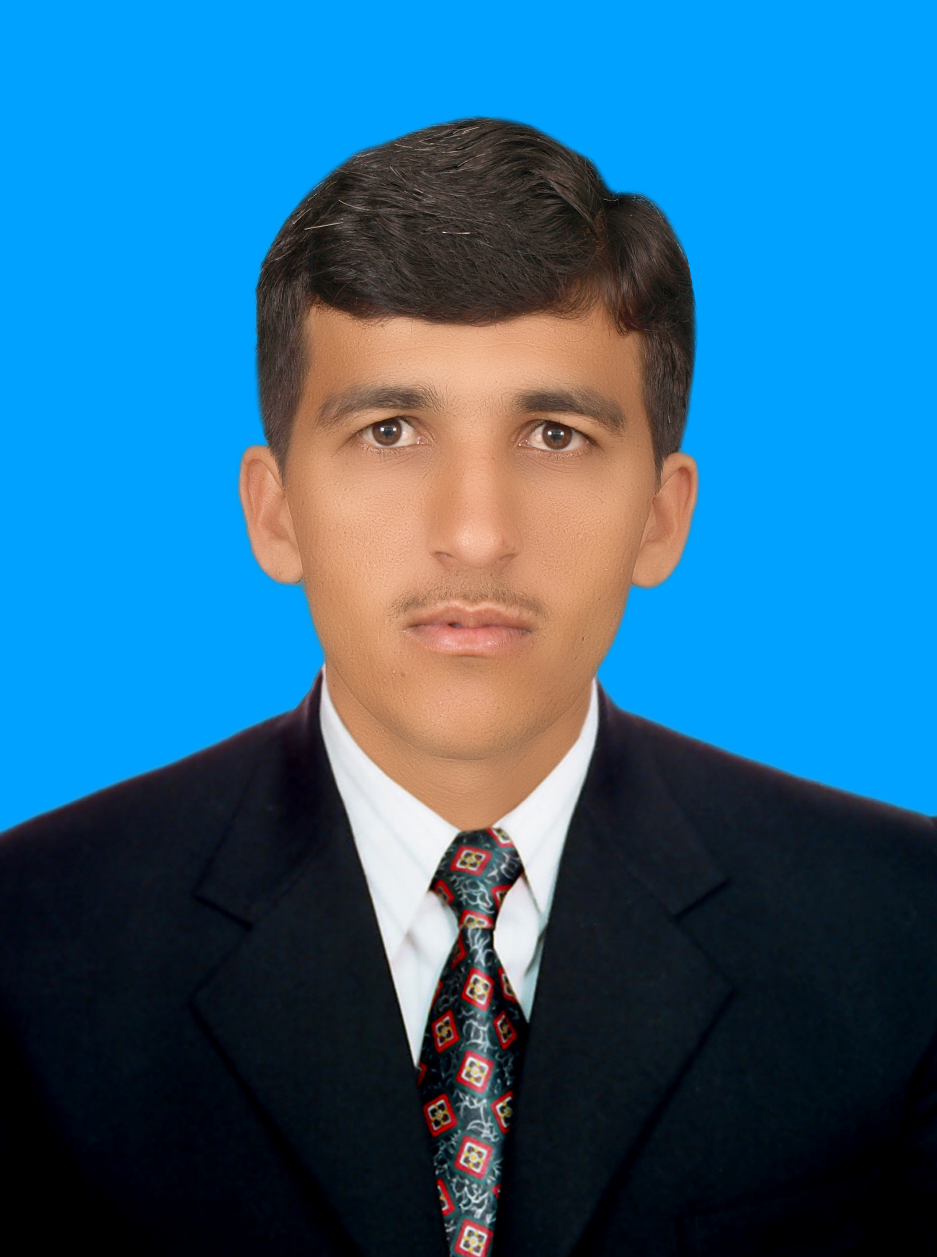
Curriculum Vitae

WAJID ULLAH
Mailing Address:
Village Mona khil p/o Shanawa Gudi khil Tehsil
takht_e_ Nusrati District Karak KPK Pakistan
Current Address:
House no#15 Street no#17 Gardan Town Khana Dhak New Shakarial Islam Abad.
Mob# 0347-9423945
0331-9172826

Email address: wajidkhattak81@yahoo.com

OBJECTIVE
To seek a career position in a progressive organization which should be challenging and demanding where I can practice my repertoire and learnt new skills.

PERSONAL INFORMATION

- Father’s Name : Mir Azad Khan
- Date of Birth : 03-05-1989
- C.N.I.C # : 14203-9818654-1
- Domicile : Karak (KPK)
- Nationality : Pakistani
- Religion : Islam
- Marital Status : Married

ACADEMIC QUALIFICATION

EXAM | YEAR | MARKS | %age | BOARD / UNIVERSITY
S.S.C | 2005 | 789/1050 | 74.62 | B.I.S.E Kohat Board
F.SC | 2007 | 806/1100 | 73.81 | B.I.S.E Kohat Board
Pharm-D | 2008-2013 | Pharm-D | 64% | Faculty Of Pharmacy Gomal University D.I.Khan

MAJOR SUBJECTS:________________________________________________________

- Pharmaceutics
- Pharmaceutical Chemistry (Organic chemistry, Analytical Chemistry and Medicinal Chemistry)
- Basic Medical Sciences (Pharmacology, Microbiology, Physiology and Anatomy)

COMPUTER SKILLS:___________________________________________________

- Ms Office
- Ms Excel
- Ms Word
- Window XP
- Internet

PROFESSIONAL SKILLS

- Currently I am working in Lund beck Pakistan as a product specialist from 1st July 2015 up to still………
- 1st Position in Detailing Presentation during cycle meeting in Lund beck Pakistan at Serena Islamabad.
- Good knowledge about products.
- Good Communication skills.
- Excellent Discipline & hard worker
- I have one year & six month experience in Getz pharmaceutical as a medical representative in RGH Belt Rawalpindi.
- 1st position in presentation competition in NIT in Getz Pharma at Karachi.
- 95% marks in written test in NIT in Getz Pharma at Karachi.
- I have five years’ experience in Naseeb & Brothers Medical Wholesale as a retail pharmacist at Teri Karak KPK.
- 45 days clinical internship in 4th proff.in HMC Hospital
(KPK).
- 45 days clinical internship in 5th proff. in DHQ Hospital Karak (KPK)
- 63 days industry internship in 4th proff in Glitz Pharmaceutical Islam Abad

COMMUNICATION SKILLS:

- English
- Urdu
- Pashto

