Waqas Masood  House No. 106, Gulfishan Street,  Gulgasht Colony, Multan.  Cell: 0300-6354594 | 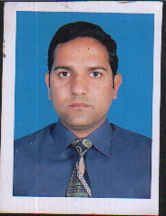
Objective
Prove myself as responsible, valuable and trustworthy member of the professional team by continues learning and hard work. Seek a challenging within an Organization/Company offering. Excellent prospects for career growth and personal development.
Personal Information
Father’s Name : Shikh Masood Ahmad
Date of Birth : 22-02-1977
NIC No. : 36302-1098351-9
Domicile : Multan (Punjab)
Nationality : Pakistani
Marital Status : Married
Religion : Islam
Qualification
M.Sc.
Computer Skills
- Basic Knowledge of Computer
Experience
- Sep 2014 to May 2016 in Scotmann Pharma as Area Sales Manager.
- Apr 2011 to Sep 2014 in Amson Pharma as Field Manager Multan.
- Feb 2007 to Apr 2011 in Sami Pharma as MIO in Multan.
- Dec 2003 to Feb 2007 in Macter Pharma as a SSPO

Attributes
- Hard worker, and smart worker, honest loyal, having objective personalities.
Hobbies
- Reading Newspaper
- Reading Books
References
- Will be furnished on demand.

