Zafar Ali  Bsc.(Bot,Zoo,Che) |  |  |  |  |  |  |  |  |  | 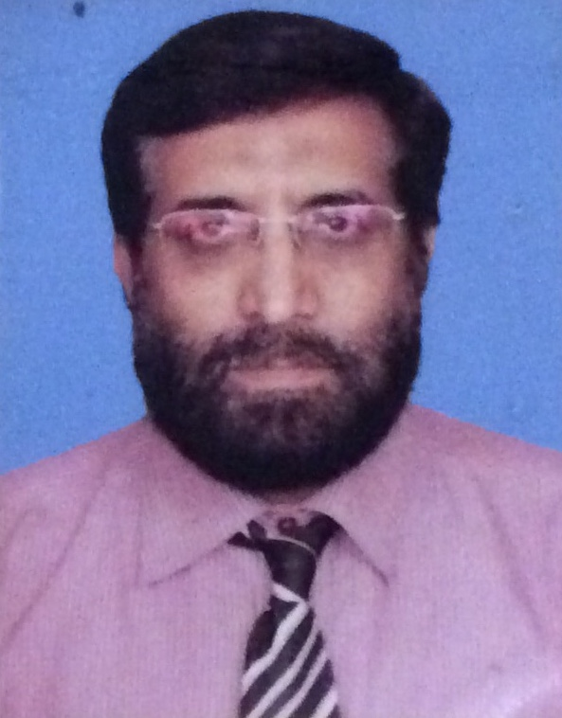

Professional Resume
Date of Birth: | 08 | - | 06 |  | - | 1963 | Age: | 52 years
Address: | 4/A Al Falah society Malir halt Karachi, Pakistan.  Permanent Add G-617,johar Town Lahore
Contact: | Cell: |  |  | +92 3008294167
Email(s): | zafaralligsk@yahoo.com

Objective: | To work with large and reputed organizations having sound foundations & Co-Operative working environment where challenging opportunities exists with good compensation, benefits & future prospects.

Current Status:
Organization: | GlaxoSmithKline
Organization Type: | Pharmaceutical Company
Designation: | Sales Manager
Brief Job Description | covering south zone (Sindh, Baluchistan & some Punjab)

Experience
Sales Manager GSK
1st Nov,2010 -21st Aug,2015
I was looking after south zone .
Geographically I was covering total Sindh,Bilochistan and some districts of Punjab till Bahwalnager.
I take care of 5 regions Karachi 1, Karachi 2, Hyderabad, Sukkur,and Quetta.
2 senior regional sales manager and 3 regional sales manager report to me.
I also looking after 24 distributers to ensure proper coverage, stock and sale.
overall turn out of my zone was 55 millions .
During Sales Manager I was lookafter products.
Second largest pharmaceutical brand AMOXIL.
New lounch FIXVAL (Cefixime) with in one year reach at sixth postion on Rx.
Zyrtec (Citrazine) compound growth in double dijit.
Calpol.Revitale multi,Motival,
Senior Regional Sale Manager GSK
1st Oct,2008 - 31st Oct 2010
As a senior Sales manager I was based in Lahore.
7 Medical Representative report to me.
I was looking after the business of
Augmentin
Fortum (Third genAntibiotic)
Regional Sales Manager GSK
June 1997 - 30th Sep 2008.
before merger with SB I was looking after Lahore region, then transfer to Jhelum after merger where I was looking Gujarat, Chakwal, Pendighaeb,Mirpur(AJK),Jhelum,Gujarkhan there I was looking after 2 teams both having large range of products, then again transfer to Lahore in team D
During my Regional sales Manager tenure I was looking after mix brands.
.
Augmentin
Amoxil
Panadol
Calpol
Fortum (Third generation antibiotic)
Zantac
Inhaelers (Serivent,ventoline,Beclofort) for asthma control.
Tracurium (Musle relexent during intubation)
Wellcodox (Antbiotic)
Medical Representative Wellcome
2nd June,1990 - 1st June,197
I was looking after multiple products and ares during my Medical Representative tenure .
I have worked in big institutes Punjab Institue of cardiology,Services Hospital,Mayo Hospital,LGH,Gulabdavi Hospital,Jinah hospital,Childern complex etc..
I was looking after products
Plandil (first antihapertance of wellcome) and achieve highest sale in Pakistan.
Penglobe (Pro antibiotic)
Cefamizine
Jectofer Iron Supliment
Xylocane range

Medical Representative French Pharma
Just work 8 months in 1989-1990
I was looking after Lahore and Sahiwal territery.
Responsible of products
Vivioptal Multivitamin
Merosine inj (Anti inflamatery)
Dicinon (Ant cogulant)

Medical Representative Asta Degussa
6 months
Responsible of
Ildamine Fort (for angina pectoris)
Sucenyl Asta (For intubation in anesthesia)
Avafortin (Antispasmodic)
Avamigrine (Anti migraine pain)

During my total professional tenure I was looking after a series of drug.
Antibiotics…..Augmentin,Amoxil,Fixval ,Wellcodox,Penglobe,Fortum,Cefamizine,Septran
Analgesic …..Panadol,calpol,Empiren,
Anti hypertensive ….Plandil,Ildamin Fort,Angisid
Anesthetics Tricurium,Sucenyl asta,Xylocane,
Anti heal mantis Zentel,antipar Alcopar,
Dermatology…Silviate,Xylocane,Polyfax,Lotrex,Pilzcin,Cortisporine.Zovirix cream,Mentadil Cream
Anti asthmatic. Ventoline Range,Servent,etaphyline,Corticosteriod inhaelers.
Eye range Polyfax Eye,cortisporine Eye,Zovirix Opth,Nesporie eye drops.
Anti Cancer Endoxen,
Haematonic Jectofar ing

Professional Certification & Academic Education
Sr. | Certification / Degree | Institution / University | Passing Year
1 | BSc.(Bot,Zoo,Che) | FC collage Lahore (Punjab University) | 1987
4 | F.Sc | Govt M.A.O Collage Lahore | 1983
5 | SSC | Govt ND Islamia High | 1980

Achievements.
1 | Numerous regional Star awards (on highest achievements in Region) | 2002-2008
2 | Zonal Star (on zonal best) two Umrah ticket and Rs.50000/ | 2005,2007
3 | Augmentin 1 Billion/ Gold Medal and second highest achievement Award. | 2002
4. | Exceeder award Rs/200000 (for three years consecutive highest achievements) | 2006-2008
5. | Panadol 500 Million Award | 2004
6. | Augumentin 3 Billion Award (Rs,100000) | 2010
7. | Zyrtec Highest sale performance award | 2011
8. | Fixval Highest sale performance award | 2012

Professional Courses
1 | Living our values | Mar-2014
2 | Ethical leadership certification. | 2012
3 | Acceptable use of IT | 2000
4 | Managing Crisis and incident and Disruption. | 2011
5 | Global module business ethics | 2010
6 | Harvard Coaching Course | 2014
7 | Harvard Developing people | 2014
8 | Numerous certificate of various courses | 2000-2015

Professional Development
Sr. | Workshops / Seminars / Academic Project | Year
1 | Anger, conflict, Stress Burnout coping strategies or healing workshop | 2010
2 | Connect GSK | 2007
3 | Microsoft (Excel ,Word and power point) excellence. | 2006

Social Membership & Co-curricular / Activities
Sr. | Description of Activities
1 | Operation Raleigh international Expedition in northern areas in 1987.
2 | Basic skiing course in1991 from adventure foundation of Pakistan.
3 | Basic courses of wilderness and rock-climbing from Adventure Foundation of Pakistan

Area of Interest
Sales & Marketing

Personal Information
Father’s Name: | Asghar Ali
Marital Status: | Married
CNIC No.: | 35202-3129648-1
Domicile | Lahore

Languages
1 | Urdu
2 | English
3 | Punjabi
References
Will be furnished on request

Medical Reperasantative Asta Degussa
6 months
Responcible of

responsible

Representative

