**SALES ANALYSIS REPORT QUERIES**

**KPIs**

**1. Units sold**

SELECT

SUM(units_sold) AS units_sold

FROM sales;



**2. Gross sales**

SELECT

ROUND(

SUM(gross_sales), 0) AS gross_sales

FROM sales;



**3. Total disocunts**

SELECT

ROUND(

SUM(discounts), 0) AS total_discounts

FROM sales;



**4. Net Sales**

SELECT

ROUND(

SUM(sales), 0) AS net_sales

FROM sales;



**5. Cost of Goods**

SELECT

ROUND(

SUM(cogs), 0) AS cost_of_goods

FROM sales;



**6. Profit**

SELECT

ROUND(

SUM(sales) - SUM(cogs), 0) AS net_profit

FROM sales;



**7. Profit Margin**

SELECT

CONCAT(

ROUND(((SUM(sales) - SUM(cogs)) / SUM(sales)) * 100, 0), "%") AS profit_margin

FROM

sales;



**SOME CHARTS’ QUERIES**

**1. Units sold by period**

SELECT

YEAR(transaction_date) AS sales_year,

MONTHNAME(transaction_date) AS month_name,

SUM(units_sold) AS total_units_sold

FROM

sales

GROUP BY

YEAR(transaction_date),

MONTHNAME(transaction_date),

MONTH(transaction_date)

ORDER BY

sales_year,

MONTH(transaction_date) ASC

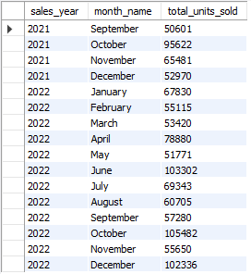

**2. Units sold by segment**

SELECT

segment,

SUM(units_sold) AS total_units_sold

FROM sales

GROUP BY segment

ORDER BY SUM(units_sold) DESC;

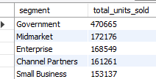

**3. Units sold, gross sales, discounts, net sales, cogs, profit and profit margin by segment**

SELECT

segment,

SUM(units_sold) AS total_units_sold,

ROUND(SUM(gross_sales), 0) AS gross_sales,

ROUND(SUM(discounts), 0) AS total_discounts,

ROUND(SUM(sales), 0) AS net_sales,

ROUND(SUM(cogs), 0) AS cost_of_goods,

ROUND(SUM(sales) - SUM(cogs), 0) AS net_profit,

CONCAT(ROUND(((SUM(sales) - SUM(cogs)) / SUM(sales)) * 100, 0), "%") AS profit_margin

FROM sales

GROUP BY segment;

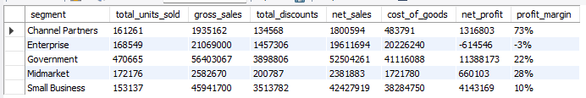

**4. Units sold by country**

SELECT

country,

SUM(units_sold) AS total_units_sold

FROM sales

GROUP BY country

ORDER BY SUM(units_sold) DESC;

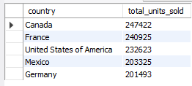

**5. Units sold, gross sales, discounts, net sales, cogs, profit and profit margin by country**

SELECT

country,

SUM(units_sold) AS total_units_sold,

ROUND(SUM(gross_sales), 0) AS gross_sales,

ROUND(SUM(discounts), 0) AS total_discounts,

ROUND(SUM(sales), 0) AS net_sales,

ROUND(SUM(cogs), 0) AS cost_of_goods,

ROUND(SUM(sales) - SUM(cogs), 0) AS net_profit,

CONCAT(ROUND(((SUM(sales) - SUM(cogs)) / SUM(sales)) * 100, 0), "%") AS profit_margin

FROM sales

GROUP BY country;

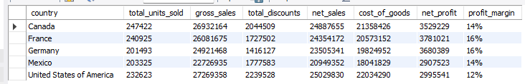

**6. Units sold by product**

SELECT

product,

SUM(units_sold) AS total_units_sold

FROM sales

GROUP BY product

ORDER BY SUM(units_sold) DESC;

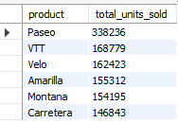

**7. Units sold, gross sales, discounts, net sales, cogs, profit and profit margin by product**

SELECT

product,

SUM(units_sold) AS total_units_sold,

ROUND(SUM(gross_sales), 0) AS gross_sales,

ROUND(SUM(discounts), 0) AS total_discounts,

ROUND(SUM(sales), 0) AS net_sales,

ROUND(SUM(cogs), 0) AS cost_of_goods,

ROUND(SUM(sales) - SUM(cogs), 0) AS net_profit,

CONCAT(ROUND(((SUM(sales) - SUM(cogs)) / SUM(sales)) * 100, 0), "%") AS profit_margin

FROM sales

GROUP BY product;

