PIZZA SALES SQL QUERIES
1. Total Revenue
SELECT
ROUND(
SUM(total_price),
2) AS Total_Revenue
FROM
pizza_sales;
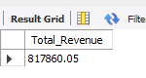
-- 2. Average Order Value
SELECT
ROUND(
SUM(total_price) / COUNT(DISTINCT order_id),
2) AS Avg_order_Value
FROM
pizza_sales;
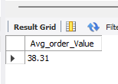
-- 3. Total Pizzas Sold
SELECT
SUM(quantity) AS Total_pizza_sold
FROM
pizza_sales;
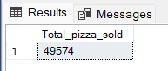

-- 4. Total Orders
SELECT
COUNT(
DISTINCT order_id
) AS Total_Orders
FROM
pizza_sales;
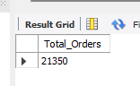
-- 5. Average Pizzas Per Order
SELECT
ROUND(
SUM(quantity) / COUNT(DISTINCT order_id),
2) AS Avg_Pizzas_per_order
FROM
pizza_sales;
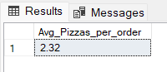
-- 6. Daily Trend for Total Orders
SELECT
DAYNAME(order_date) AS order_day,
COUNT(DISTINCT order_id) AS total_orders
FROM
pizza_sales
GROUP BY
DAYNAME(order_date);
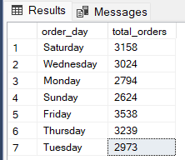
-- 7. Monthly Trend for Orders
SELECT
MONTHNAME(order_date) as Month_Name,
COUNT(DISTINCT order_id) as Total_Orders
FROM
pizza_sales
GROUP BY
MONTHNAME(order_date);
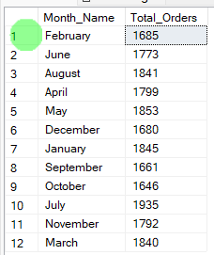
-- 8. % of Sales by Pizza Category
SELECT
pizza_category,
CAST(SUM(total_price) AS DECIMAL(10,2)) AS total_revenue,
ROUND((SUM(total_price) * 100 / (SELECT SUM(total_price) FROM pizza_sales)),2) AS PCT
FROM
pizza_sales
GROUP BY
pizza_category;
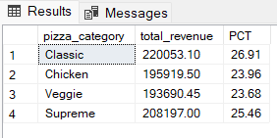
-- 9. % of Sales by Pizza Size
SELECT
pizza_size,
CAST(SUM(total_price) AS DECIMAL(10,2)) AS total_revenue,
ROUND((SUM(total_price) * 100 / (SELECT SUM(total_price) FROM pizza_sales)),2) AS PCT
FROM
pizza_sales
GROUP BY
pizza_size
ORDER BY
pizza_size;
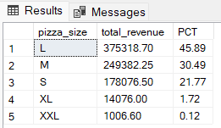
-- 10. Total Pizzas Sold by Pizza Category
SELECT
pizza_category,
SUM(quantity) as Total_Quantity_Sold
FROM
pizza_sales
GROUP BY
pizza_category
ORDER BY
Total_Quantity_Sold DESC;
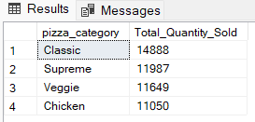
-- 11. Top 5 Pizzas by Revenue
SELECT
pizza_name,
SUM(total_price) AS Total_Revenue
FROM
pizza_sales
GROUP BY
pizza_name
ORDER BY
Total_Revenue DESC
LIMIT 5;
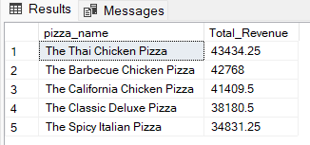

-- 12. Bottom 5 Pizzas by Revenue
SELECT
pizza_name,
ROUND(SUM(total_price),2) AS Total_Revenue
FROM
pizza_sales
GROUP BY
pizza_name
ORDER BY
Total_Revenue ASC
LIMIT 5;
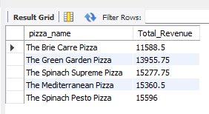
-- 13. Top 5 Pizzas by Quantity
SELECT
pizza_name,
SUM(quantity) AS Total_Pizza_Sold
FROM
pizza_sales
GROUP BY
pizza_name
ORDER BY
Total_Pizza_Sold DESC
LIMIT 5;
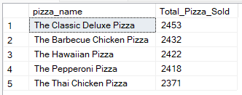
-- 14. Bottom 5 Pizzas by Quantity
SELECT
pizza_name,
SUM(quantity) AS Total_Pizza_Sold
FROM
pizza_sales
GROUP BY
pizza_name
ORDER BY
Total_Pizza_Sold ASC
LIMIT 5;
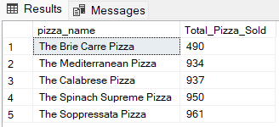
-- 15. Top 5 Pizzas by Total Orders
SELECT
pizza_name,
COUNT(DISTINCT order_id) AS Total_Orders
FROM
pizza_sales
GROUP BY
pizza_name
ORDER BY
Total_Orders DESC
LIMIT 5;
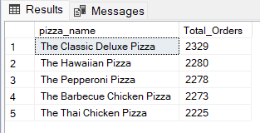
-- 16. Bottom 5 Pizzas by Total Orders
SELECT
pizza_name,
COUNT(DISTINCT order_id) AS Total_Orders
FROM
pizza_sales
GROUP BY
pizza_name
ORDER BY
Total_Orders ASC
LIMIT 5;
