HR DATA ANALYTICS QUERIES
1. Total Employee Count:
SELECT
COUNT(emp_no) AS employee_count
FROM employees;
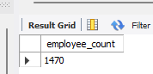
2. Attrition Count:
SELECT
COUNT(emp_no) AS attrition_count
FROM employees
WHERE attrition = 'Yes';
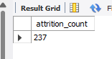
3. Attrition rate:
SELECT
ROUND(
(SUM(CASE WHEN attrition = 'Yes' THEN 1 ELSE 0 END) / COUNT(emp_no) * 100),
2
) AS attrition_rate
FROM employees;
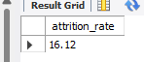
4. Active employee count:
SELECT
COUNT(emp_no) AS active_employee_count
FROM employees
WHERE attrition = 'No';
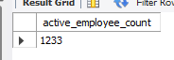
5. Average employee age:
SELECT
ROUND(AVG(age), 0) AS average_age
FROM employees;
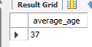
6. Attrition by gender:
SELECT
gender,
COUNT(attrition) AS attrition_count
FROM employees
WHERE attrition = 'Yes'
GROUP BY gender;
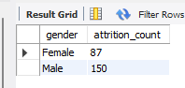
7. Department wise Attrition Count and Rate:
SELECT
department,
COUNT(attrition) AS attrition_count,
ROUND(
COUNT(attrition) / NULLIF((SELECT COUNT(attrition) FROM employees WHERE attrition = 'Yes'), 0) * 100,
2
) AS percentage_of_total
FROM
employees
WHERE
attrition = 'Yes'
GROUP BY
department
ORDER BY
attrition_count DESC;
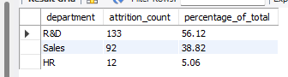
8. Number of employees by age group:
SELECT
age,
COUNT(*) AS number_of_group
FROM employees
GROUP BY age
ORDER BY age;
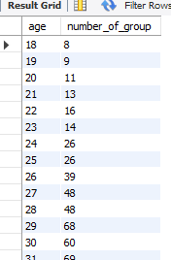
9. Education wise attrition:
SELECT
education,
COUNT(*) AS attrition
FROM employees
WHERE attrition = 'Yes'
GROUP BY education
ORDER BY attrition DESC;
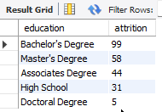
10. Attrition Count and Rate by Gender for different Age Group:
SELECT
age_band,
gender,
COUNT(attrition) AS attrition_count,
ROUND(
COUNT(attrition) / NULLIF((SELECT COUNT(attrition) FROM employees WHERE attrition = 'Yes'), 0) * 100,
2
) AS percentage_of_att_by_ageBand
FROM
employees
WHERE
attrition = 'Yes'
GROUP BY
age_band,
gender
ORDER BY
age_band,
gender;
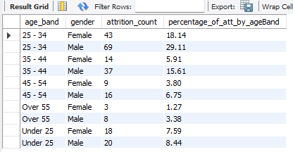
11. Job Satisfaction Rating by Job-Role:
SELECT
job_role,
SUM(CASE WHEN job_satisfaction = 1 THEN 1 ELSE 0 END) AS "1",
SUM(CASE WHEN job_satisfaction = 2 THEN 1 ELSE 0 END) AS "2",
SUM(CASE WHEN job_satisfaction = 3 THEN 1 ELSE 0 END) AS "3",
SUM(CASE WHEN job_satisfaction = 4 THEN 1 ELSE 0 END) AS "4"
FROM employees
GROUP BY job_role
ORDER BY job_role;
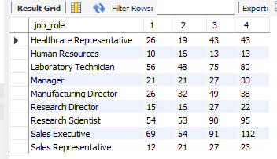
12. Number of employees by age group and gender:
SELECT
age_band,
gender,
COUNT(*) AS number_of_active_emp
FROM employees
WHERE attrition = 'No'
GROUP BY
age_band,
gender
ORDER BY
age_band,
gender;
