LALE MARKET QUERIES AND OUTPUTS
KPIs
1. Current month orders(transactions – not the quantity)
SELECT
COUNT(order_date) AS current_month_orders
FROM sales
WHERE
DATE_FORMAT(order_date, '%Y-%m') = (
SELECT
DATE_FORMAT(MAX(order_date), '%Y-%m')
FROM
sales
);
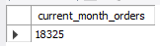
2. Current month profit
SELECT
ROUND(SUM(sales.order_quantity * products.product_price) -
SUM(sales.order_quantity * products.product_cost), 0) AS current_month_profit
FROM sales
INNER JOIN products ON products.product_id = sales.product_id
WHERE
DATE_FORMAT(order_date, '%Y-%m') = (
SELECT
DATE_FORMAT(MAX(order_date), '%Y-%m')
FROM
sales
);
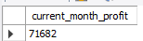

3. Current month returns (return transactions - not the quantity)
SELECT
count(return_date) AS current_month_returns
FROM returns
WHERE
DATE_FORMAT(return_date, '%Y-%m') = (
SELECT
DATE_FORMAT(MAX(return_date), '%Y-%m')
FROM returns
);
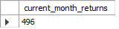
4. Current month revenue
SELECT
ROUND(
SUM(sales.order_quantity * products.product_price), 0) AS current_month_revenue
FROM sales
INNER JOIN products ON products.product_id = sales.product_id
WHERE
DATE_FORMAT(order_date, '%Y-%m') = (
SELECT
DATE_FORMAT(MAX(order_date), '%Y-%m')
FROM sales
);
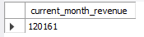
5. Total active customers
SELECT
COUNT(DISTINCT customer_id) AS total_active_customers
FROM
sales;
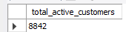
SOME OF THE CHARTS
1. Monthly revenue trending
SELECT
YEAR(order_date) AS sales_year,
MONTHNAME(order_date) AS month_name,
ROUND(SUM(sales.order_quantity * products.product_price), 0) AS month_revenue
FROM sales
INNER JOIN products ON products.product_id = sales.product_id
GROUP BY YEAR(order_date),
MONTHNAME(order_date);
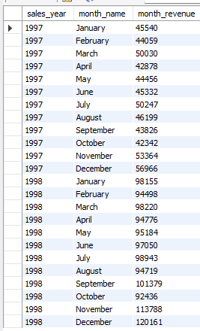
2. The most sold product by quantity
SELECT
products.product_name
FROM sales
INNER JOIN products ON products.product_id = sales.product_id
GROUP BY products.product_name
ORDER BY SUM(sales.order_quantity) DESC
LIMIT 1;
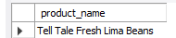
3. The most returned product by quantity
SELECT
products.product_name
FROM returns
INNER JOIN products ON products.product_id = returns.product_id
GROUP BY products.product_name
ORDER BY SUM(returns.return_quantity) DESC
LIMIT 1;

4. Orders/Transactions by countries
SELECT
stores.store_country,
COUNT(product_id) AS total_transactions
FROM sales
INNER JOIN stores ON stores.store_id = sales.store_id
GROUP BY stores.store_country
ORDER BY total_transactions DESC;
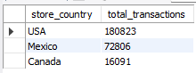
5. Revenue by countries and cities
SELECT
stores.store_country,
stores.store_city,
ROUND(SUM(sales.order_quantity * products.product_price), 0) AS revenue
FROM sales
INNER JOIN stores ON stores.store_id = sales.store_id
INNER JOIN products ON products.product_id = sales.product_id
GROUP BY stores.store_country,
stores.store_city
ORDER BY stores.store_country DESC,
revenue DESC;
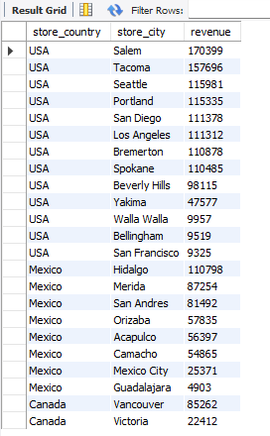
6. Top 50 Customers by Revenue
SELECT
customers.customer_id,
CONCAT_WS(" ",customers.first_name, customers.last_name) AS Customer,
ROUND(SUM(sales.order_quantity * products.product_price), 0) AS Revenue
FROM sales
INNER JOIN customers ON customers.customer_id = sales.customer_id
INNER JOIN products ON products.product_id = sales.product_id
GROUP BY customers.customer_id
ORDER BY Revenue DESC
LIMIT 50;
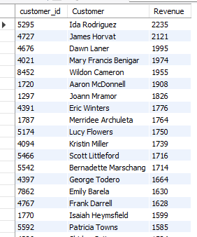
7. Total customers by month
SELECT
YEAR(order_date) AS sales_year,
MONTHNAME(order_date) AS month_name,
COUNT(DISTINCT customer_id) AS total_active_customers
FROM sales
GROUP BY
sales_year,
MONTH(order_date),
month_name
ORDER BY
sales_year,
MONTH(order_date);
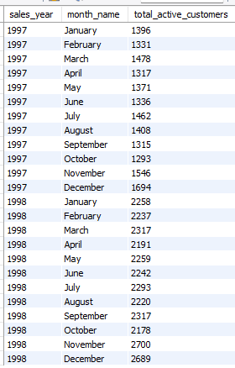
8. Total revenue by occupation
SELECT
customers.occupation,
ROUND(SUM(sales.order_quantity * products.product_price), 0) AS revenue
FROM sales
INNER JOIN customers ON customers.customer_id = sales.customer_id
INNER JOIN products ON products.product_id = sales.product_id
GROUP BY customers.occupation
ORDER BY revenue DESC;
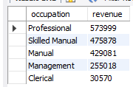
9. Revenue by customers who has child/children and by country
SELECT
stores.store_country,
CASE WHEN customers.children > 0 THEN 'Y' ELSE 'N' END AS children,
ROUND(SUM(sales.order_quantity * products.product_price), 0) AS revenue
FROM
sales
INNER JOIN
customers ON customers.customer_id = sales.customer_id
INNER JOIN
products ON products.product_id = sales.product_id
INNER JOIN
stores ON stores.store_id = sales.store_id
GROUP BY
stores.store_country,
CASE WHEN customers.children > 0 THEN 'Y' ELSE 'N' END
ORDER BY
stores.store_country DESC,
revenue DESC;
